BARANGAY SOUTH SIGNAL VILLAGE WEB APP

Project Documentation Submitted to the Faculty of the

School of Computing and Information Technologies

Asia Pacific College

In Partial Fulfillment of the Requirements for

Applied Project – System Prototype for IT

MCSPROJ

By

|  |  |
| --- | --- |
| Rark Mowen L. Alcantara | Mikedale B. Dellera |
| Jakerson B. Bermudo | Princess Joy H. Ferrer |
| Wilkins V. Caducio | Mohammad Darwish T. Mustary |
|  |  |
|  |  |

ASIA PACIFIC COLLEGE

Approval Sheet

BARANGAY SOUTH SIGNAL VILLAGE WEB APP

Prepared and submitted by

Rark Mowen L. Alcantara

Jakerson B. Bermudo

Wilkins V. Caducio

Mikedale B. Dellera

Princess Joy H. Ferrer

Mohammad Darwish T. Mustary

In Partial Fulfillment of the Requirements for the Degree of

Bachelor Science in Information Technology

Examined and Recommended for Acceptance and Approval for

Research/Capstone Presentation

___________________________

<Name>, Adviser

Panelists

_________________________

<Name>, Chairperson

|  |  |
| --- | --- |
| ___________________________ | ___________________________ |
| <Name>, Panel Member | <Name>, Panel Member |

Acceptance and Approved in Partial Fulfillment of the Requirements for the Degree of

Bachelor of Science in Information Technology

___________________________

Rhea-Luz R. Valbuena

Executive Director

School of Computing and Information Technologies

Table of Contents

Executive Summary i

List of Figures ii

List of Tables iv

I. Introduction 1

1.1 Project Context 1

1.2 Statement of the Problem 2

1.3 Objectives 2

1.4 Significance of the Project 3

1.5 Scope and Limitations 4

II. Review of Related Literature / Systems 6

2.1 Related System 6

2.2 Related Literature 7

2.3 Synthesis 10

III. Technical Background 11

3.1 Current System 11

3.2 Proposed System 11

IV. Methodology 14

4.1 Requirements Analysis 15

4.1.1 Product Backlog / User Stories 15

4.1.2 Event Tables 18

4.1.3 Use Case Diagrams 19

4.1.4 Use Case Full Description 19

4.2 Gap Analysis 36

4.3 System Analysis and Design 37

4.3.1 Context Diagram 37

4.3.2 Data Flow Diagrams 38

4.3.3 Entity-Relationship Diagrams 42

4.3.4 Activity Diagrams 43

4.3.5 Object Diagram 44

4.3.6 Class Diagrams 44

4.3.7 Sequence Diagrams 45

4.3.9 Use Case Package Diagram 53

4.3.10 Component Diagram 54

4.3.11 Deployment Diagram 55

V. Results and Discussion 56

5.1 Release Plan 56

5.2 Prototype 57

A. Resident Prototype: 57

B. Barangay Employee Prototype 64

5.3 Use Classes and Characteristics 67

VI. Conclusion 69

References 72

Appendices 75

Appendix A: Project Vision 75

Appendix B: Schedule 76

Appendix C: Product Roadmap 80

Appendix D: Users’ Manual 81

Appendix E: Team Meetings 82

Appendix F: Source Code 108

Appendix G: Curriculum Vitae 113

Appendix H: Links 119

# Executive Summary

**What is the product or service?**

The product is a Web Application for Barangay South Signal Village that aims to provide an online service that takes on document requests and sends inquiries to the community of the barangay. The Web Application will contain substantial information about the barangay such as: organizational chart, history, demography, mission, vision, and the hazard map.

**Who are its customers?**

The Barangay South Signal Village Web Application customers will only be limited to the Barangay South Signal Village residents.

**Problem Summary**

The Barangay South Signal Village heavily relies on papers and most of their records and documents are stored in physical filing cabinets, making their client wait for minutes that delay client service as well as their data being unsecured.

**Solution Summary**

Integrate its current system into the digital setting by making a web application that provides information about the barangay and online service/s for their community in a more efficient, effective, and transparent way.

**The Team**

The team consists of six (6) members who are currently studying and taking a Bachelor of Science in Information Technology. All members of the team are students at Asia Pacific College.

# List of Figures

Figure 1 MVC Model 13

Figure 2 SDLC Agile Methodology 14

Figure 3 Use Case Diagram 19

Figure 4 Context Diagram 37

Figure 5 Data Flow Diagram Level 0 38

Figure 6 Data Flow Diagram Level 1 (Process 1) 39

Figure 7 Data Flow Diagram Level 1 (Process 2) 39

Figure 8 Data Flow Diagram Level 1 (Process 2) 40

Figure 9 Data Flow Diagram Level 1 (Process 3) 40

Figure 10 Data Flow Diagram Level 1 (Process 3) 41

Figure 11 Data Flow Diagram Level 1 (Process 4) 41

Figure 12 Data Flow Diagram Level 1 (Process 5) 41

Figure 13 Entity-Relationship Diagrams 42

Figure 14 Activity Diagram 43

Figure 15 Object Diagrams 43

Figure 16 Class Diagram 44

Figure 17 Sequence Diagram: Manage Resident Account 44

Figure 18 Sequence Diagram: Manage Request 45

Figure 19 Sequence Diagram: Manage Concern 45

Figure 20 Sequence Diagram: Manage Barangay Employee Accounts 46

Figure 21 Sequence Diagram: Manage Barangay Secretary Account 46

Figure 22 Sequence Diagram: Process Request 47

Figure 23 Sequence Diagram: Process Concern 47

Figure 24 State Machine Diagram: Manage Resident Account (Create) 48

Figure 25 State Machine Diagram: Manage Resident Account (Log-in) 48

Figure 26 State Machine Diagram: Manage Resident Account (Edit) 48

Figure 27 State Machine Diagram: Manage Request 49

Figure 28 State Machine Diagram: Manage Concern 49

Figure 29 State Machine Diagram: Manage Employee Account 49

Figure 30 State Machine Diagram: Manage Barangay Secretary Account. 50

Figure 31 State Machine Diagram: Manage Barangay Secretary Account Edit. 50

Figure 32 State Machine Diagram: Process Request 50

Figure 33 State Machine Diagram: Process Concern 51

Figure 34 State Machine Diagram: Manage Employee Account (Log-in) 51

Figure 35 State Machine Diagram: Manage Employee Account (Edit) 51

Figure 36 Use Case Package Diagram 52

Figure 37 Component Diagram 53

Figure 38 Deployment Diagram 54

Figure 39 Home Page 56

Figure 40 About Us Page 57

Figure 41 Safety Section 58

Figure 42 Contacts 58

Figure 43 Requirements 59

Figure 44 Track Request 59

Figure 45 Data Privacy Notice 60

Figure 46 Registration Page 60

Figure 47 Log in page 61

Figure 48 Resident Dashboard 61

Figure 49 Resident Dashboard Side Bar 62

Figure 50 Resident Dashboard - My Profile 62

Figure 51 Transaction History 63

Figure 52 Admin portal login 63

Figure 53 Administrator Dashboard 64

Figure 54 Barangay Captain Dashboard 64

Figure 55 Barangay Secretary Dashboard 65

Figure 56 Request Manager Dashboard 65

Figure 57 Concern Manager Dashboard 66

Figure 58 Project Vision 73

Figure 59 Work Bench Structure (WBS) 77

Figure 60 Product Roadmap 78

Figure 61 Source Codes 91

# List of Tables

Table 1 User Stories with Acceptance Criteria 15

Table 2 Event Table 18

Table 3 Use Case Full Description: Create Resident Account 20

Table 4 Use Case Full Description: Log-in Resident Account 21

Table 5 Use Case Full Description: Edit Resident Account 22

Table 6 Use Case Full Description Create New Request 23

Table 7 Use Case Full Description: Create New Request 24

Table 8 Use Case Full Description: Cancel Request 25

Table 9 Use Case Full Description: Manage Concern 26

Table 10 Use Case Full Description: Track Concern Status 27

Table 11 Use Case Full Description: Cancel Concern 28

Table 12 Use Case Full Description: Process Request 29

Table 13 Use Case Full Description: Process Concern 30

Table 14 Use Case Full Description: Edit Barangay Secretary Account 31

Table 15 Use Case Full Description: Create Employee Account 32

Table 16 Use Case Full Description: Edit Employee Account 33

Table 17 Use Case Full Description: Deactivate Employee Account 34

Table 18 Use Case Full Description: View Report 35

Table 19 Gap Analysis 36

Table 20 Use Classes and Characteristics 66

Table 21 Schedule Table 74

# Introduction

## Project Context

Barangay is the smallest political unit in the country [1]. It is composed of elective officials called the Punong Barangay, the Sangguniang Barangay members, and the Sangguniang Kabataan Chairman. The primary requisite for creating a barangay is at least 2000 in population; as of 2021, there are about 42,046 barangays in the Philippines [2] . Each barangay maintains a database holding different information about their barangay, like population, houses built in the community, records of their funds, cases filed, and the resident's socio-economic profile. The Punong Barangay cannot carry these tasks alone, which is why they appointed their own Barangay Secretary and Barangay Treasurer to serve as their hands in terms of dealing with fiscal and administrative relations.

The Barangay South Signal Village is one of the 28 barangays of Taguig City, Philippines. South Signal was formerly a part of Barangay Signal Village before being divided into four other barangays. The South Signal Village is composed of segregated areas from other barangays of Signal Village. The COMELEC Board of Canvassers duly confirmed the Barangay South Signal Village on December 19, 2008.

The Barangay South Signal Village heavily relies on papers, and most of its records and documents are stored in its physical filing cabinets. With the advancement of technology, selected barangays are already using computers and electronic devices to provide service and carry out official transactions. However, most barangays are still stuck with manual-based operations. Every request made by their client would take minutes to perform because of the tedious search for records stored in their physical file cabinets, which delays client service. All the essential and relevant information is encoded into a spreadsheet or a logbook, which uses many papers. The team would like to introduce the document management system to keep track of records, providing services and complaints in a modern approach with the use of computers as a primary medium that can speed up the process and reduce the consumption of paper.

Their Facebook page is the only platform they use to spread information, such as announcements, barangay news, and events. As of this moment, the barangay is still manually recording every request and transaction through pen and paper using only their logbook. The barangay wants to integrate its current system into the digital setting, but they need to know where to begin since they do not have an allocated budget. That is why the team proposed a new system that will digitize transactions and create a database on their servers or clouds.

## Statement of the Problem

In this chapter, the identified problems with the current system of Barangay South Signal Village will be discussed. Below are the main problems that the team is going to address:

1. **Long Processing Time** - The minimum number of processes the barangay can cater per day is 50. An average of 15 to 20 minutes is the processing time for the documents in the barangay, according to the barangay secretary. Considering the time to fill out the application form and getting in line, the processing time can increase from 30 minutes to 1 hour, depending on how long the line is.
2. **Risk of acquiring disease/s** – To request documents in the barangay, the residents will need to go to the barangay to request the needed documents personally. Personal requests will put the client and the residents at risk of contracting a disease due to social distancing concerns.
3. **Common errors using manual input -** The barangay secretary estimated that 4 out of 10 recorded data have errors. She identified that the causes of these errors are due to the input of the residents. Manual input of the residents in the application form is prone to typographical errors and illegible handwriting.
4. **A manual search of records in the database** – Due to having a physical file storage/database, the barangay has no way to automatically search records within the barangay. The barangay secretary and her department will need to manually dig into the physical file storage to find a single record that they need.
5. **Unsecured data** – The barangay does not have a secured database in the cloud; instead, they have multiple physical file storage. This makes it prone to many workplace hazards making the data unsafe/unsecured and exposed to danger.

## Objectives

The "Barangay South Signal Village Web App" proposed solution aims to provide online services to the barangay community. It will also contain substantial information about the barangay, including its current officials and location. Below are its general and specific objectives:

**General Objectives:**

To develop a web app that provides information about the barangay and online service/s for their community more efficiently, effectively, and transparently.

**Specific Objectives:**

1. To create a web application that can handle online document requests that will reduce the barangay residents processing time and time consumption by up to 80%.
2. To help the community, especially the vulnerable residents such as PWDs and senior residents, to lessen the risk of acquiring contagious diseases such as COVID-19 by requesting barangay documents by applying through the web app that lessens their direct contact with other people.
3. To create online forms to remove errors regarding illegible handwriting and reduce manual input errors by up to 90% through proper guidance in each part of the information to be filled out on the form.
4. To provide barangay staff with real-time insights regarding the number of requests per day, number of pending requests/s, number of online requests, and number of registered accounts by going through a statistics dashboard/page.
5. To build a secure and safe storage location for data using the cloud, which saves data over the internet, and this can only be accessed by the administrator, or the barangay staff itself by logging in to the account, making it 90% more secure than using filing cabinet/s.
6. To develop a web application that provides timely, accurate, and trustworthy information verified and approved by the barangay and its officials to the community.

## Significance of the Project

The direct beneficiaries of this project are the Barangay South Signal Village Officials, Barangay South Signal Village Residents, and Future Researchers.

1. **Barangay South Signal Village Officials** – They will benefit from this project because it will help them to digitize their organization by sharing valuable information about their barangay. It will also help them to have a new and easier way to process and record barangay transactions online.
2. **Barangay South Signal Village** **Residents** – Barangay South Signal Village residents will benefit from this project because they will have a new and effortless way to access public information about their barangay. It will also help them to have a new and easier way to request barangay documents ahead of time without having to wait in line and spend time requesting at the barangay.
3. **Future Researchers** – This project will also benefit other future researchers as they can use this project as a reference to any similar or related project.

This project focuses primarily on three Sustainable Development Goals (SDG), namely Goal 8, Goal 11, and Goal 16.

1. SDG 8 is about inclusive and sustainable economic growth that can drive progress, create decent jobs for all, and improve living standards [3].

* SDG 11 is all about sustainable cities and communities which aim to give inclusive, safe, resilient, and sustainable cities and residences [4].

1. SDG 16 is about promoting peace, justice, and strong institutions that address public access to information and accountable, effective, and transparent governance [5].

## Scope and Limitations

The project's scope will be focused only on creating a web-based application and implementing the limited features provided by the client. The web-based application will be made up of Figma for wireframe, Hypertext Markup Language (HTML), and Cascading Style Sheets (CSS) for the UI / UX Design.

Barangay South Signal Village residents can quickly request the following: (1) Barangay documents that fit their needs, (2) Help for community problems (sewage blockage, electricity pole that fell out of place, or a fallen tree).

The residents can use the web app using the internet and their cell phones, computers, and tablets to access their needs. The residents can quickly know the details, information, and other services that the barangay can accommodate based on the needs of the residents.

The web app is limited to the following: (1) The Online Document Request Feature which will only be processed for the verified users/residents of the barangay. (2) The web app will provide a soft copy of the request form and documents when making an online request. The constituents will still claim the document through the barangay office, where the original copy of the stated requirements will be presented for verification. (3) The web app will not automatically verify the users; instead, the administrator/staff that oversees the document request will do the manual verifications. (4) Bills payment are not connected to this web app or other accounting-related transactions. All the transactions will be processed through the barangay office. (5) All residents without internet connection cannot access the online barangay services; hence, all requests and complaints in the case must be filed personally at the barangay office. The requested online documents are only limited to Barangay ID, Community Tax Certificate, Barangay Clearance, Barangay Certificate, and Business Clearance.

# Review of Related Literature / Systems

This chapter contains ideas, conclusions, methodologies, and information that may be related to the results and features of our proposed solution, “Barangay South Signal Village Web-app” Which is composed of related systems and literature that talks about its similarities and goals for the barangay. This chapter is divided into two parts: (1) related systems, the existing barangay website and systems; and (2) related literature, which uses research studies that provide information in this study.

## Related System

Below are some of the features that exist in other government websites that provide its citizens with the latest news and information that is currently happening in the barangay/city, barangay/city profile, and online services such as a request for ID/documents, and a database to hold and record every transaction.

**2.1.1 Advisory and Information System and Online Services**

A Hybrid Barangay Information Management System can rapidly gather, encode, store, and maintain data of the barangay. Modern technology opens a broader opportunity for barangays to serve their constituents better through computerization of the documents, as it provides certificates of indulgence, letters of recommendation, barangay clearance, and generating reports [6].

The Barangay Fort Bonifacio website provides information about the barangay profile. It shows the history, demography, mission, and vision, as well as the barangay officials. The main feature of the Barangay Fort Bonifacio Website is the Online Services; in this tab, the website allows the user to request documents such as Business Clearance, Barangay Clearance/Certificate, and Barangay ID [7].

The official website of Taguig City contains the latest news and information about the different events in the city. It also contains announcements about different issues to help the residents be aware of what to do and what to follow prior to the announcement. This feature of the websites allows the citizens to be informed about up-to-date information for the city of Taguig to achieve peace and order [8].

The official website of Pasig City provides different general information, including data, lists of city government, history, timeline, and past mayors of Pasig City. It also contains a city tour wherein it will find information about the historical places and tourist spots in the City of Pasig. Lastly, it includes a list of job openings helpful for citizens looking for job opportunities. That is why they can easily find out information about job openings [9].

## Related Literature

The following is a collection of existing literature that has contributed to strengthening the project's purpose. The literature consists of the importance of computerized systems in a barangay, their meaning, and how a barangay management information system functions and contributes to a barangay.

Based on the "Computerized Information System in Barangay Poblacion, Danao City, Cebu - CAPSTONE PROJECT [10], computerization is a control system that manages industrial operations. It reduces human errors and processing time, increasing productivity and product quality. This can result in a significantly faster and more accurate system than a manual one. This will also ensure that barangay staff and residents receive effective and efficient services.

As discussed by the System (BMIS) for Cities and Municipalities in the Philippines [11] , the Barangay Management Information System for San Carlos City is a web-based and offline system for storing, processing, retrieving, and updating of information of barangays and city halls over a secure network interface. It is meant to manage various data about barangay profiles, constituent profiles, barangay clearances, cases, activities, and City Hall reports. The barangay's functions, operations, and transactions are also included in this report. It is meant to provide comprehensive and accurate information to the barangay, city hall administrations, and stakeholders.

According to C. O. Carpio, "Barangay Management System," International Journal of Multidisciplinary Research and Publications [12] , the increasing trend for Information Technology has risen above the surface of development endeavors as the global environment ages. It is at the heart of simplifying procedures in public and private sectors as a process innovation. Computers play a critical role in supporting people in organizing, storing, and retrieving vast amounts of data, making them less of a choice and more of a necessity for individuals. It also serves as a tool that allows users to do more activities, making it a valuable commodity, particularly in professional contexts. Nonetheless, several barangays have already begun to employ computers and electrical devices.

On the other hand, most barangay still rely on manual processes to conduct official transactions. Clearances and certifications are created with little or no baseline data to ensure reliability. This exposes non-residents to the risk of exploiting the process fault. Hence, the need for a Barangay Management System. It is also known as e-barangay, a web-based management approach aiming to transform barangay management from a traditional and centralized entity to a more inclusive and resident-oriented system. Its primary goal is to simplify administrative operations such as requesting papers, submitting complaints, and generating appropriate and accurate local data.

As discussed by B. Jacobe, M. L. Pascua, B. J. Tumbali, M. C. Aquino and M. V. Gumabay, "Barangay Profiling System with Analytics," International Journal of Advanced Trends in Computer Science and Engineering [13] , the necessity to focus on the societal issues of every barangay is a relevant aspect that needs awareness from the person in authority. They also said that using technology, managing, monitoring, and tracking the most critical information of each household in the barangay could be realized. They also added that profiling the information of each household using a system could make the person more productive and give a better service to the community.

Based on the study of J. K. P. Imus, E. D. Magleo, M. A. A. Soriano and R. L. Olalia, Jr., "Barangay Management Information System (BMIS) for," International Journal of Computer Applications [14] , no one is left behind in using high technologies to make work or complex activities more accessible in the age of advanced operation technologies. They said it is a powerful and convenient builder for simultaneous growth in society and industries. Lastly, an information service provides a way to electronically access, retrieve, and transmit the information stated by them.

In the study of I. A. A. Cristobal, C. K. O. Cruz, J. M. P. Dela Cruz, J. H. Manalansan, B. S. Fabito, R. L. Rodriguez, and M. V. Octaviano.[15] , to create a framework for an e-participation platform for Pasig City's 2nd District, Philippines; the e-participation platform is intended to be implemented in the various barangays that fall under its scope. The application will facilitate better and more convenient communication between the community and barangay officials. The platform expresses all opinions, issues, concerns, and requests.

Based on the "E-Barangay: A Framework for a Web-Based System for Local Communities and Its Usability," International Journal of Electronic Government Research [16], it was discovered that a mobile application that accepts residents' complaints, disseminates information, expedites the processing of government documents, and supports decision-making is essential to provide better public services. As a result, a mobile application called E-Barangay with such capabilities is being developed.

J. E. L. Caubang, "Barangay Resident Record Management and Certificate Issuance System of Barangay Ticol Sorsogon City [17] stated that the Barangay Residents Record Management and Certificate Issuance System aims to improve record management, certificate issuance, and residents' confidential records. This system is intended to provide efficient, reliable, fast, and accurate information to provide high-quality service, secure the client's file, and ensure that services and information are provided appropriately to meet the client's needs.

E-Government Master Plan (EGMP) focuses on the municipal or national setup, and due to the lack of a smaller community-level e-government framework like the barangay, the study entitled "E-Barangay: A Framework for a Web-Based System for Local Communities and Its Usability" promotes a solution to address those gaps by introducing the e-barangay framework, which focuses for more minor community-based online services. Based on their study about the e-barangay, four core elements will satisfy the barangay's needs and their people: submitting concerns or complaints, requesting documents, making comments, and disseminating announcements [18]. As mentioned in the study, the primary purpose of the e-barangay as a framework was to gather and generate insights and information, which is contemplated as a critical component for good governance as well as to have a more robust engagement between the barangay and the resident in the development of e-Governance in a smaller setup.

According to C. J. S. Santiago, M. L. P. Ulanday, Z. J. R. Centeno and M. C. D. Bayla [19], it is necessary to recognize the importance of Information and Communication Technology (ICT) in transforming the local government sector into an information-driven, contemporary, and competitive sector. They are required to provide information delivery and access methods that are both more modern and quicker. The way individuals conduct their businesses and their lives, in general, has continued to alter in tandem with developments in ICT. eGovernment symbolizes a large wave of technological innovation and the government's ongoing effort to reinvent itself alongside e-Commerce. It is a tremendous chance to advance in the 21st century with better quality, more cost-effective government services, and tighter collaboration between the people and the government. However, there are a few roadblocks in the integration of ICT.

Literacy in information and communication technology (ICT) is vital for people to have for them to be able to utilize eGovernment programs. It is essential to the success of eGovernment that people have the knowledge and proficiency in using technologies such as desktops, laptops, and the internet, which plays a crucial role in Information and Communications Technology (ICT) for the staff. Investment in technological skills is highly significant, and the training of staff members is necessary for managing newly implemented systems. Based on the result of "Access, Skills and Constraints of Barangay Officials towards the Use of Information and Communications Technology (ICT)," [19] it was found that most of their respondents, barangay secretaries and barangay treasurers, are competent enough to handle their duties using their current system because their Local Government Unit (LGU) supported them in enhancing their knowledge and skills in Information and Communications Technology (ICT). However, on the same data, their ICT skills may be restricted by slow internet connections and limited funding resources [19].

In the study of C. J. S. Santiago, M. L. P. Ulanday, Z. J. R. Centeno and M. C. D. Bayla [19], The quality of services in the barangay is deteriorating due to manual transaction processing, which takes longer, is more prone to human mistakes and is less secure in retaining records. As a result, improving government transactions and public service delivery through digitization is vital, as modern technology provides new opportunities for barangays to serve their constituents better. Thus, the need to develop a new system, a web-based Barangay Information System, to reinvent the ways of Barangay Mangga in handling transactions and administrative processes.

## Synthesis

Websites are essential, especially for the government sector, such as cities and barangay. Not only does it provide a way for residents to be updated about the latest news and announcements, but it will also help them to know the barangay better by seeing its history included on the website, like the City of Taguig. Features such as online services are a great way to lessen the staff's workload in the barangay and the time spent requesting documents by the residents going to the barangay. The website will also help the barangay have safe and secured storage for data called "Database," which will reduce the risk of memory loss due to workplace hazards given by websites like the barangay website of Fort Bonifacio.

As mentioned in the studies above, computerization helps reduce human errors and processing time while increasing productivity and product quality which will soon lead to a faster, more accurate, efficient, and effective service.

# Technical Background

The proponents discussed the technical background of the project in this chapter, focusing on the current system of their client, Barangay South Signal Village, and the proposed system, Barangay South Signal Web App. The current system includes the process that the Barangay South Signal Village currently uses, especially in requesting barangay documents. The proposed system is the system that the proponents would develop to address and solve specific concerns and problems in Barangay South Signal Village using different functionalities on their proposed barangay web application.

## Current System

The barangay currently uses application forms and close monitoring to process requests for the residents. They are given a form in which they will fill out all the necessary information and submit a hard copy of the requirement with at least one photocopy of each. The forms will be submitted to the department of the barangay secretary, which will be processed. The resident will need to wait at the barangay to claim the document after the requirements are verified, and the document is printed. After the residents claim their documents, the submitted application form will be kept in a file that serves as their database. The information will be manually written in a logbook.

## Proposed System

The proposed solution of the team to the client is to build a centralized and live web application for their barangay residents that have distinct functions:

1. **About Us** – where the Barangay South Signal Village information will be posted, such as the barangay profile, including the history of the barangay, mission, vision, demography, and the organizational chart of the barangay officials.
2. **Safety Section** – where the safety guidelines are posted and the Map Book of the barangay (provided by the Philippine Red Cross), which includes the base map, capacity map, vulnerability map, land use map, historical hazard map, and flood hazard map.

(3) **Contacts**– where the contact information of the barangay is displayed, such as the barangay hotlines and emergency hotline. It also includes the embedded Google map of the Barangay South Signal Village Office that can be used to track the barangay's location.

(4) **Requirements Guidelines** – wherein all the available documents that can be requested are listed, including how much it will cost, instructions for manual request, estimated time of the process, and the requirements needed.

In the proposed project of the team, the resident can register in the web application wherein they will have their resident dashboard that will utilize the functions of the barangay's web app, such as:

1. **Online Request** – the registered residents can request barangay documents online without personally going to the barangay. After the resident submits their request online, the web app will send an email that will notify them and include the tracking key of their request.
2. **Submitting a Concern**: the registered residents can inquire and report any problem or incidents near the barangay.
3. **Track a Request** – the registered residents can track the status of their requested documents and submitted concerns by inputting the track key given by the system.
4. **Transaction History** - the registered residents can see all his/her transactions using their assigned barangay account.

The web app will provide an alternative translation for each part of the application form in Filipino for the constituents to understand the form better.

The web app will also send an email to the constituents requesting documents/submitted concerns for them to be updated on their request/query status.

In our proposed solution, the team will also implement different roles for the barangay side, namely as the Barangay Secretary, Web-App administrator, and the Barangay Captain, wherein they will have their dashboard with different tasks and functions such as

1. processing the online requests and concerns of the residents,
2. manage the barangay employee accounts and resident's account in the web application,
3. generating reports, and
4. managing web applications.

The team proposes to their client to upgrade their records from the manual into a database wherein the data for all online requests will be stored.

To create the Barangay South Signal Village Web Application, the team will use LARAVEL, an open-source PHP web framework for developing a web application. Laravel is based on the MVC architecture design, which stands for Model, View, and Controller.

* **Model** – supervises and controls the database of the Barangay South Signal Village Web Application. It uses queries to add, retrieve, modify, and delete records or tables in the database. The team will use MYSQL as their database for this web application, an open source that can store and retrieve data in a tabular form.
* **View** - responsible for creating and rendering the web application's user interface (UI) and user experience (UX). In LARAVEL, the team will use Blade Templates, a solid templating engine included in the Laravel framework. Blade Templates uses PHP to write a script for HTML, CSS (Bootstrap), and JAVASCRIPT for front-end development.
* **Controller** – oversees the web application's logic and processes user activities that engage with the model and view. It sends data from the model (database) to the view (front-end).
* 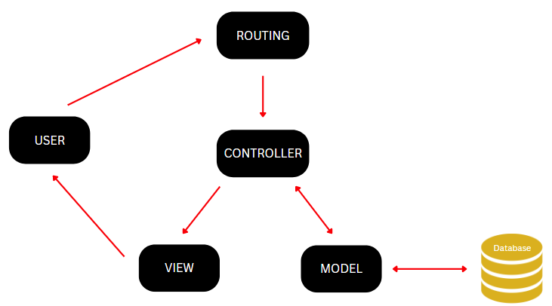**Routing** – in addition to the MVC architecture for Laravel, routing is used to map URLs to the designated controller's actions.

Figure 1 MVC Model

# Methodology

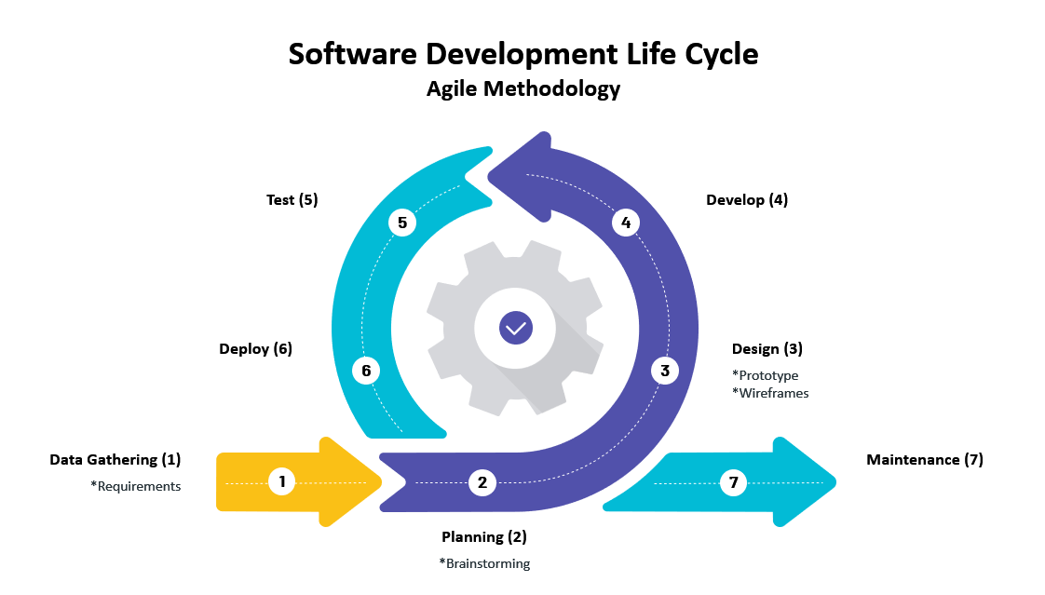

Figure 2 SDLC Agile Methodology

Throughout this project, the team utilized an SDLC or Software Development Cycle to guide them, explicitly using the Agile Method. Software Development Cycle is one of the fundamental methods in developing software step-by-step. Using the Agile Method in the Software Development Cycle focuses attention on the team to respond to the changes that the clients demand throughout the development process [20]. This method emphasizes the efficient and effective collaboration between the team and the client. Figure 2 SDLC Agile Methodology shows the model which the team used throughout the software development.

* + - 1. **Data Gathering Phase**

The team gathered data that would fulfill their first requirements in software development. They used the technique in data gathering through several interviews, discussions, and meetings. In this phase, the team gathered data about the client’s current system, problem, desired system, features the system, and background/profile.

* + - 1. **Planning Phase**

After gathering data from several meetings with their client, the team conducted several brainstorming phases to analyze the main problem and develop viable solutions. The team proposed an appropriate solution based on the problems that the client discussed. Further, the team discussed the solution with the client for them to understand it fully. After the approval of the proposed solution, the team went to another brainstorming phase to discuss technologies and software to be used in the creation of the prototype and, later, the completed system.

* + - 1. **Design Phase**

The team applied the discussed design, functions, and layout with the client through the proposed wireframe and prototype. Likewise, the team has provided the proper UI and UX design to meet the client’s standards and demands.

* + - 1. **Development Phase**

In this phase, the team developed the proposed solution that used the right technologies and software discussed in the planning phase. They also developed the front, database, and back end in this phase.

* + - 1. **Testing Phase**

In this phase, the team tested their software using the functionalities, performance, security, and overall system. They also followed one or more evolutionary development phases to put the most recent expansion into production.

* + - 1. **Deploying Phase**

In the deployment phase, the team has handed out the responsibilities over the web app and the ownership to the client based on the current agreement.

* + - 1. **Maintenance Phase**

In this phase, the team provided the user’s manual, which helped the client navigate and maintain the web app. The overall system maintenance has been handed to the client.

## Requirements Analysis

### Product Backlog / User Stories

Table 1 User Stories with Acceptance Criteria

|  |  |  |  |  |
| --- | --- | --- | --- | --- |
| ID | TITLE | USER STORY | ACCEPTANCE | PRIORITY |
| 1 | Manage Resident Account | “As the Resident, I want to have my resident account, so that I can use the services offered by the web-app” | Ability to create a resident account.    Ability to login in the resident profile account using the resident account details.    Ability to modify/update resident account information such as valid ID information, email, password, address, and mobile number. | High |
| 2 | Manage Requests and Concerns | “As the Resident, I want to use online services of the barangay web-app, so that I can request document online, submit concerns, and track all my transactions” | Ability to use online services of the barangay web-app such as:   1. Document Request 2. Submit concerns.     Ability to track the status of the requested document and submitted concerns.    Ability to see all transaction history. | High |
| 3 | Process the requests of the residents | “As the Barangay Secretary and Barangay Request Manager, we want to manage the request of the residents, so that we can view and process the request submitted by the resident.” | Ability to have access to the Request Database.    Ability to see the list of requests from the resident’s profile.    Ability to receive requests from the resident’s profile.    Ability to validate requests and update the request’s status.    Ability to deny requests.    Ability to manually create a request for face-to-face transaction.    Ability to add the manually created request to the requested database. | High |
| 4 | Process the concern of the residents. | “As the Barangay Secretary and Barangay Concern Manager, we want to process the submitted concern of the residents, so that we can view and manage the concerns submitted by the resident.” | Ability to have access to the Concern Database.    Ability to see the list of submitted concerns from the resident’s profile.    Ability to receive submitted concerns from the resident’s profile.    Ability to validate submitted concerns and update the concern’s status.    Ability to deny submitted concerns. | High |
| 5 | Manage the Barangay Employee Account | “As the Barangay Employees, we want to manage our own employee account, so that I can change/update information in the web-app” | Ability to login to the admin portal of the barangay web-app system.    Ability to change/update the email or password of the barangay employee account. | Medium |
| 6 | Manage the Barangay Employee Accounts | “As the Administrator, I want to manage the barangay employee accounts on the web-app, so that I can add, edit, and deactivate accounts to the web app system.” | Ability to have access to the Barangay Employee Database.    Ability to create/register barangay employee accounts to the system.    Ability to modify/update profile of any barangay employee’s account to the system.    Ability to deactivate any barangay employee’s account to the system.    Ability to view the list of all barangay employees’ accounts. | Medium |
| 7 | View Reports | “As the Barangay Captain, I want to see all the generated reports, so that I can monitor the web-app and its transactions.” | Ability to view the generated report about:   1. List of Document Request 2. List of Submitted Concern 3. List of Resident Accounts 4. List of Barangay Employee Account | Medium |
| 8 | Manage the Web-Application | “As the Administrator, I want to manage the Barangay South Signal Village Web Application System, so that I can edit the content of the barangay web-app.” | Ability to have access to the Barangay Web-App Database.    Ability to modify the content of the barangay web-app system such as:   1. Banner on the home page 2. Contact list 3. Safety Section page 4. About Us page. 5. Requirements Guidelines | Medium |

Event Table – **Barangay Employee** (Administrator, Barangay Captain, Barangay Secretary, Barangay Concern Manager, Barangay Request Manager)

|  |  |  |  |  |  |
| --- | --- | --- | --- | --- | --- |
| Event | Trigger | Source | Use Case | Response | Destination |
| Administrator wants to manage the employee accounts | Manage the employee accounts | Administrator | Manage Employee Accounts | Updated Admin Account Details | Administrator |
| * Employees want to manage their admin accounts | Manage my admin account | Barangay Concern Manager    Barangay Secretary    Barangay Request Manager | Manage Barangay Secretary Account | Updated Admin Account Details | Barangay Concern Manager    Barangay Secretary    Barangay Request Manager |
| Administrator wants to manage web application | Manage the Web-Application | Administrator | Manage Web-Application | Updated Web-Application details | Administrator |
| Barangay Captain wants to view the generated report for the document request transaction online | End of Month |  | View Generated Report | Generated Report | Barangay Captain |
| *Employees want to manage document and concerns | Process the document and concerns | Barangay Request Manager    Barangay Secretary    Barangay Concern Manager | Process Request and Concerns | List of Document    Document Details    List of concerns    Concern Details | Barangay Request Manager    Barangay Secretary    Barangay Concern Manager |

### Use Case Diagrams

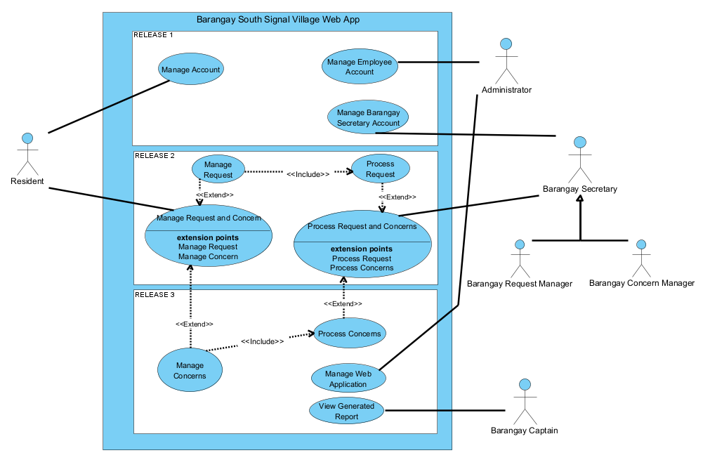

Figure 3 Use Case Diagram

### Use Case Full Description

Table 3 Use Case Full Description: Create Resident Account

|  |  |  |
| --- | --- | --- |
| **Use Case Name:** | Registration | |
| **Scenario:** | Registration of resident | |
| **Triggering Event:** | Manage Account | |
| **Brief Description:** | The Resident registers an account which involves providing personal information. | |
| **Actors:** | Resident | |
| **Related Use Cases:** | Includes: | |
| **Stakeholders:** | Barangay Captain: view the registered account | |
| **Preconditions:** | Residents should reside in Barangay South Signal Village | |
| **Postconditions:** | Resident account will be created | |
| **Flow of Activities:** | **Actor** | **Flow of Activities:** |
| 1. From the services tab click on register 2. Click Yes, I’m 18 years old and above. 3. Click Accept Data Privacy Notice 4. Fill out Personal Information/ Address/   Account Information   1. Check the box understood, and accepted Privacy Policy and Terms & Conditions 2. Click Submit 3. Go to your registered email account. 4. Click the link to verify account. | * 1. Show age confirmation.   2. Show Data Privacy Notice   3.1 Display Registration Form    6.1 Validate Inputted Form  6.2 Send email verification.   * 1. Add Resident Details into Resident Database.   2. Display confirmation of account |
| **Exception Conditions:** | 2.1 If the resident did not click yes, do not redirect to the registration form.  3.1 If the resident did not Accept Data Privacy Notice, do not redirect to the registration form.  5.1 If the resident did not check the box, the account would not be registered.  8.1 If the resident did not click the verification link, the user would not be registered | |

Table 4 Use Case Full Description: Log-in Resident Account

|  |  |  |
| --- | --- | --- |
| **Use Case Name:** | Log-in Resident Account | |
| **Scenario:** | Resident Log-in Account | |
| **Triggering Event:** | Manage Account | |
| **Brief Description:** | When Residents Logs-in to the account, the residents can use the functions of the Barangay South Signal Village Account such as request documents and submit their concerns to the barangay online. | |
| **Actors:** | Resident | |
| **Related Use Cases:** | N/A | |
| **Stakeholders:** | Barangay Captain: views the report from the resident. | |
| **Preconditions:** | Resident must be logged-in | |
| **Postconditions:** | Resident account should be verified as a member | |
| **Flow of Activities:** | **Actor** | **Flow of Activities:** |
| 1. Residents must go to the website and click Online Request  2. Residents input credentials (email and password) and click log-in button | 1.1 Display *Home Page*  1.2 Display *Log-in Page*  2.1 Display Resident Account Dashboard |
| **Exception Conditions:** | 2.1 If the Resident provided an incorrect email or password, then it will show a log-in error message. | |

Table 5 Use Case Full Description: Edit Resident Account

|  |  |  |
| --- | --- | --- |
| **Use Case Name:** | Edit Resident Account | |
| **Scenario:** | Resident Edit Account | |
| **Triggering Event:** | Manage Account | |
| **Brief Description:** | When the Resident edits the account, The residents can use the limited functions of the Barangay South Signal Village such as being able to update email address, mobile number, and change password. | |
| **Actors:** | Resident | |
| **Related Use Cases:** | Includes:  Create Employee Account | |
| **Stakeholders:** | Barangay Captain: views the generated report from the resident. | |
| **Preconditions:** | Resident must be logged-in | |
| **Postconditions:** | Resident must be present  Requirement should be valid | |
| **Flow of Activities:** | **Actor** | **Flow of Activities:** |
| 1. Residents must go to the website and click Online Request  2. Residents input credentials (email and password) and click log-in button  3. Residents click My Profile tab  4. Resident click the edit button besides the information wanted to edit and input necessary information required in the form.  5. Resident click submit button  7. Resident should see a confirmation from the web app | 1.1 Display *Home Page*  1.2 Display *Log-in Page*  2.1 Display Resident Account Dashboard  3.1 Display Account Information  3.2 Display form for changing information  4.1 Check for input validation  7.1 Update Resident Details  7.2 Display confirmation of the account |
| **Exception Conditions:** | 2.1 If the Resident inputted wrong email or password, then show log-in error message.  4.1 If Resident does not fill in all the information properly and have the same existing email and phone number, then an error message appears, and the wrong form will be highlighted.  6.1 If Resident fails to input the OTP three times, then the registration of the account will be denied. | |

Table 6 Use Case Full Description Create New Request

|  |  |  |
| --- | --- | --- |
| **Use Case Name:** | Create New Request | |
| **Scenario:** | Create New Request | |
| **Triggering Event:** | Manage Request | |
| **Brief Description:** | When the residents want to use the Barangay South Signal Village Web App, they can create new requests for their documents or events. | |
| **Actors:** | Barangay Residents | |
| **Related Use Cases:** | Includes:  Manage Concern | |
| **Stakeholders:** | Barangay Captain: views the generated report from the resident. | |
| **Preconditions:** | Resident must be present  Requested document must exist  Requirement should be valid | |
| **Postconditions:** | The barangay cashier must provide an official receipt to the Residents  The requested barangay document should have a signature or dry seal stamp from the barangay  The official receipt and request form should be recorded in the database | |
| **Flow of Activities:** | **Actor** | **System** |
| 1. Residents must go to the website and click Online Request  2. Residents input credentials (email and password) and click log-in button  3. Resident clicks the type of document being requested and upload necessary requirements  4. Residents click the submit button to proceed. | 1.1 Display *Home Page*  1.2 Display *Log-in Page*  2.1 Display Resident Account Dashboard  3.1 Display document information  4.1 Save the Request Details to Request Database  4.2 Display details for submitted document request and the transaction key.  4.3 Send the confirmation through email. |
| **Exception Conditions:** | 2.1 If the Resident provided the wrong email or password, then show log-in error message.  4.1 If the Resident did not meet the requirements of the document, then the transaction will be terminated | |

Table 7 Use Case Full Description: Create New Request

|  |  |  |
| --- | --- | --- |
| **Use Case Name:** | Track Request Status | |
| **Scenario:** | Track Request | |
| **Triggering Event:** | Manage Request | |
| **Brief Description:** | When the residents want to use the Barangay South Signal Village Web App, they can track request status to know the status of their request. | |
| **Actors:** | Barangay Residents | |
| **Related Use Cases:** | When the residents want to use the Barangay South Signal Village Web App, they can track request status to know the status of their request. | |
| **Stakeholders:** | Barangay Captain: views the generated report from the resident. | |
| **Preconditions:** | Resident must be present  Requested document must exist  Requirement should be valid | |
| **Postconditions:** | The barangay cashier must provide official receipt to the Residents  The requested barangay document should have a signature or dry seal stamp from the barangay  The official receipt and request form should be recorded in the database | |
| **Flow of Activities:** | **Actor** | **System** |
| 1. Residents must go to the website and click Track Request  2. Residents input request key | 1.1 Display *Home Page*  1.2 Display *Track Request Page*  2.1 Display request information and status |
| **Exception Conditions:** | 2.1 If the Resident inputted wrong request key, then show error message. | |

Table 8 Use Case Full Description: Reset Password

|  |  |  |
| --- | --- | --- |
| **Use Case Name:** | Reset Password | |
| **Scenario:** | Resident wants to reset their password | |
| **Triggering Event:** | Resident password change | |
| **Brief Description:** | The resident registers an account which involves providing personal information. | |
| **Actors:** | Resident | |
| **Related Use Cases:** | Includes: | |
| **Stakeholders:** | Barangay Captain: view the registered account | |
| **Preconditions:** | Residents should reside in Barangay South Signal Village | |
| **Postconditions:** | Resident will change password | |
| **Flow of Activities:** | **Actor** | **Flow of Activities:** |
| 1. Click side bar and locate My Profile 2. Click and Locate Change Password 3. Input Old and New Password   3.1 Click Save | 1. Login Page 2. Resident Personal Information Page 3. Change Password Tab |
| **Exception Conditions:** | 2. Resident did not click Change Password  3. Resident inputs wrong password  3.1 Resident did not put the correct password requirements.  3.2 Resident did not click the Save button. | |

Table 9 Use Case Full Description: Manage Concern

|  |  |  |
| --- | --- | --- |
| **Use Case Name:** | Manage Concern | |
| **Scenario:** | Submit New Concern | |
| **Triggering Event:** | Manage Concern | |
| **Brief Description:** | When the Resident wants to Manage Concern to the account, the residents can use the functions of the Barangay South Signal Village Web App such as managing and submitting a concern. | |
| **Actors:** | Barangay Residents | |
| **Related Use Cases:** | Includes:  Manage Request | |
| **Stakeholders:** | Barangay Captain: views the generated report from the resident. | |
| **Preconditions:** | Resident must be present  Requested document must exist  Requirement should be valid | |
| **Postconditions:** | The barangay cashier must provide an official receipt to the Residents  The requested barangay document should have a signature or dry seal stamp from the barangay  The official receipt and request form should be recorded in the database | |
| **Flow of Activities:** | **Actor** | **System** |
| 1. Residents must go to the website and click Online Request  2. Residents input credentials (email and password)  3. Residents click log-in button  4. Resident click the Submit Concern Button and input necessary information about the concern  5. Residents click the submit button to proceed. | 1.1 Display *Home Page*  1.2 Display *Log-in Page*  3.1 Display Resident Account Dashboard  4.1 Display information about the services concerned.  5.1 Save the Concern Details to the Concern Database  5.2 Display details for submitted concern and transaction key.  5.3 Send the confirmation through email. |
| **Exception Conditions:** | 2.1 If the Resident provided the wrong email or password, then show log-in error message.  4.1 If the Resident did not input the information properly, then the concern service will be terminated | |

Table 10 Use Case Full Description: Track Concern Status

|  |  |  |
| --- | --- | --- |
| **Use Case Name:** | Track Concern Status | |
| **Scenario:** | Track Concern | |
| **Triggering Event:** | Manage Concern | |
| **Brief Description:** | When the Resident wants to Track Concern Status, the residents can use the functions of the Barangay South Signal Village Web App if the residents want to know its status. | |
| **Actors:** | Barangay Residents | |
| **Related Use Cases:** | Includes:  Manage Concern | |
| **Stakeholders:** | Barangay Captain: views the generated report from the resident. | |
| **Preconditions:** | Resident must be present  Requested document must exist  Requirement should be valid | |
| **Postconditions:** | The barangay cashier must provide an official receipt to the Residents  The requested barangay document should have a signature or dry seal stamp from the barangay  The official receipt and request form should be recorded in the database | |
| **Flow of Activities:** | **Actor** | **System** |
| 1. Residents must go to the website and click Track Request  2. Residents input concern key | 1.1 Display *Home Page*  1.2 Display *Track Request Page*  2.1 Display concern information and status |
| **Exception Conditions:** | 2.1 If the Resident provided the wrong concern key, then it will show an error message. | |

Table 12 Use Case Full Description: Process Request

|  |  |  |
| --- | --- | --- |
| **Use Case Name:** | Process Request | |
| **Scenario:** | Process Request | |
| **Triggering Event:** | Process Request | |
| **Brief Description:** | When the Secretary and Request Manager uses the Barangay South Signal Village Web App, they have the power to process requests. | |
| **Actors:** | Barangay Secretary  Barangay Request Manager | |
| **Related Use Cases:** | Includes: Process Concern | |
| **Stakeholders:** | Barangay Captain: views the generated report from the resident. | |
| **Preconditions:** | Secretary must be logged-in | |
| **Postconditions:** | Secretary should be verified as Barangay Employee Account  Employee account information will be stored in the Barangay Employee Database | |
| **Flow of Activities:** | **Actor** | **System** |
| 1. Barangay Secretary/ Barangay Request Manager click the Process Document Request.  2. Barangay Secretary/ Barangay Request Manager clicks the view of the request to be processed.  3. Barangay Secretary/ Barangay Request Manager changes the status of the Request Details | * 1. Display list of Request   2.1 Display Request Details  3.1 Update the Request Details  3.1 Send email for updates to the resident |
| **Exception Conditions:** | 2.1 If the request is invalid, the status will be changed to denied.  2.2 If the request is valid, the status will be changed to approved. | |

Table 13 Use Case Full Description: Process Concern

|  |  |  |
| --- | --- | --- |
| **Use Case Name:** | Process Concern | |
| **Scenario:** | Process Concern | |
| **Triggering Event:** | Process Concern | |
| **Brief Description:** | When the Secretary and Request Manager use the Barangay South Signal Village Web App, they have the power to process concern. | |
| **Actors:** | Barangay Secretary  Barangay Concern Manager | |
| **Related Use Cases:** | Includes:  Process Request | |
| **Stakeholders:** | Barangay Captain: views the generated report from the resident. | |
| **Preconditions:** | Secretary must be logged-in | |
| **Postconditions:** | Secretary should be verified as Barangay Employee Account  Employee account information will be stored in the Barangay Employee Database | |
| **Flow of Activities:** | **Actor** | **System** |
| 1. Barangay Secretary/ Barangay Concern Manager click the Process Concern.  2. Barangay Secretary/ Barangay Concern Manager click the view of the concern to be processed.  3. Barangay Secretary/ Barangay Concern Manager forward the concern to necessary department  4. Barangay Secretary/ Barangay Concern Manager change the status of the Concern Details | * 1. Display list of Concerns   2.1 Display Concern Details  4.1 Update the Concern Details  4.2 Send email for updates to the resident |
| **Exception Conditions:** | 2.1 If the concern is invalid, the status will be changed to denied.  2.2 If the concern is valid, the status will be changed to approved. | |

Table 14 Use Case Full Description: Edit Barangay Secretary Account

|  |  |  |
| --- | --- | --- |
| **Use Case Name:** | Edit Barangay Secretary Account | |
| **Scenario:** | Modify Barangay Secretary Account | |
| **Triggering Event:** | Manage Barangay Secretary Account | |
| **Brief Description:** | When the Barangay Secretary accesses the managed Barangay Employee Account, the Secretary can change the password of his/her Employee Account. | |
| **Actors:** | Barangay Employee | |
| **Related Use Cases:** | N/A | |
| **Stakeholders:** | Barangay Captain: views the generated report from the resident. | |
| **Preconditions:** | Secretary must be logged-in | |
| **Postconditions:** | Secretary should be verified as Barangay Employee Account  Employee account information will be stored in the Barangay Employee Database | |
| **Flow of Activities:** | **Actor** | **System** |
| 1. Barangay Employee inputs account credential to log-in  2. Barangay Employee clicks the edit account  3. Barangay Employee clicks the edit button besides the information he/she wanted to edit  4. Barangay Employee inputs necessary account information required in the form and click submit button  5. Barangay Employee should see a confirmation from the web app | 1.1 Display Barangay Secretary Dashboard  2.1 Display Account Information  3.1 Display form for changing information  4.1 Update Barangay Employee Details  5.1 Display confirmation of account |
| **Exception Conditions:** | 2.1 If Barangay Employee does not use a valid email address, then the web app shows missing/wrong information.  5.1 If the form submitted is invalid, then an error message appears. | |

Table 15 Use Case Full Description: Create Employee Account

|  |  |  |
| --- | --- | --- |
| **Use Case Name:** | Create Employee Account | |
| **Scenario:** | Create new Barangay Employee Account | |
| **Triggering Event:** | Manage Barangay Employee Accounts | |
| **Brief Description:** | When the Secretary and Request Manager want to use the Barangay South Signal Village Web App, the Administrator has the power to process a request. | |
| **Actors:** | Administrator | |
| **Related Use Cases:** | N/A | |
| **Stakeholders:** | Barangay Captain: views the generated report from the resident. | |
| **Preconditions:** | Administrator must be logged-in | |
| **Postconditions:** | Administrator should be verified as Barangay Employee Account  information which will be stored in the Barangay Employee Database; additionally, information should be valid. | |
| **Flow of Activities:** | **Actor** | **System** |
| 1. Administrator inputs account credential to log-in  2. Administrator clicks add employee account tab.  3. Administrator inputs Barangay Employee details.  4. Administrator clicks Create Account button | 1.1 Display Administrator Dashboard  2.1 Display Create Employee Account Form  4.1 Add Employee Details to Barangay Employee Dashboard |
| **Exception Conditions:** | 4.1 If the Administrator does not fill in all the information properly and has the same existing email and phone number within the database, then an error message appears, and the wrong form will be highlighted. | |

Table 16 Use Case Full Description: Edit Employee Account

|  |  |  |
| --- | --- | --- |
| **Use Case Name:** | Edit Employee Account | |
| **Scenario:** | Edit Barangay Employee Account | |
| **Triggering Event:** | Manage Barangay Employee Accounts | |
| **Brief Description:** | When the Administrator uses the Barangay South Signal Village Web App, the Administrator has the power to edit Barangay Employee Account. | |
| **Actors:** | Administrator | |
| **Related Use Cases:** | Includes:  Create Employee Account | |
| **Stakeholders:** | Barangay Captain: views the generated report from the resident. | |
| **Preconditions:** | Administrator must be logged-in | |
| **Postconditions:** | Administrator should be verified as Barangay Employee Account  information which will be stored in the Barangay Employee Database; additionally, information should be valid. | |
| **Flow of Activities:** | **Actor** | **System** |
| 1. Administrator inputs account credential to log-in  2. Administrator clicks modify employee account tab.  3. Administrator clicks the barangay employee account to be edited.  4. Administrator clicks the edit button besides the information wanted to edit  5. Administrator clicks save button | 1.1 Display Administrator Dashboard  2.1 Display list of Employee Account  3.1 Display Barangay Employee Account Details  4.1 Display form for information to be edit.  5.1 Update Barangay Employee Details to Barangay Employee Database |
| **Exception Conditions:** | 5.1 If the Administrator does not fill in all the information properly and has the same existing email and phone number within the database, then an error message appears, and the wrong form will be highlighted. | |

Table 17 Use Case Full Description: Deactivate Employee Account

|  |  |  |
| --- | --- | --- |
| **Use Case Name:** | Deactivate Employee Account | |
| **Scenario:** | Deactivate Barangay Employee Account | |
| **Triggering Event:** | Manage Barangay Employee Accounts | |
| **Brief Description:** | When the Administrator uses the Barangay South Signal Village Web App, the Administrator has the power to deactivate the Barangay Employees Account. | |
| **Actors:** | Administrator | |
| **Related Use Cases:** | Includes:  Create Employee Account | |
| **Stakeholders:** | Barangay Captain: views the generated report from the resident. | |
| **Preconditions:** | Administrator must be logged-in | |
| **Postconditions:** | Administrator should be verified as Barangay Employee Account  Employee account information will be stored in the Barangay Employee Database; additionally, information should be valid. | |
| **Flow of Activities:** | **Actor** | **System** |
| 1. Administrator inputs account credential to log-in  2. Administrator clicks modify employee account tab.  3. Administrator clicks the barangay employee account to be edited.  4. Administrator clicks the deactivate button to deactivate  5. Administrator inputs password for confirmation | 1.1 Display Administrator Dashboard  2.1 Display list of Employee Account  3.1 Display Barangay Employee Account Details  4.1 Display form for password input  5.1 Update Barangay Employee Details to Barangay Employee Database |
| **Exception Conditions:** | 5.1 If the Administrator does not fill in all the information properly and has the same existing email and phone number within the database, then an error message appears, and the wrong form will be highlighted. | |

Table 18 Use Case Full Description: View Generated Report

|  |  |  |
| --- | --- | --- |
| **Use Case Name:** | View Generated Report | |
| **Scenario:** | View Generated Report | |
| **Triggering Event:** | Barangay Captain View Generated Report | |
| **Brief Description:** | When the Barangay Captain logs-in into the Barangay Web App, the barangay captain account can view generated report. | |
| **Actors:** | Barangay Captain | |
| **Related Use Cases:** | Includes:  N/A | |
| **Stakeholders:** | N/A | |
| **Preconditions:** | Barangay Captain must be logged-in | |
| **Postconditions:** | Barangay Captain should be verified as Barangay Employee Account | |
| **Flow of Activities:** | **Actor** | **System** |
| 1. Barangay Captain goes to the Admin Portal.  2. Barangay Captain inputs account credentials to login.  3. Barangay Captain clicks the tab to show the report. | 1.1 Display *Home Page*  2.1 Display Barangay Captain Dashboard  3.3 View the generated report. |
| **Exception Conditions:** | 2.1 If the Barangay Captain provided the wrong credentials, then error message appears. | |

## Gap Analysis

Table 19 Gap Analysis

|  |  |  |  |
| --- | --- | --- | --- |
| Product Backlog ID | Current System | Proposed Changes | Impact |
| 1 | Manual document request | Can request documents online | 1. Save time and effort in requesting documents. 2. Digitalized transaction. |
| 2 | Manual input in forms | Can input data in online forms within the web app with guides | 1. Less typographical errors 2. More understandable data |
| 3 | Data stored in a physical file cabinet | Can store data in the cloud | 1. More security 2. Easier to search and navigate through the data. 3. Less space consumption |
| 4. | A manual search of data | Can lookup available data be using a database | 1. Save time and effort in searching data |
| 5 | Physical transaction | Can request documents and submit concerns online | 1. Less risk of having contagious disease/s 2. Save time going to barangay |
| 6 | Manual generation of report | Can generate reports based on the transaction online | 1. Efficient generation of needed report |

## System Analysis and Design

### Context Diagram

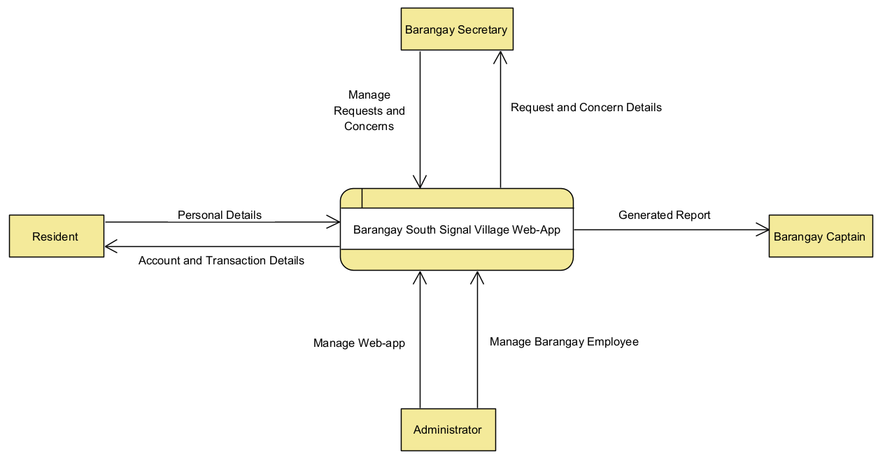

Figure 4 Context Diagram

### Data Flow Diagrams

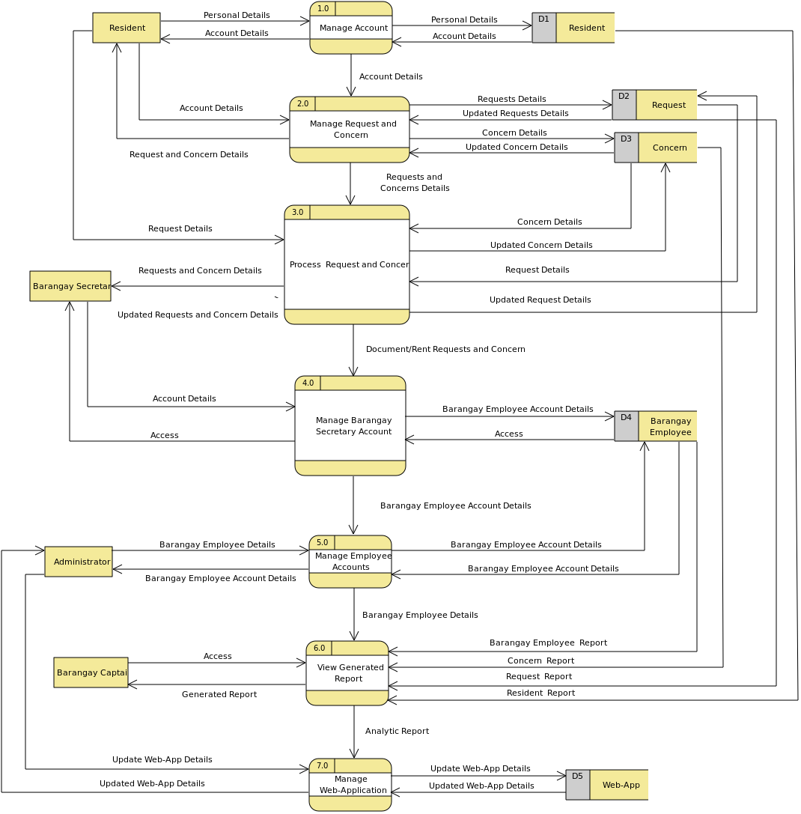

Figure 5 Data Flow Diagram Level 0

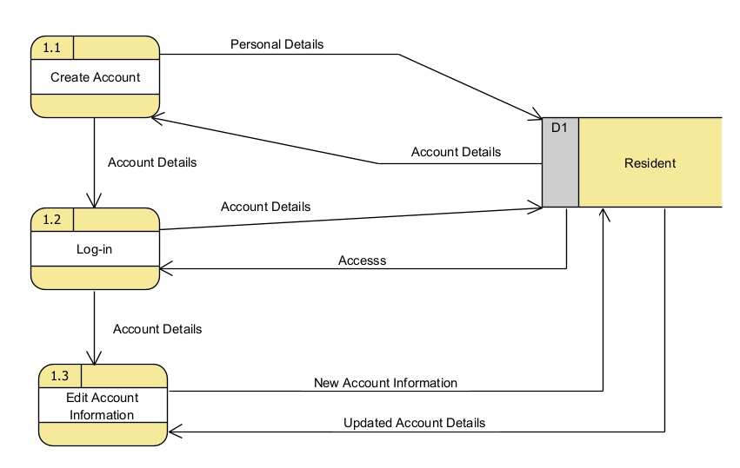

Figure 6 Data Flow Diagram Level 1 (Process 1)

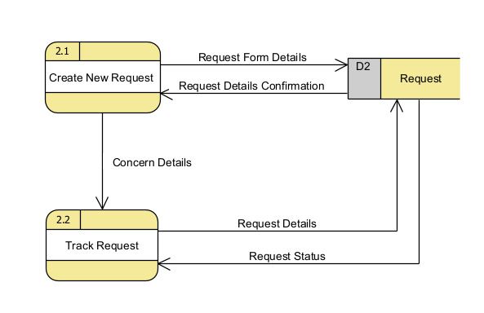

Figure 7 Data Flow Diagram Level 1 (Process 2)

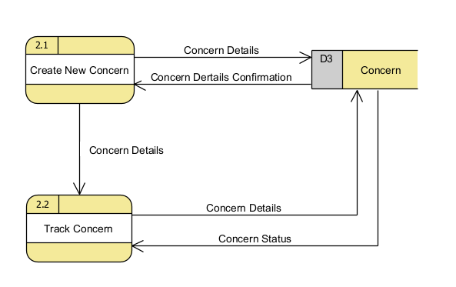

Figure 8 Data Flow Diagram Level 1 (Process 2)

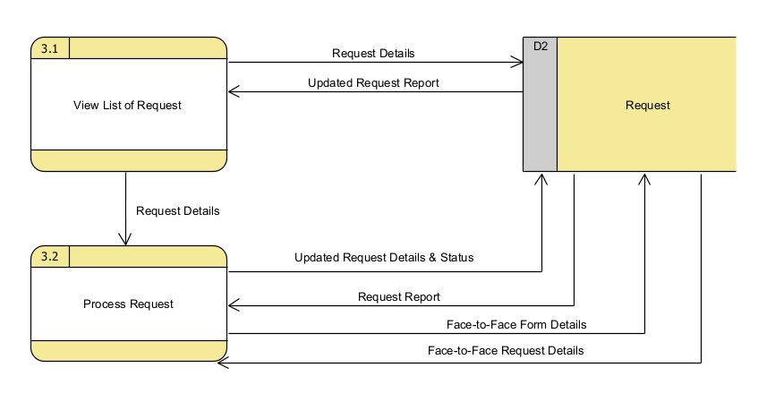

Figure 9 Data Flow Diagram Level 1 (Process 3)

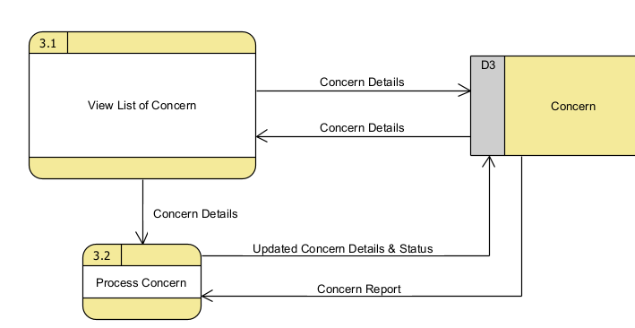

Figure 10 Data Flow Diagram Level 1 (Process 3)

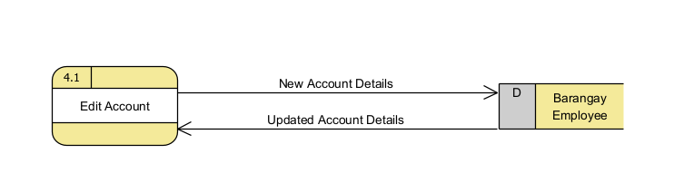

Figure 11 Data Flow Diagram Level 1 (Process 4)

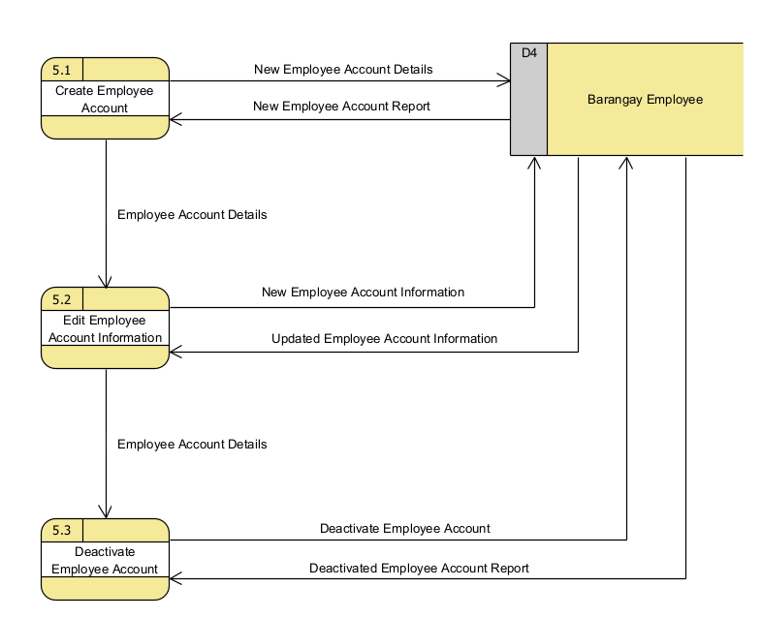

Figure 12 Data Flow Diagram Level 1 (Process 5)

### Entity-Relationship Diagrams

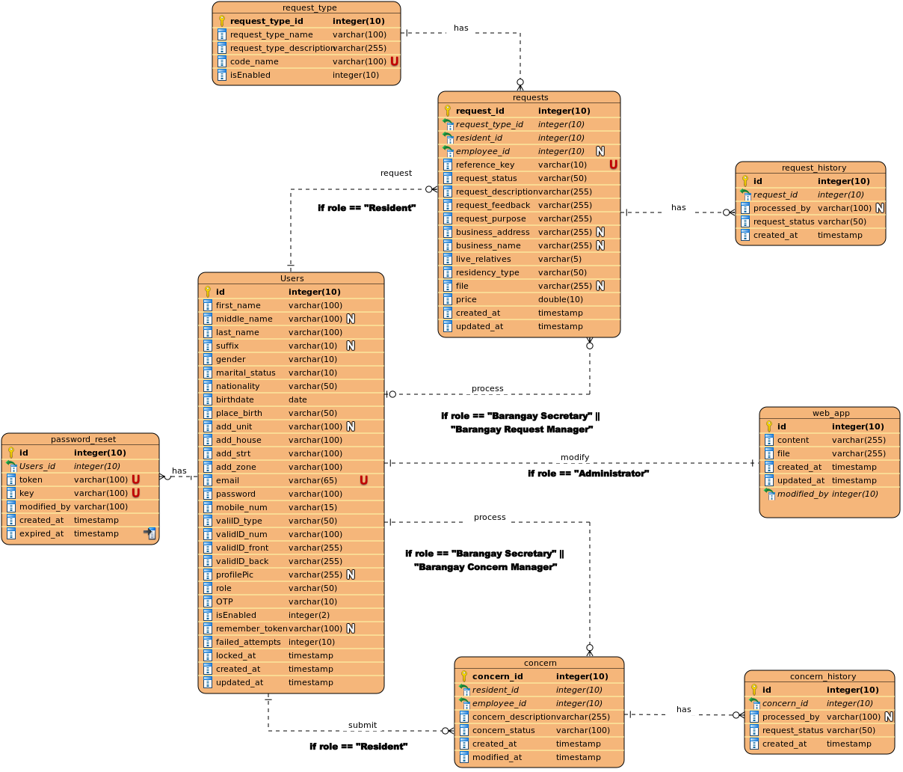

Figure 13 Entity-Relationship Diagrams

### Activity Diagrams

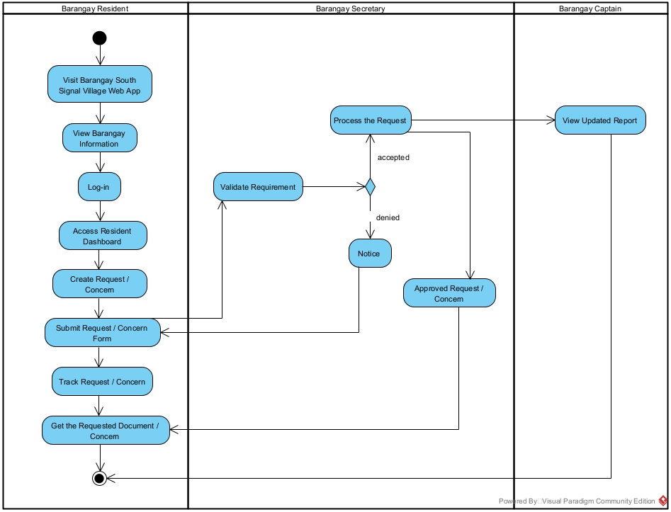

Figure 14 Activity Diagram

### Object Diagram

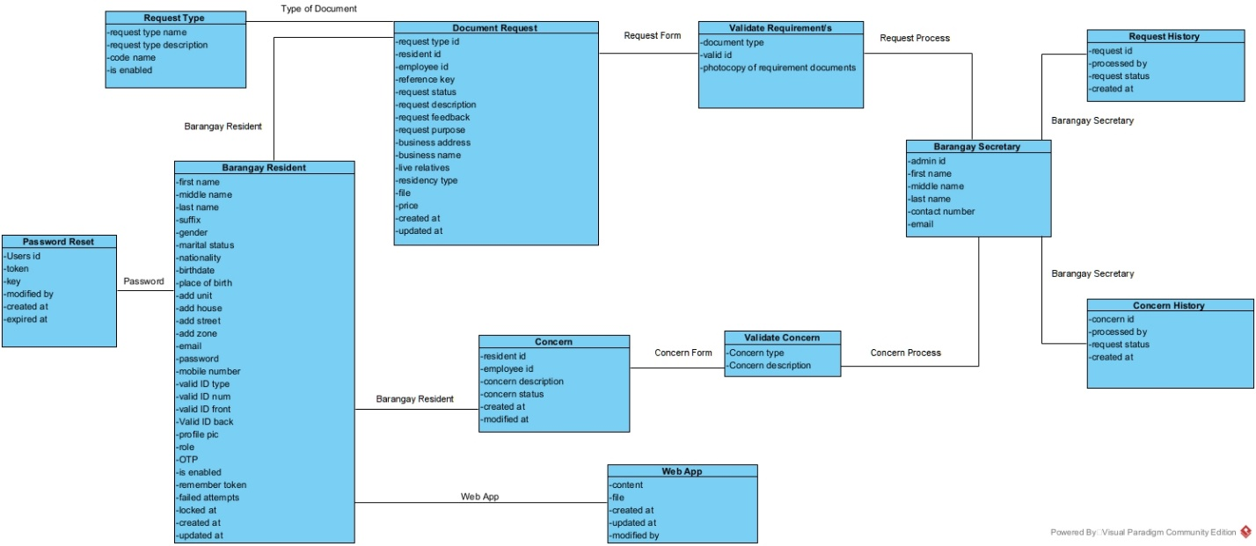

Figure 15 Object Diagrams

### Class Diagrams

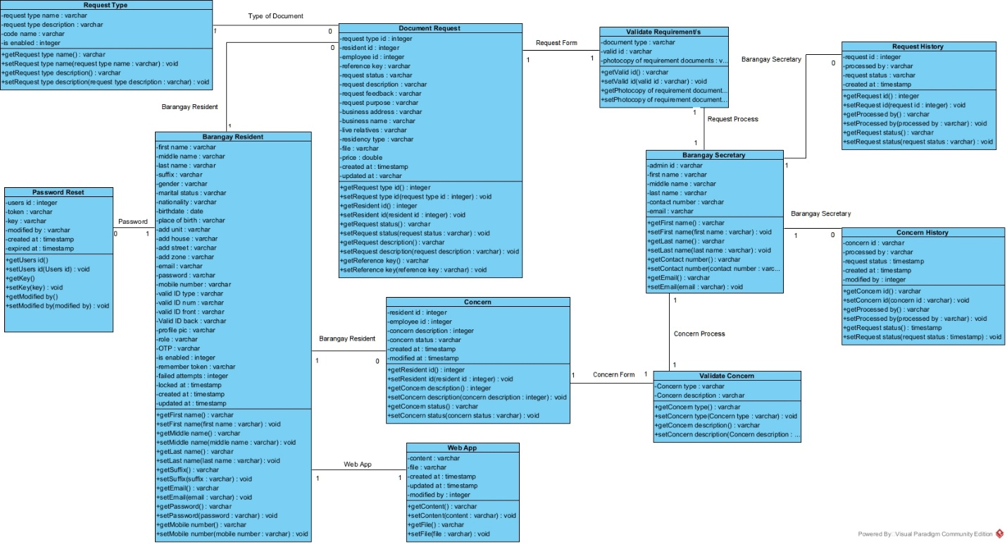

Figure 16 Class Diagram

### Sequence Diagrams

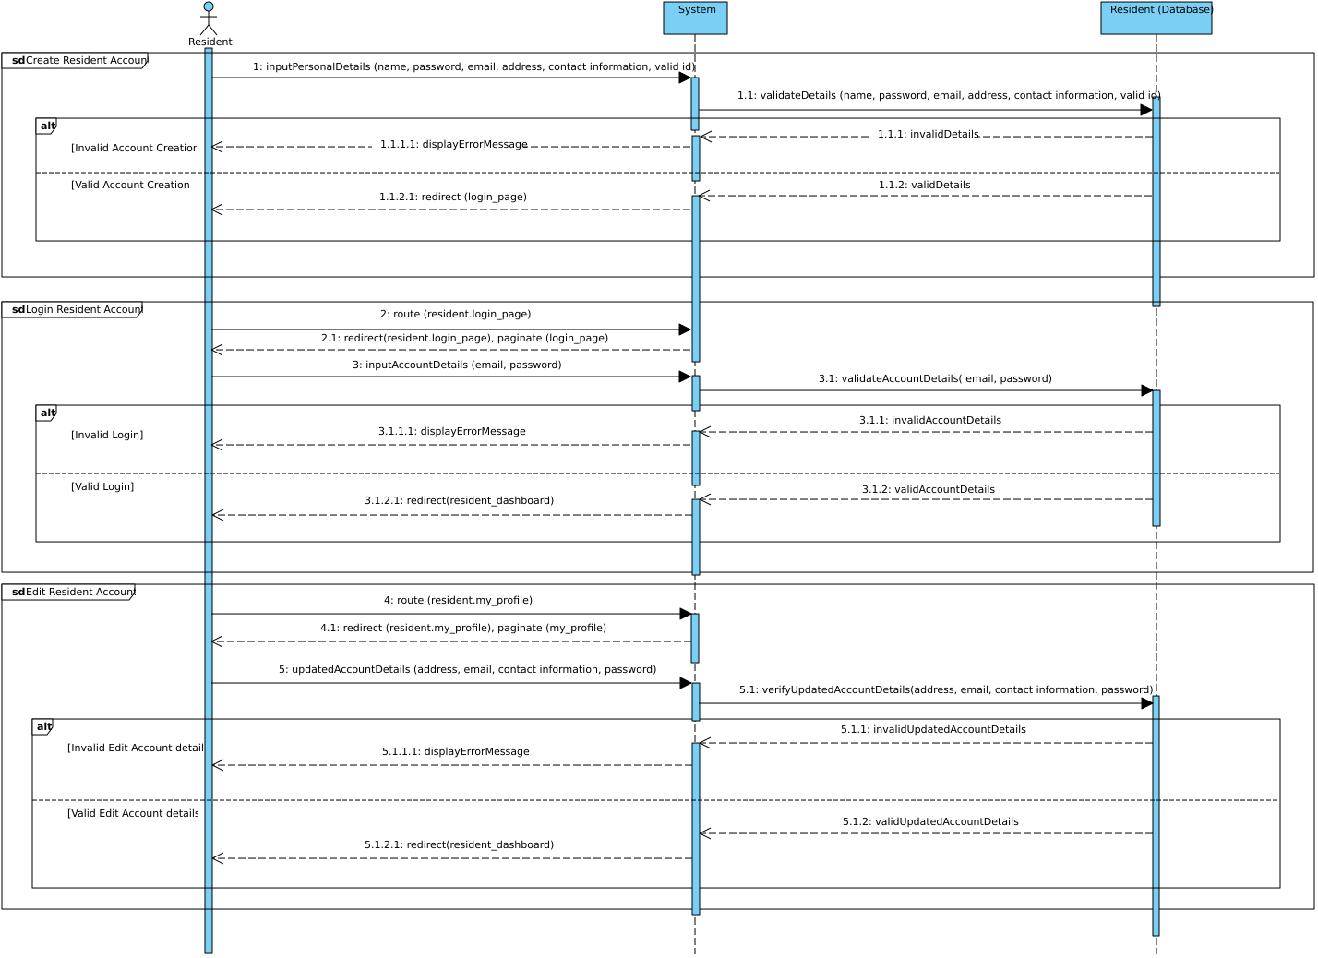

Figure 17 Sequence Diagram: Manage Resident Account

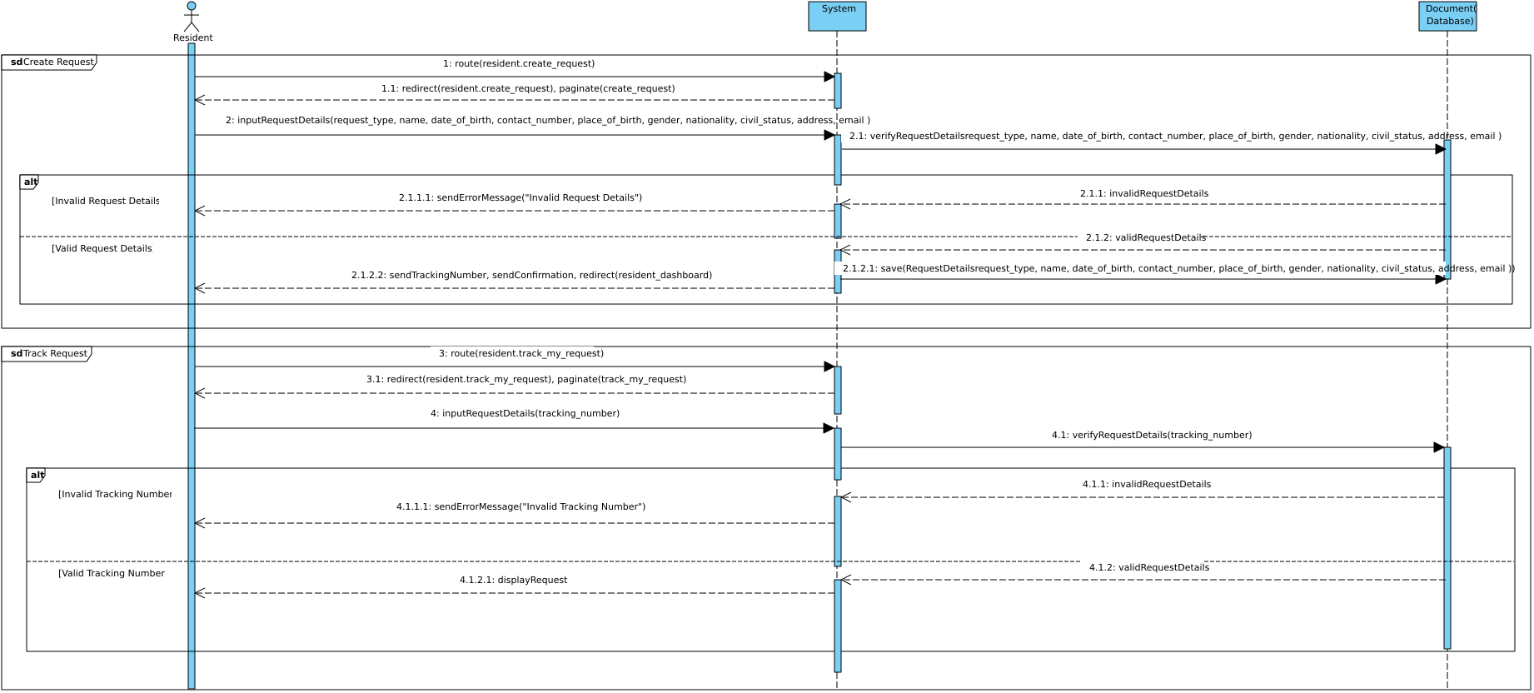

Figure 18 Sequence Diagram: Manage Request

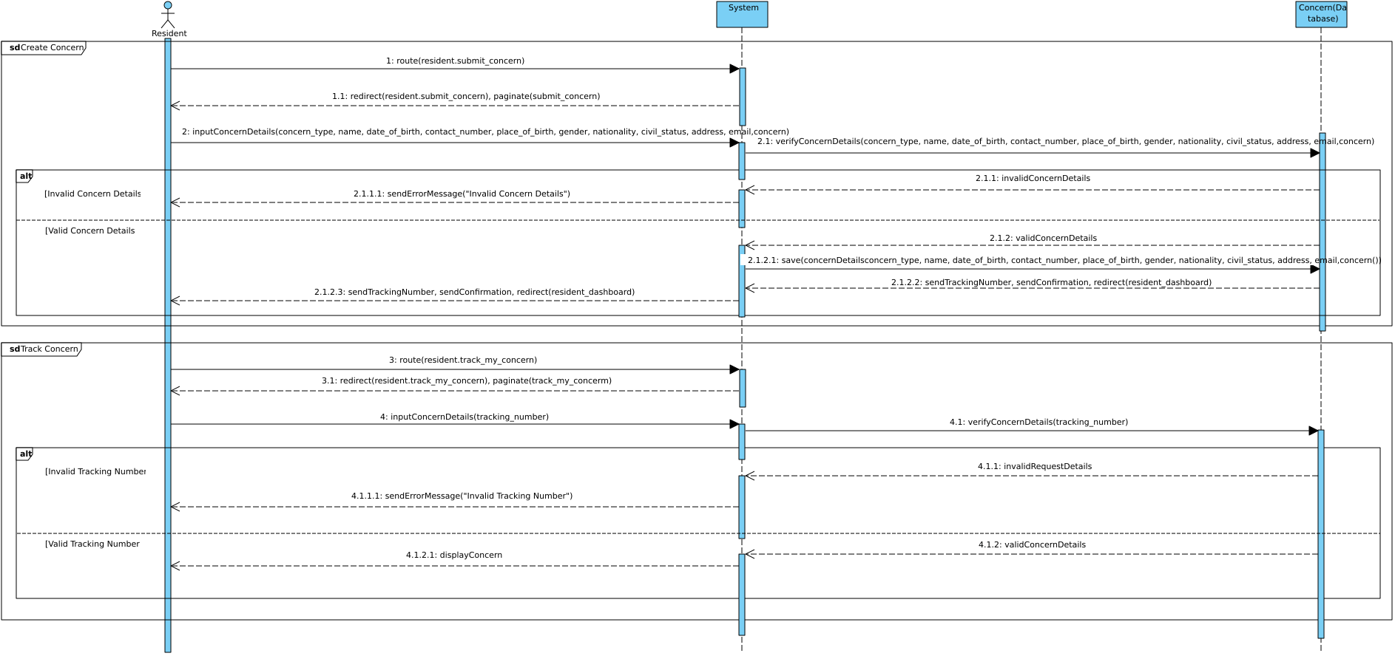

Figure 19 Sequence Diagram: Manage Concern

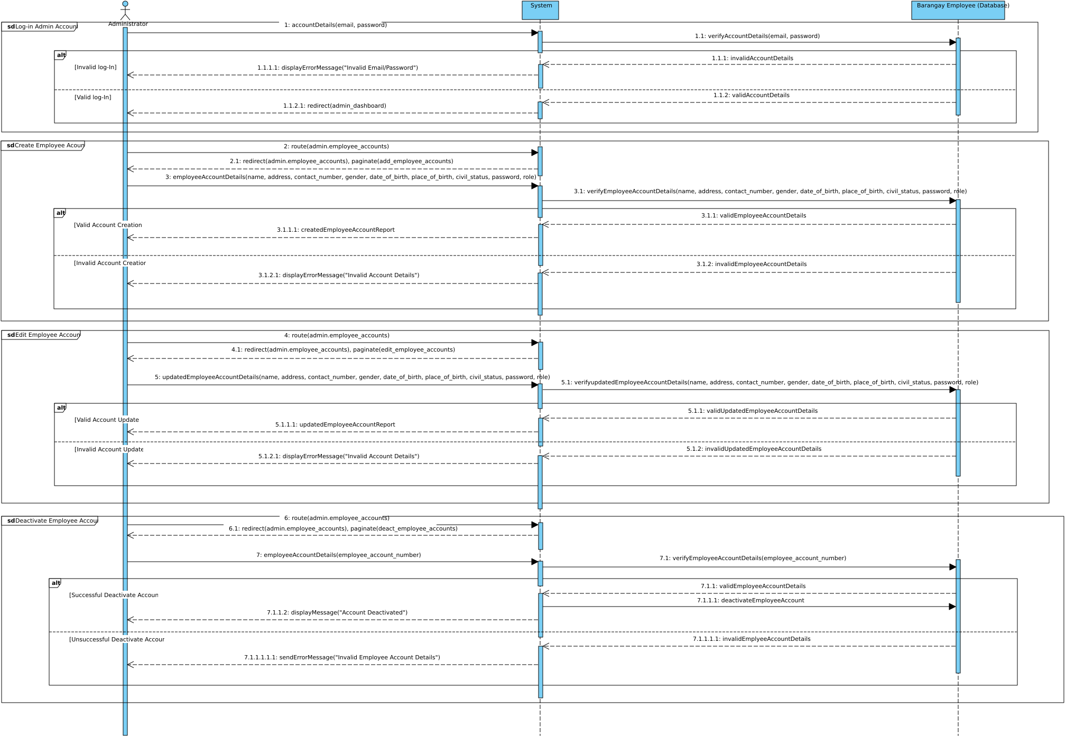

Figure 20 Sequence Diagram: Manage Barangay Employee Accounts

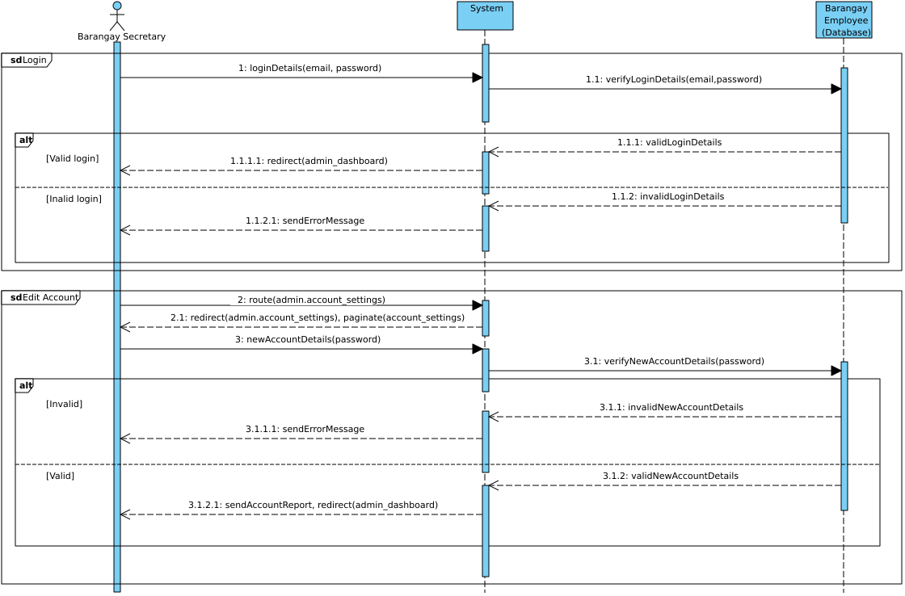

Figure 21 Sequence Diagram: Manage Barangay Secretary Account

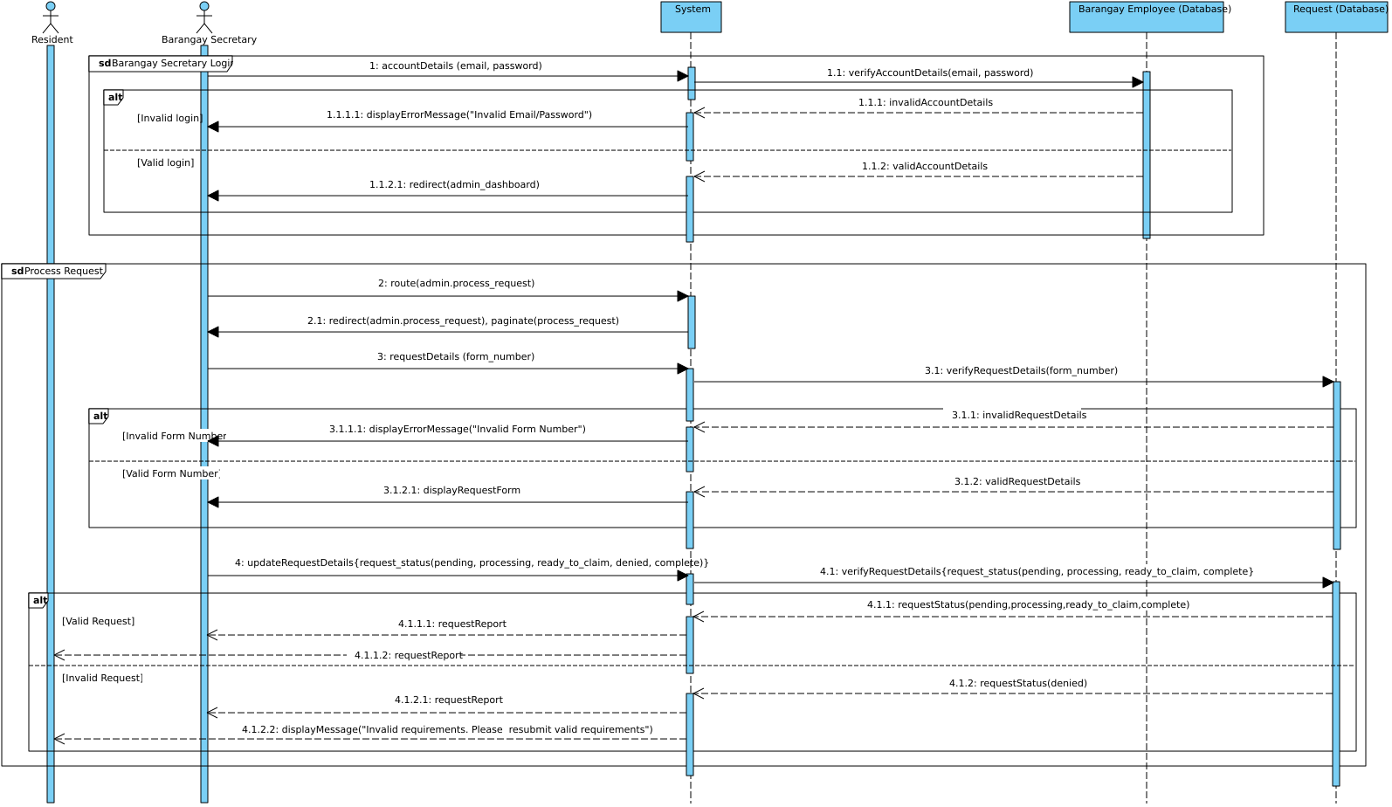

Figure 22 Sequence Diagram: Process Request

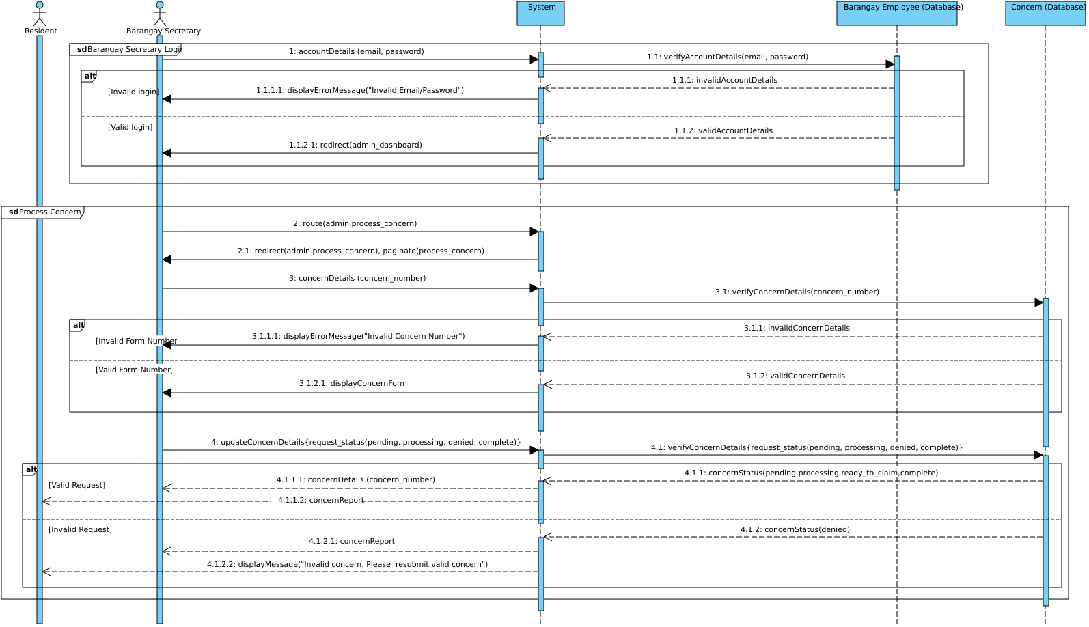

Figure 23 Sequence Diagram: Process Concern

1. State Machine Diagram

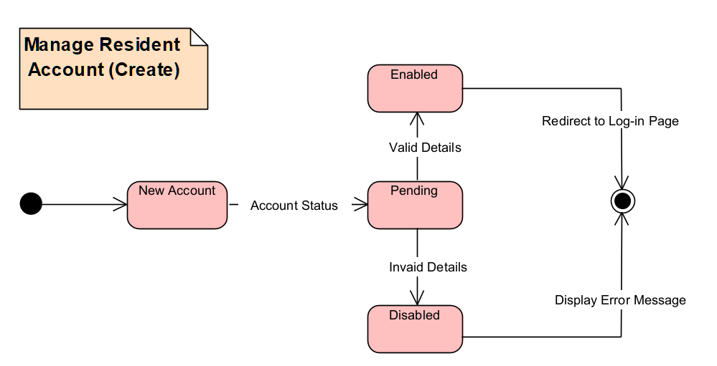

Figure 24 State Machine Diagram: Manage Resident Account (Create)

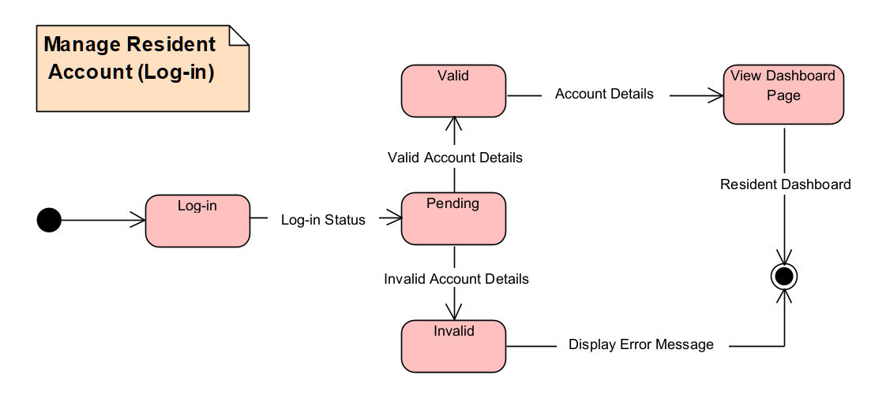

Figure 25 State Machine Diagram: Manage Resident Account (Log-in)

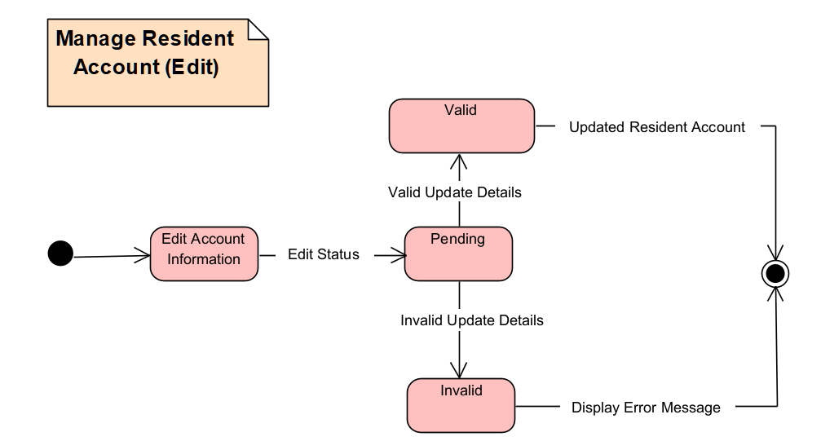

Figure 26 State Machine Diagram: Manage Resident Account (Edit)

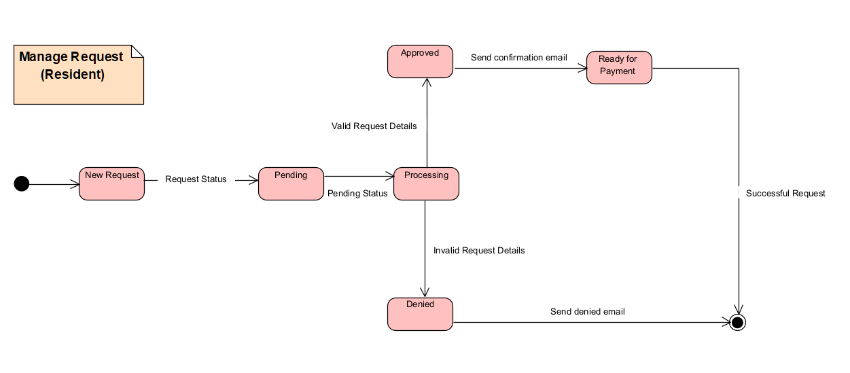

Figure 27 State Machine Diagram: Manage Request

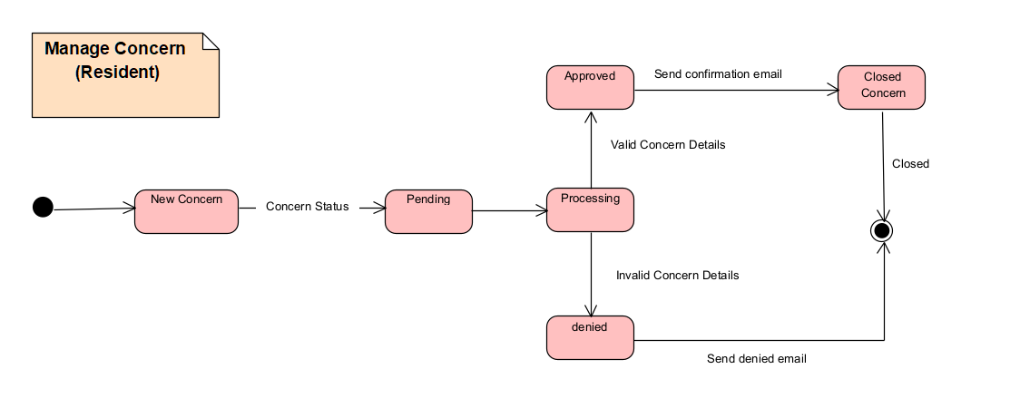

Figure 28 State Machine Diagram: Manage Concern

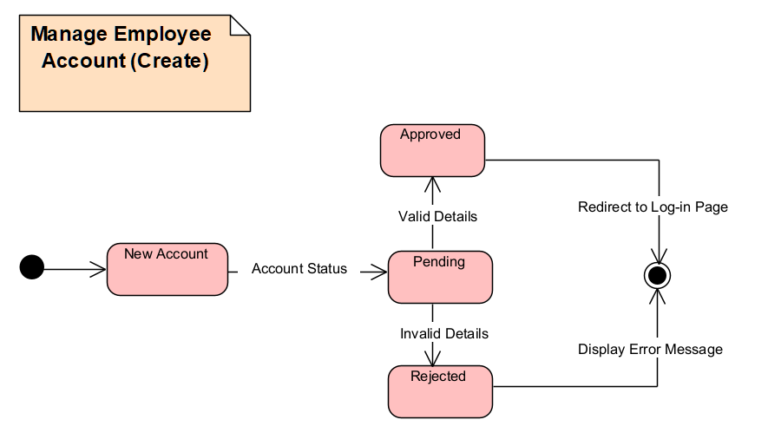

Figure 29 State Machine Diagram: Manage Employee Account

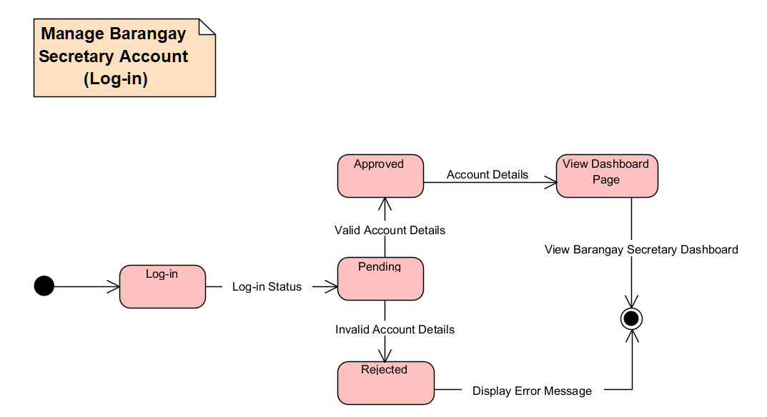

Figure 30 State Machine Diagram: Manage Barangay Secretary Account.

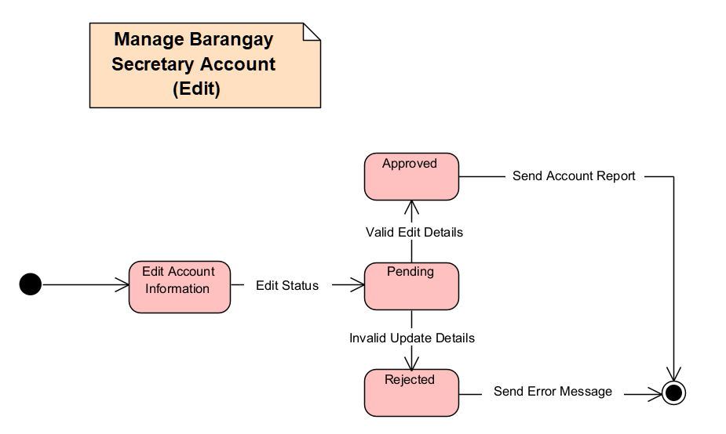

Figure 31 State Machine Diagram: Manage Barangay Secretary Account Edit.

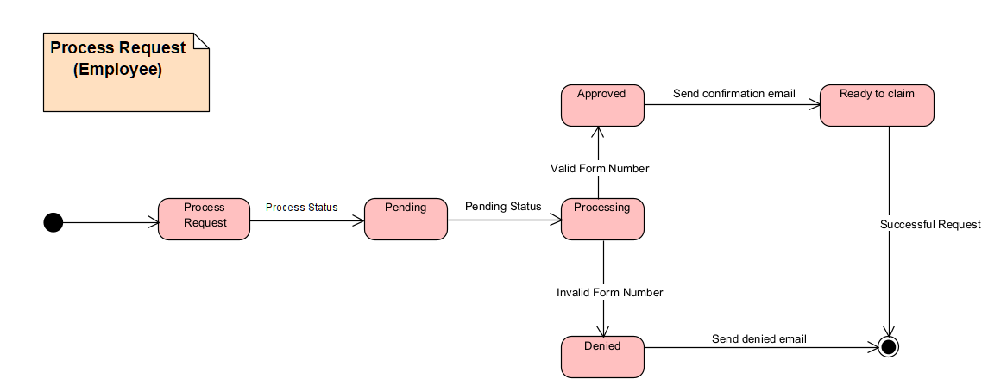

Figure 32 State Machine Diagram: Process Request

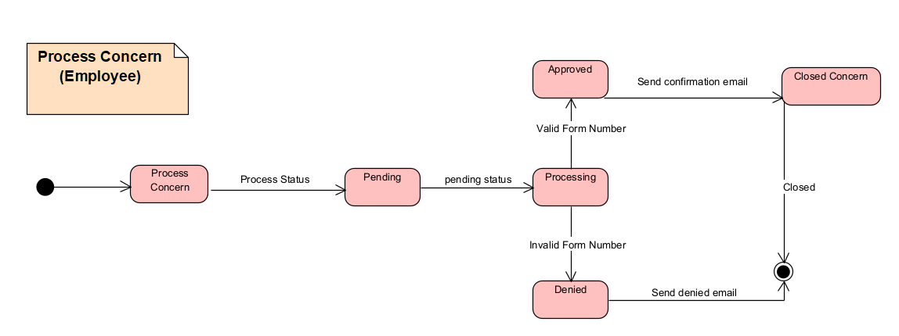

Figure 33 State Machine Diagram: Process Concern

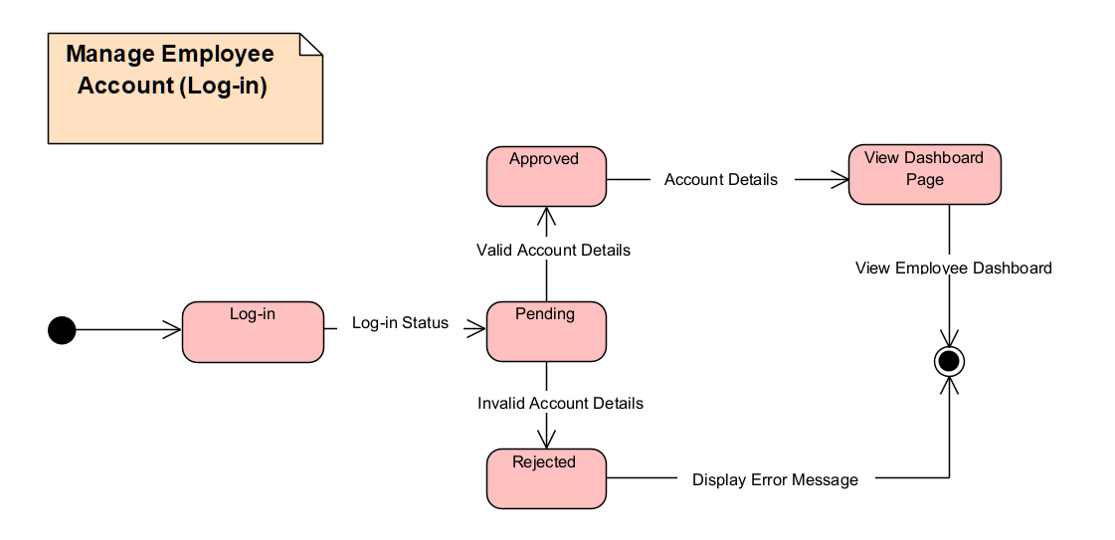

Figure 34 State Machine Diagram: Manage Employee Account (Log-in)

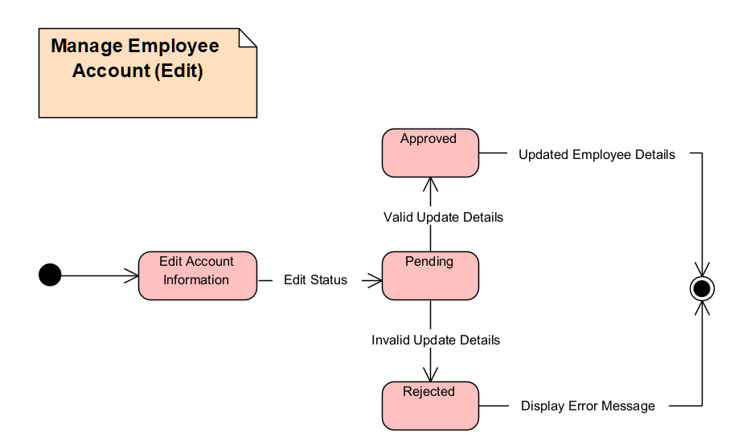

Figure 35 State Machine Diagram: Manage Employee Account (Edit)

### Use Case Package Diagram

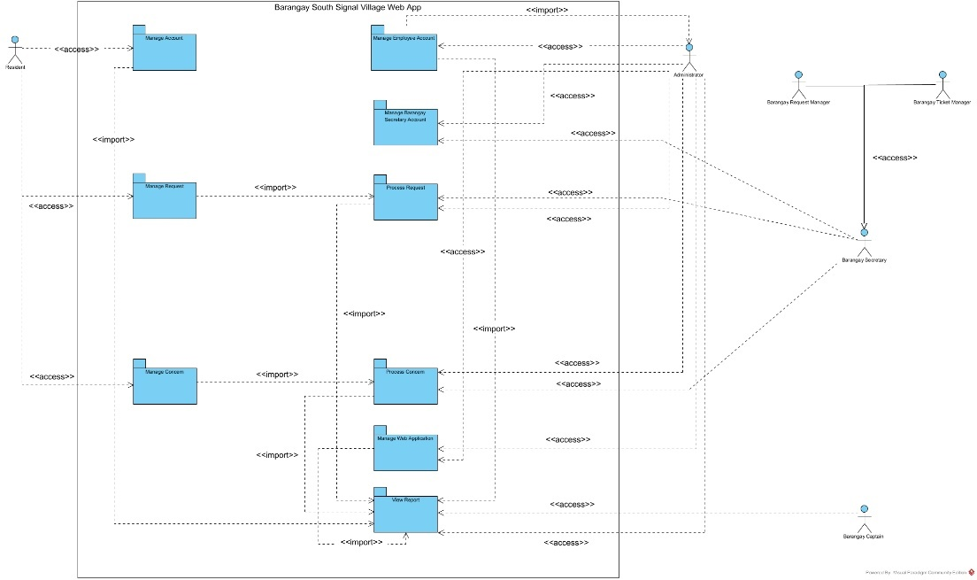

Figure 36 Use Case Package Diagram

### Component Diagram

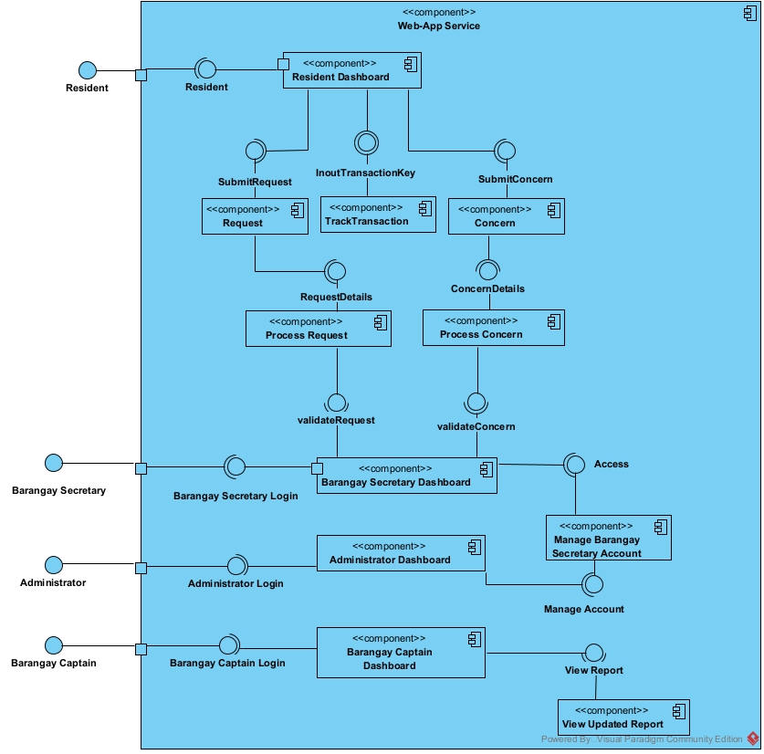

Figure 37 Component Diagram

### Deployment Diagram

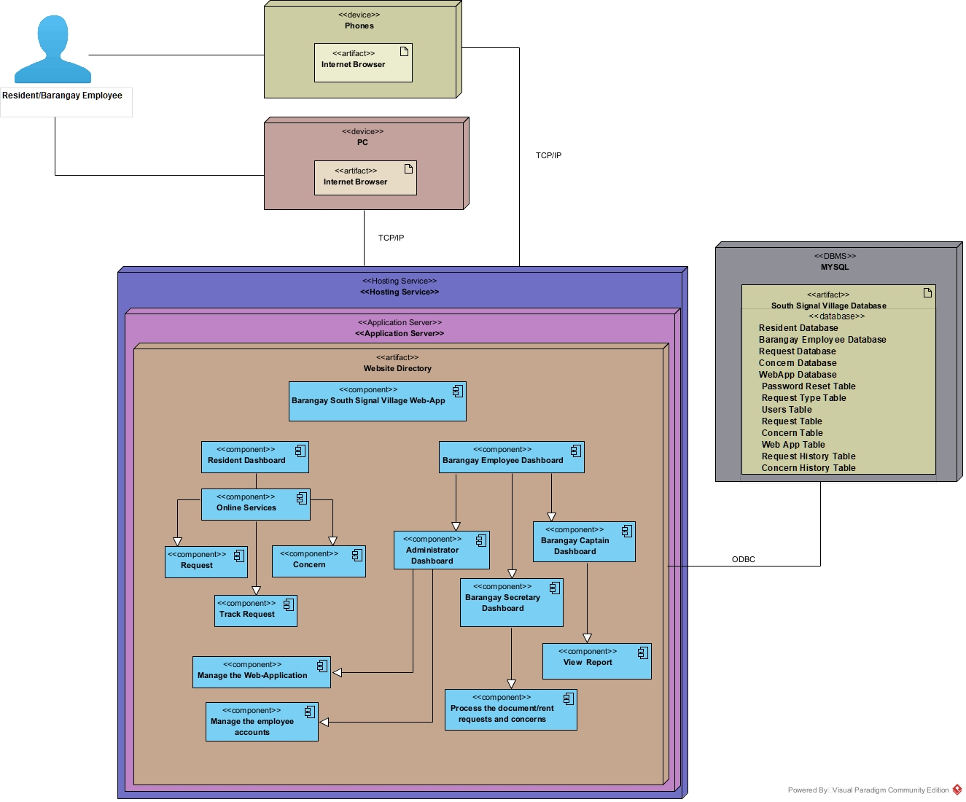

Figure 38 Deployment Diagram

# Results and Discussion

This chapter will discuss what the team has accomplished so far. This chapter contains the progress and changes that the team has achieved as well as the plan and list of objectives that the team will do next.

## 5.1 Release Plan

**RELEASE 1**

* Residents can visit the website and view the home page, contact page, safety section page, and about us page.
* Residents can register on the web app.
* Residents can access their resident profile by logging-in using email and password.
* Residents can edit on the resident dashboard on his/her address, email, mobile number, and password.
* Administrators can add, view, and edit Barangay Employee accounts (Barangay Secretary, Barangay Request Manager, Barangay Concern Manager, and Barangay Captain).
* Barangay Employee (Barangay Secretary, Barangay Request Manager, Barangay Concern Manager, Administrator and Barangay Captain) can access their dashboard by logging-in using email and password.

**RELEASE 2**

* Residents can request documents on their resident profile.
* Residents can receive tracking key through email or text.
* Residents can track the status of their requests.
* The Barangay Secretary and Barangay Request Manager can receive document request.
* The Barangay Secretary and Barangay Request Manager can view document request.
* The Barangay Secretary and Barangay Request Manager can change the status (approved or denied) of document request
* The Barangay Secretary can input the information into the database on their dashboard of all requested barangay documents done manually.

**RELEASE 3**

* Residents can submit concerns on their resident profile.
* Residents can receive notification about the submitted concerns.
* Residents can track the status of their submitted concerns.
* Barangay Secretary and Barangay Concern Manager can receive submitted concerns from the residents.
* The Barangay Secretary and Barangay Concern Manager can view, and process submitted concerns from the residents.
* The Barangay Secretary and Barangay Concern Manager can change the status of submitted concerns from the residents.
* Barangay Captain can view the report.
* Administrator can manage the web application.
* Security measures are created.

## Prototype

### Resident Prototype:

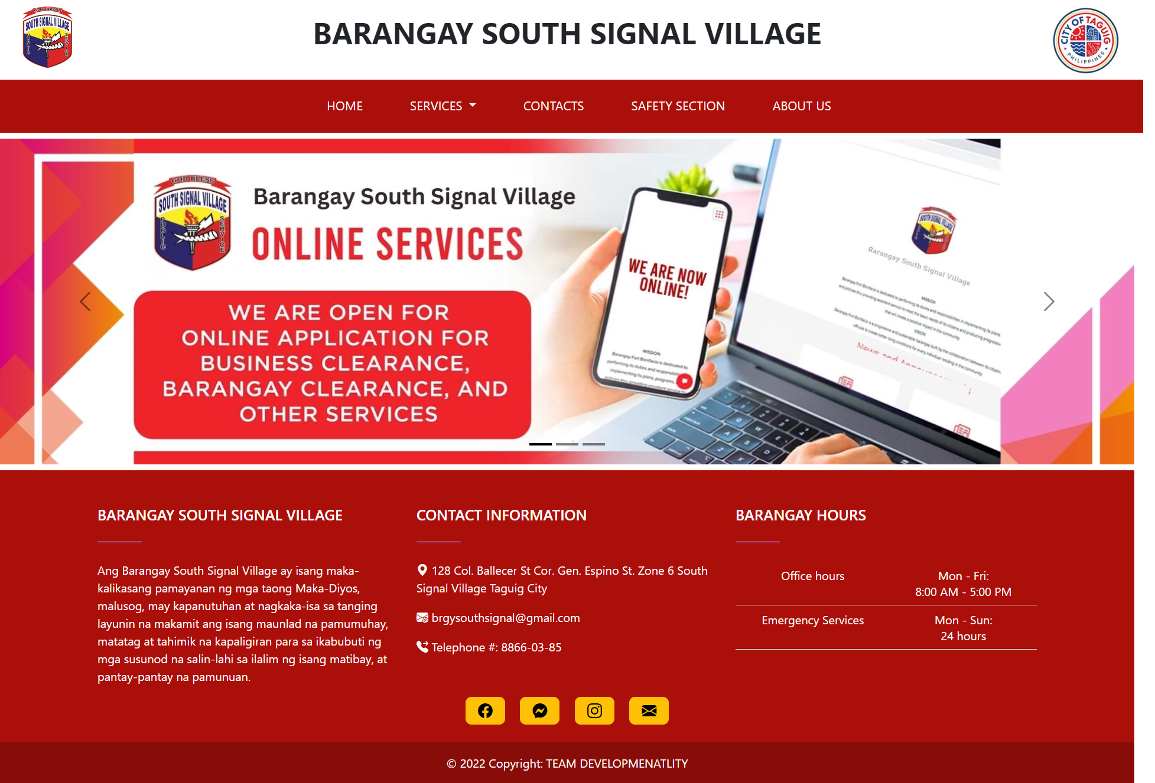

Figure 39 Home Page

This is the homepage featuring a carousel, a slideshow component that cycles through images of announcements made by the barangay.

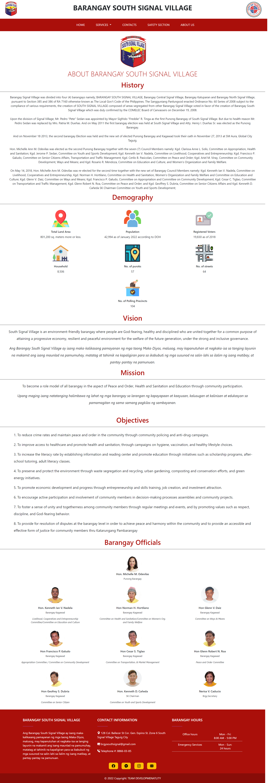

Figure 40 About Us Page

The 'About Us' page contains the barangay profile, including its history, demographic information, vision, mission, objectives, and a list of the current barangay officials.

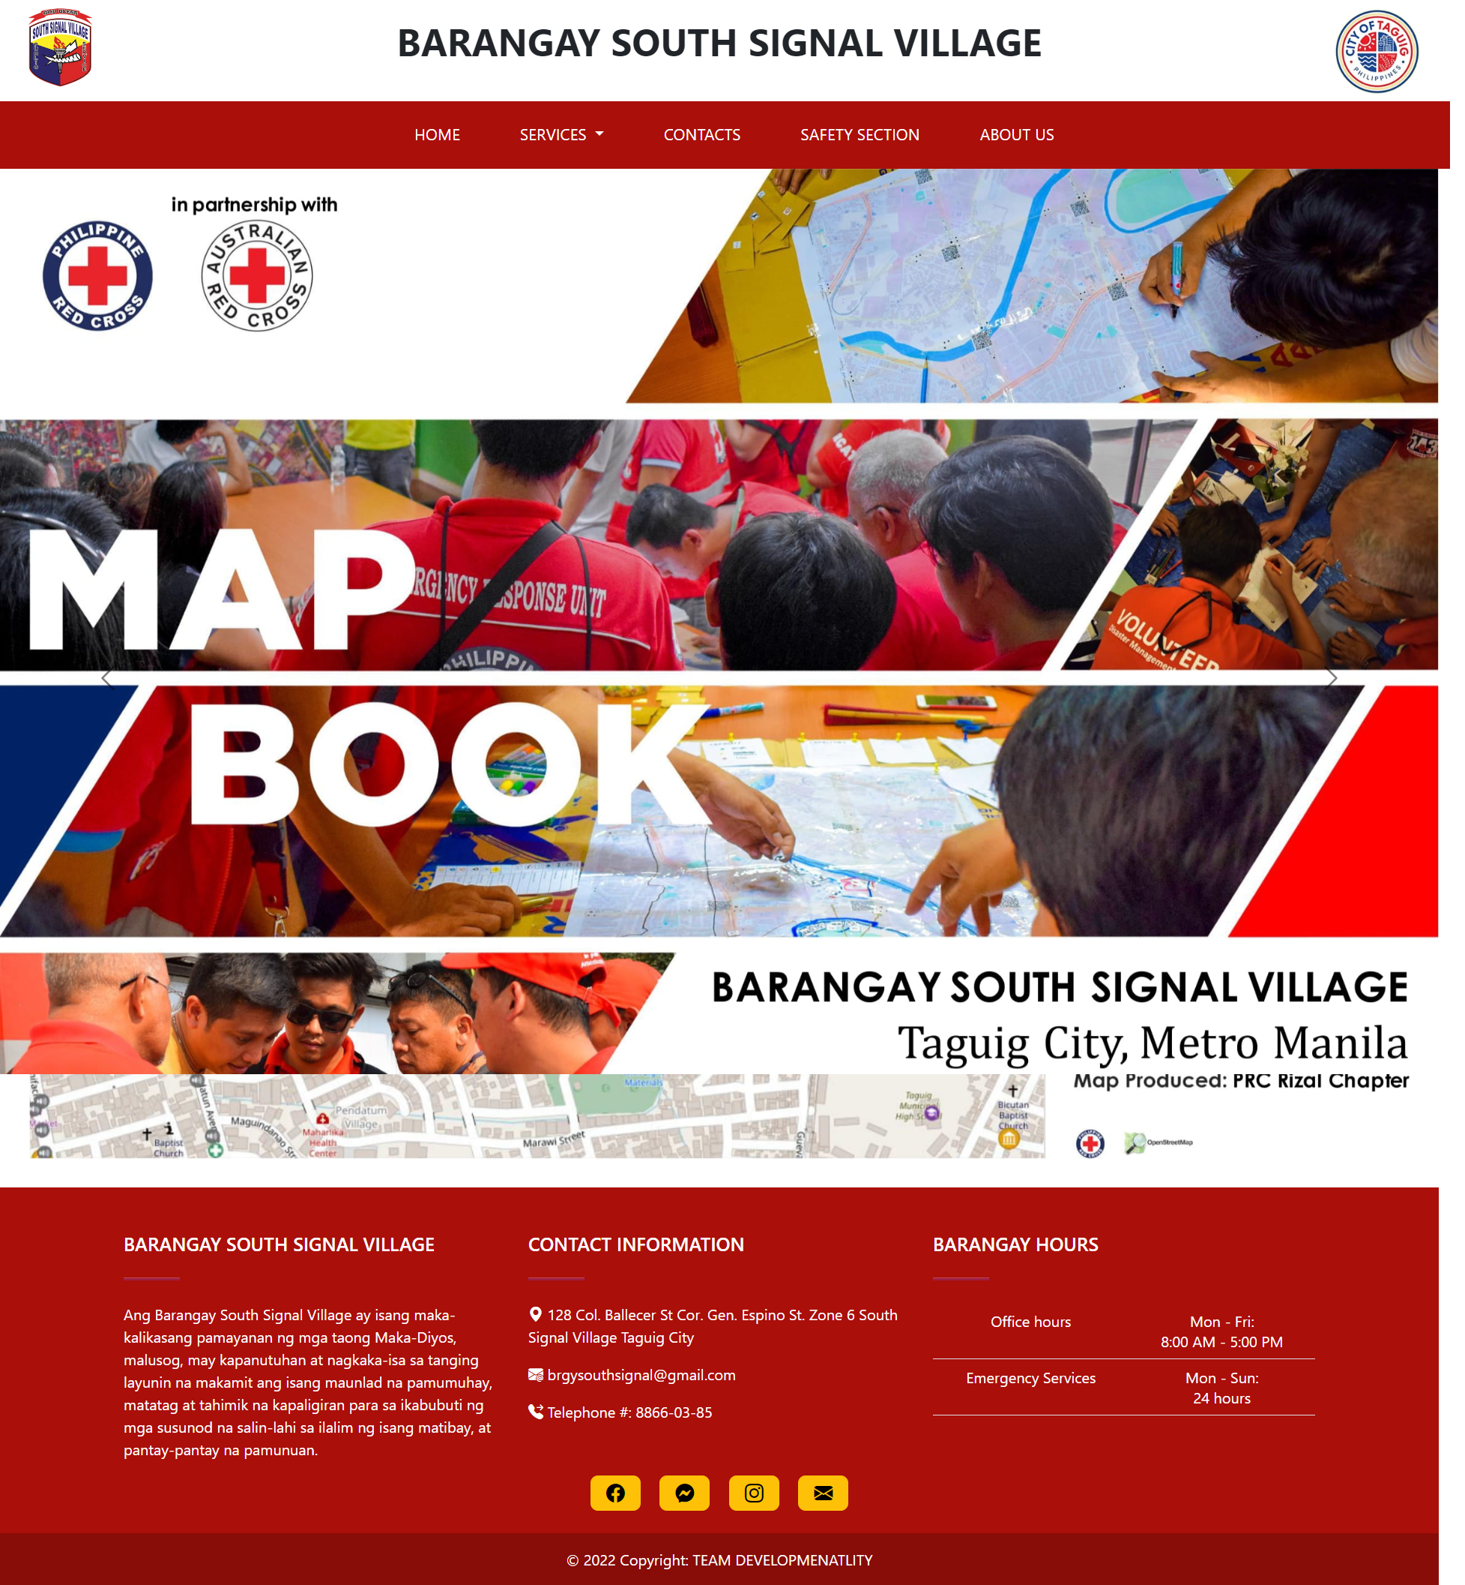

Figure 41 Safety Section

The 'Safety Section' page presents a Red Cross Philippines base map with a legend of barangay infrastructure, a population density map, a vulnerability map, a land use map, a historical hazard map, and a flood hazard map with risk levels.

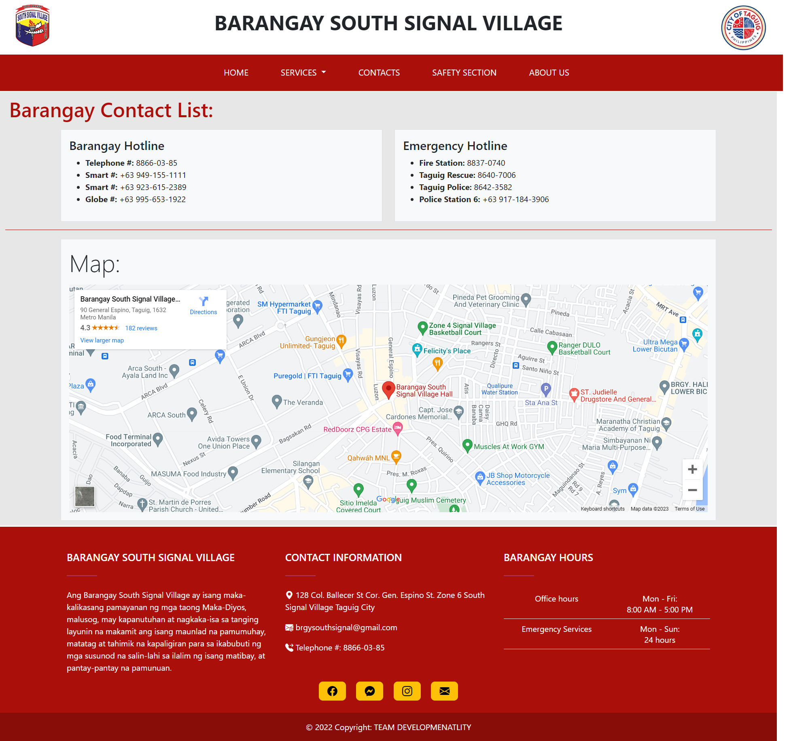

Figure 42 Contacts

The 'Contact' page lists various contact information and hotlines for residents to use and includes an embedded map of the barangay main office.

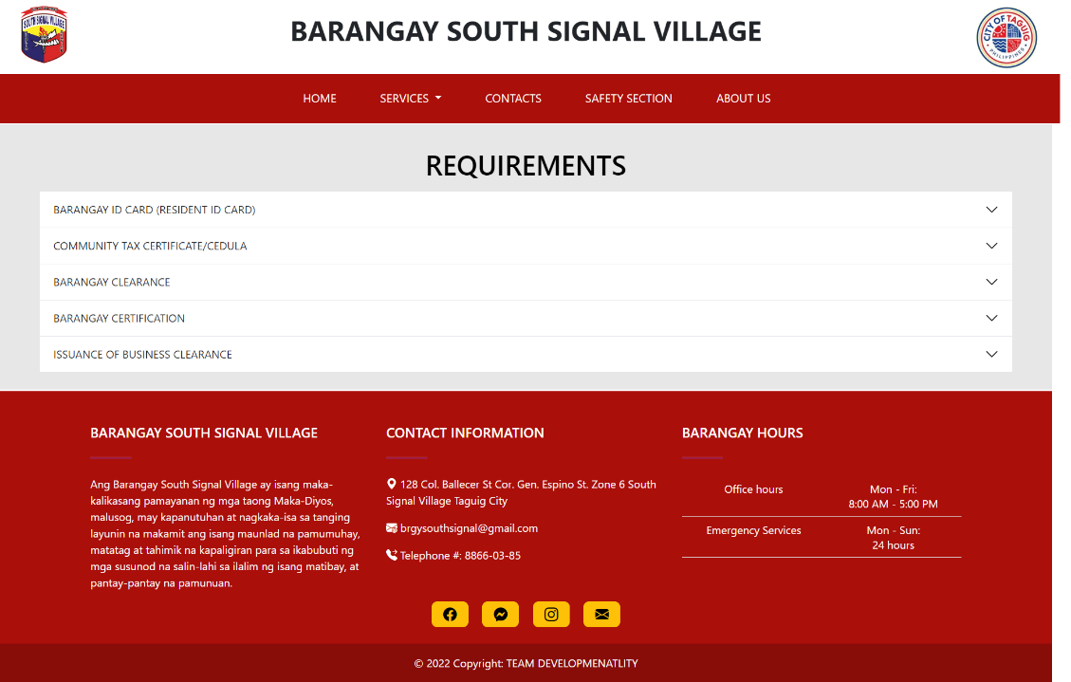

Figure 43 Requirements

The 'Requirements' page displays the various documents available from the barangay, along with information on the fees, the process for obtaining the requirements, and the necessary supporting documents for each requirement.

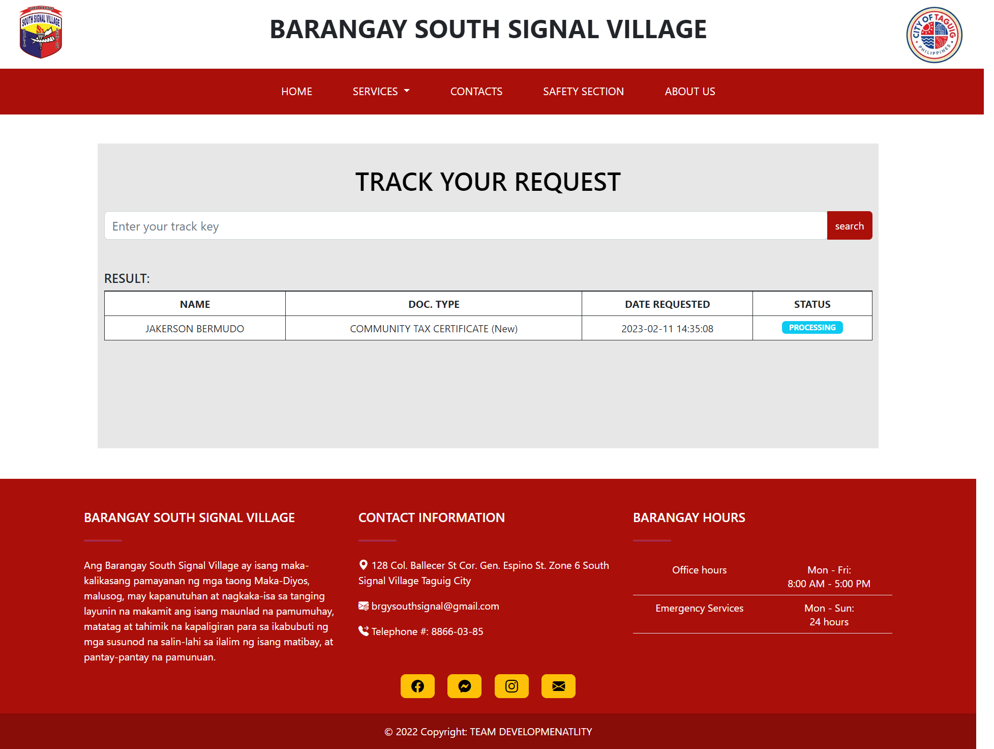

Figure 44 Track Request

The 'Request Tracking' page lets residents track document requests using a tracking key, which displays document type, date, and status (Pending, Processing, Ready for Payment, Done, or Denied).

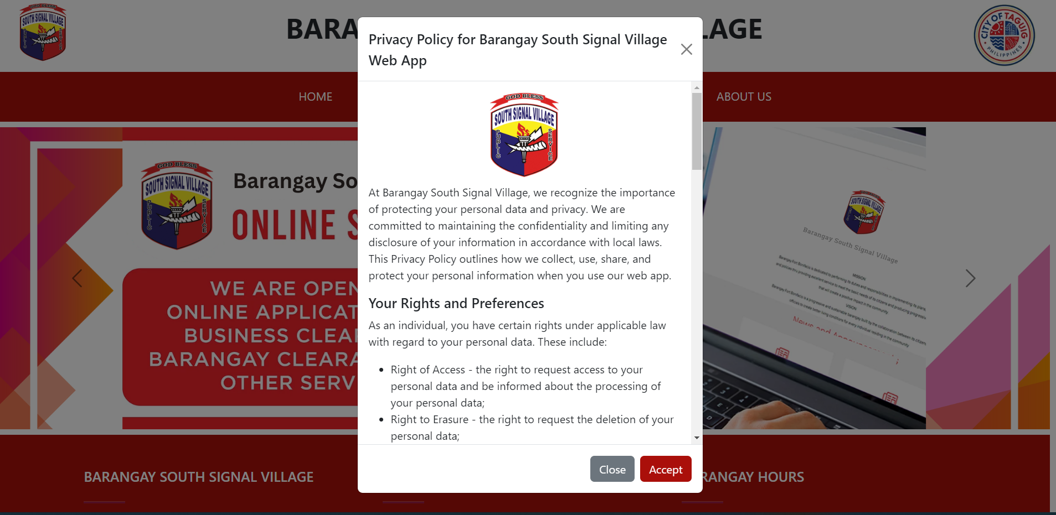

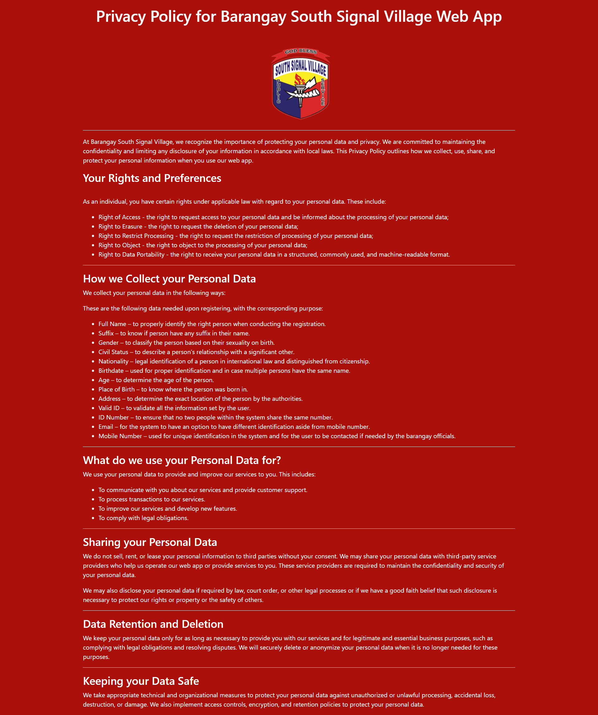

Figure 45 Data Privacy Notice

When a user tries to register for the web app, a pop-up window appears that displays the barangay's data privacy policy for resident information collected during the registration process.

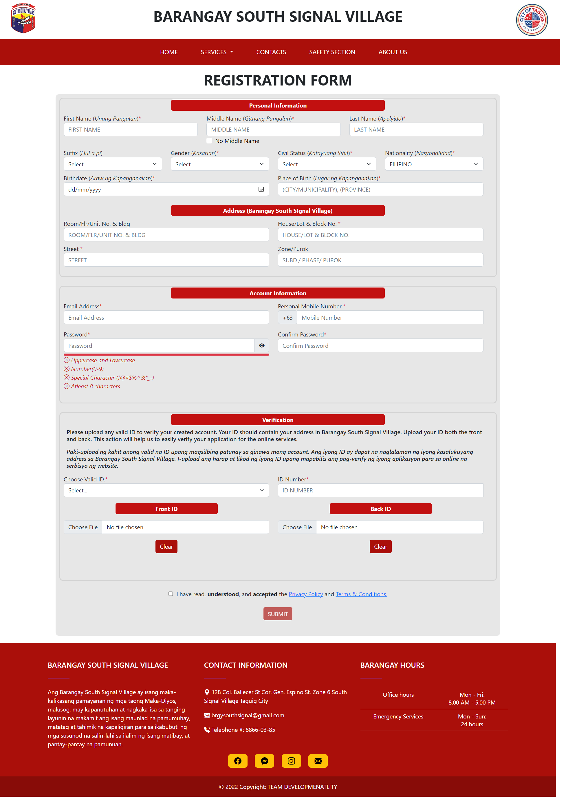

Figure 46 Registration Page

The 'Registration' page is a form for residents to create a resident account on the web app. Residents provide personal information, address, account details, and upload valid identification for verification.

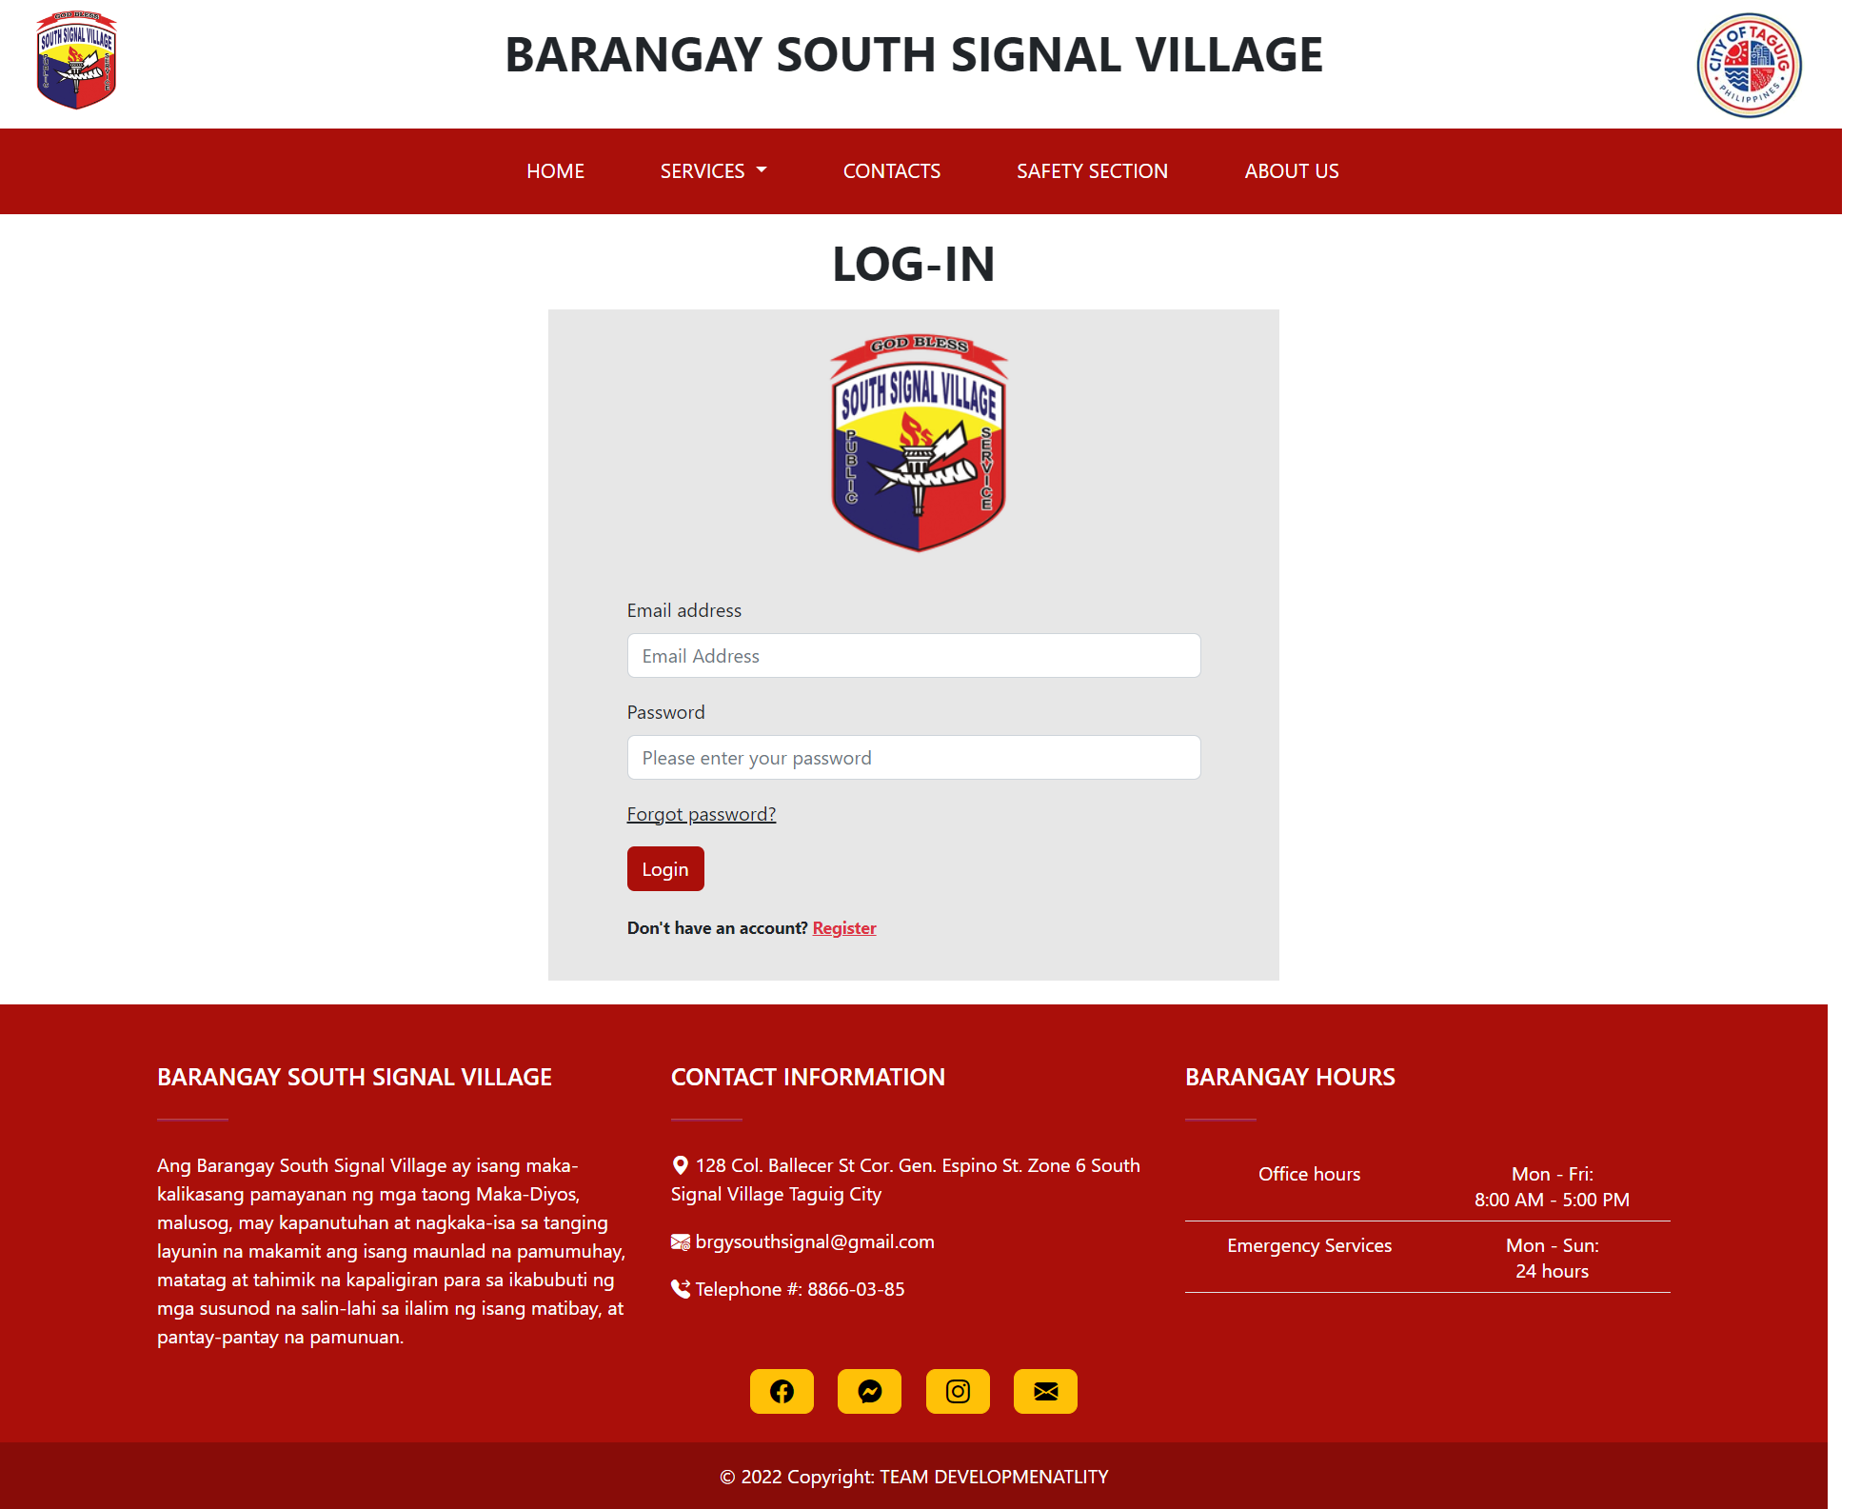

Figure 47 Log in page

The 'Login' page allows residents with a resident account to securely access their account on the web app by entering their registered email and password.

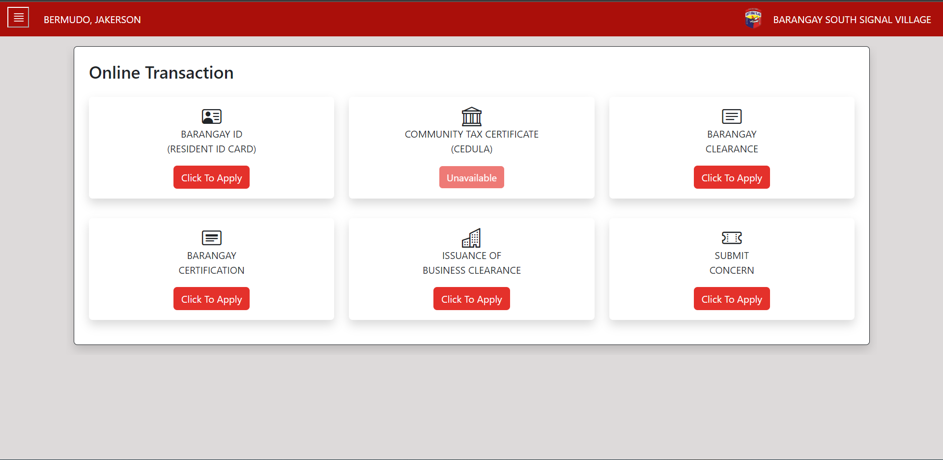

Figure 48 Resident Dashboard

Upon successful login, the resident is taken to their 'Resident Dashboard' page. This page displays the various online transactions that are available on the web app for the resident to access.

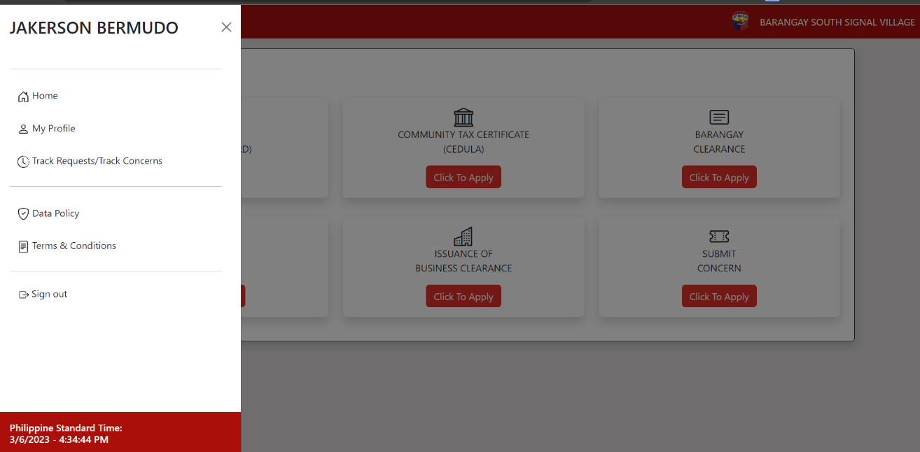

Figure 49 Resident Dashboard Side Bar

The side bar of the resident dashboard features six tabs: Home, Profile, Transaction History, Data Policy, Terms and Conditions, and Sign-out.

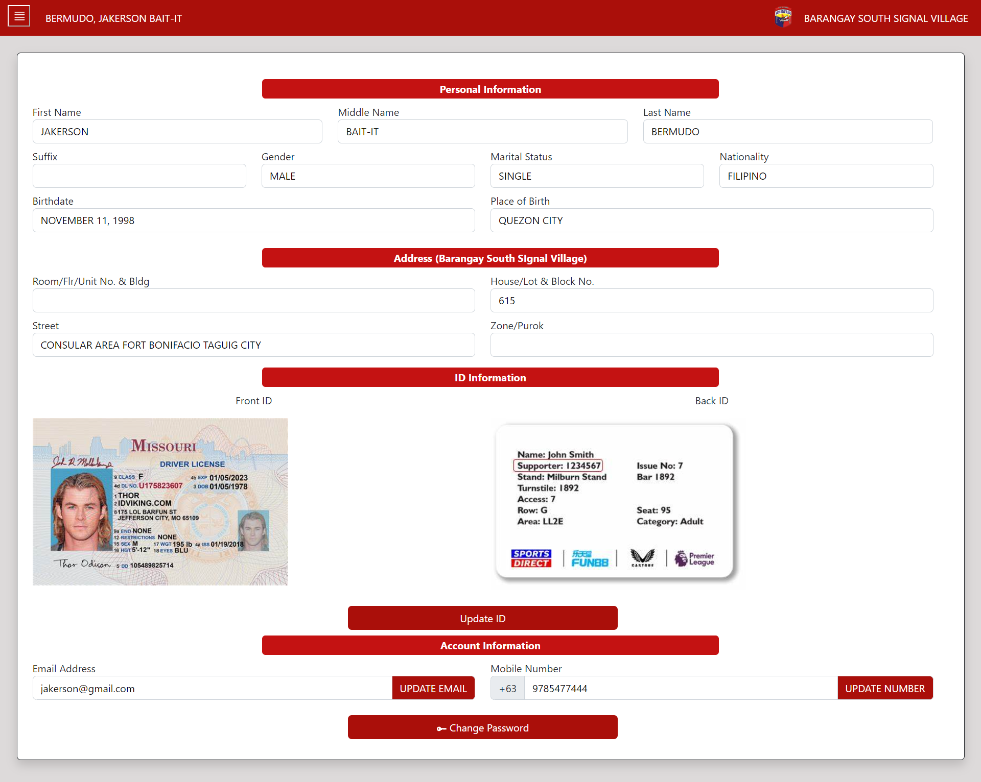

Figure 50 Resident Dashboard - My Profile

The 'My Profile' tab on the resident dashboard displays the resident's personal information. The resident can update their valid IDs, email, mobile number, and password.

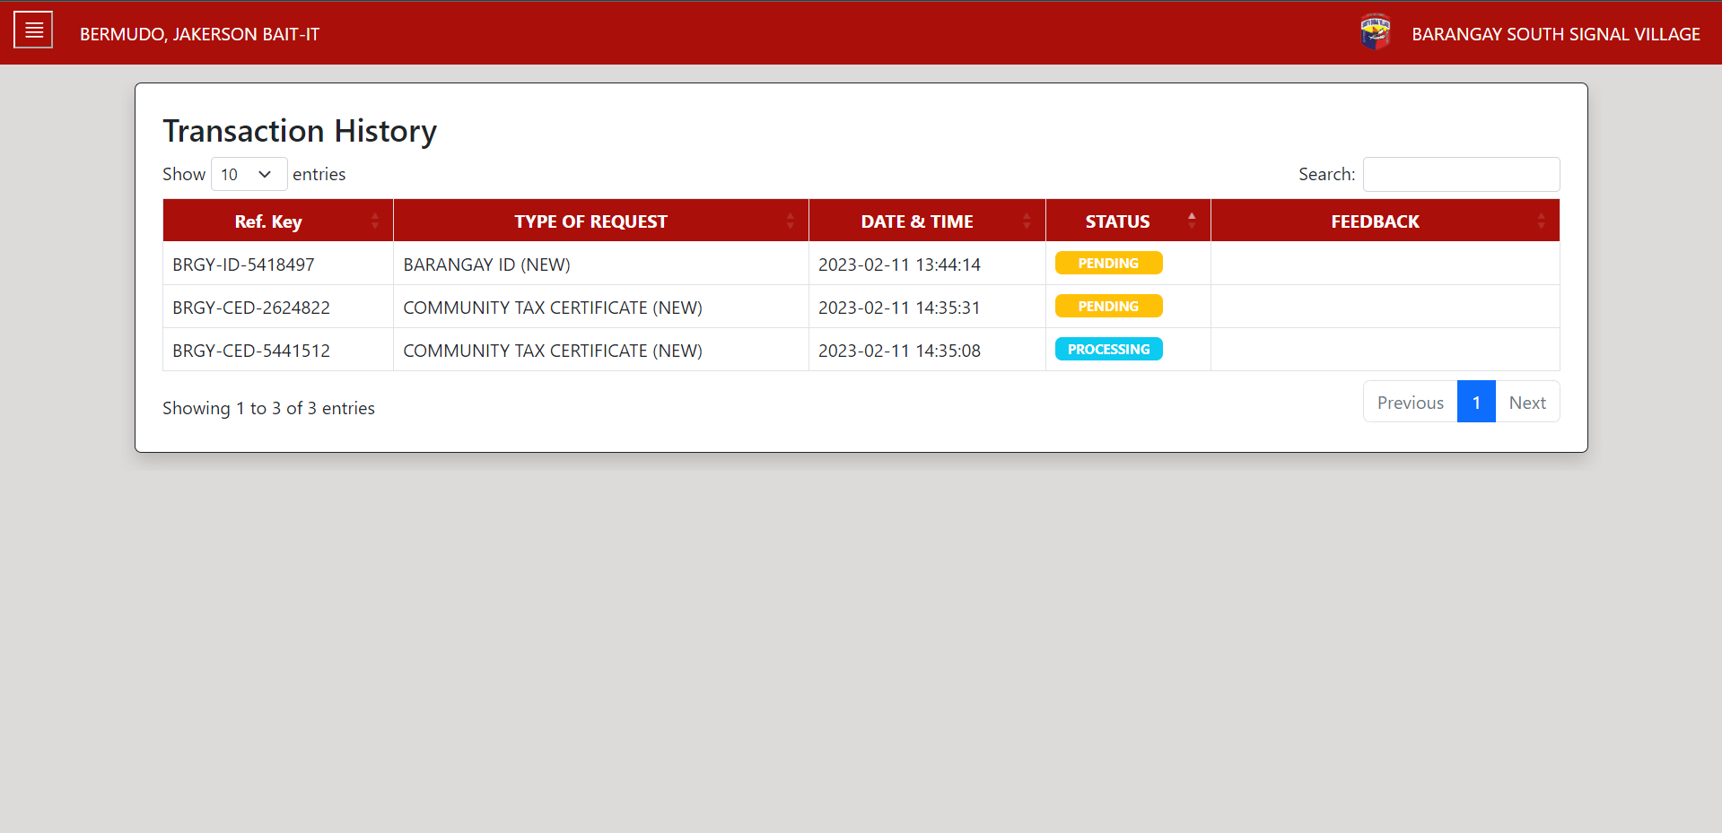

Figure 51 Transaction History

The 'Transaction History' tab on the resident dashboard displays a list of all the transactions that the resident has completed through the web app, including the date, type of transaction, and status.

### Barangay Employee Prototype

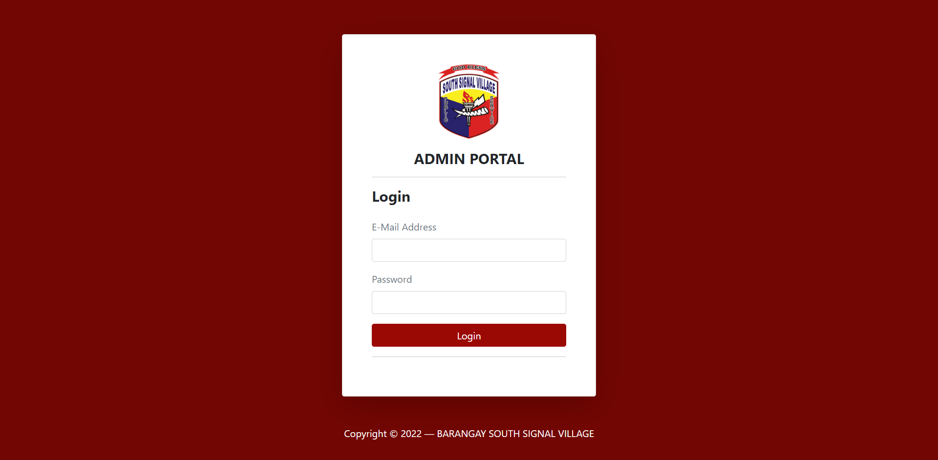

Figure 52 Admin portal login

The admin portal is a separate login page specifically for Barangay Employee of the web app, allowing them to access and manage different functions and information within the web app.

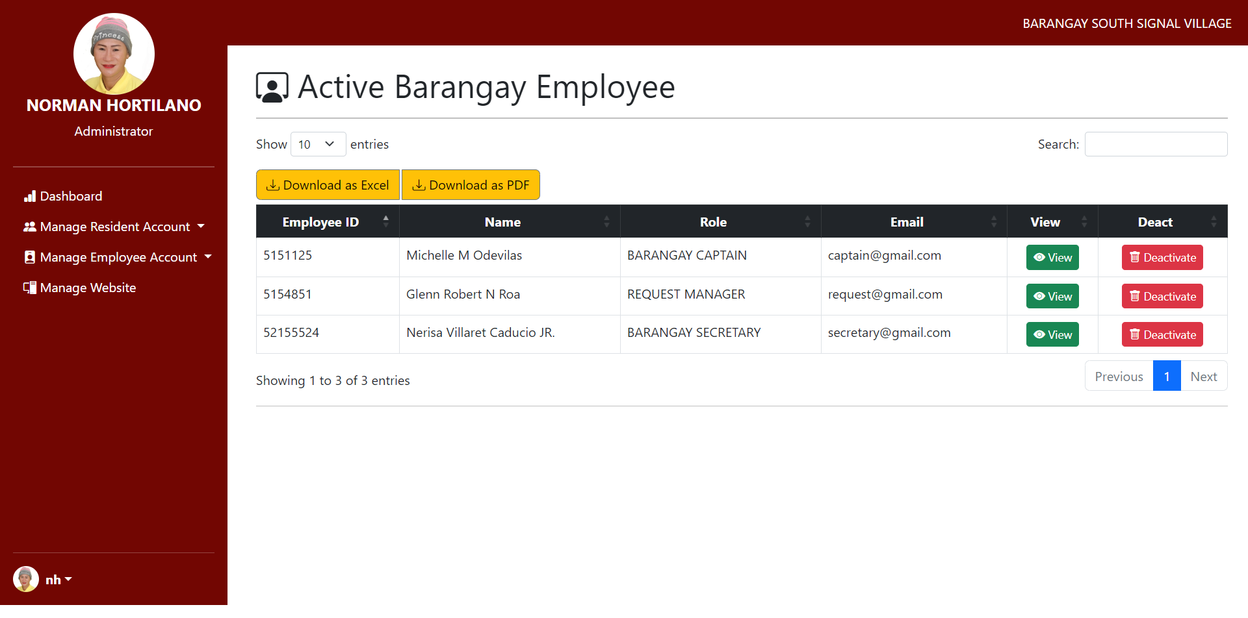

Figure 53 Administrator Dashboard

The Administrator Dashboard page is where the administrator can manage the barangay employees by adding, deactivating, and assigning roles to them. Additionally, the administrator can also manage the web-app, including editing the carousel announcements on the home page, updating the information about the barangay officials in the 'About Us' page, and updating the barangay's demography.

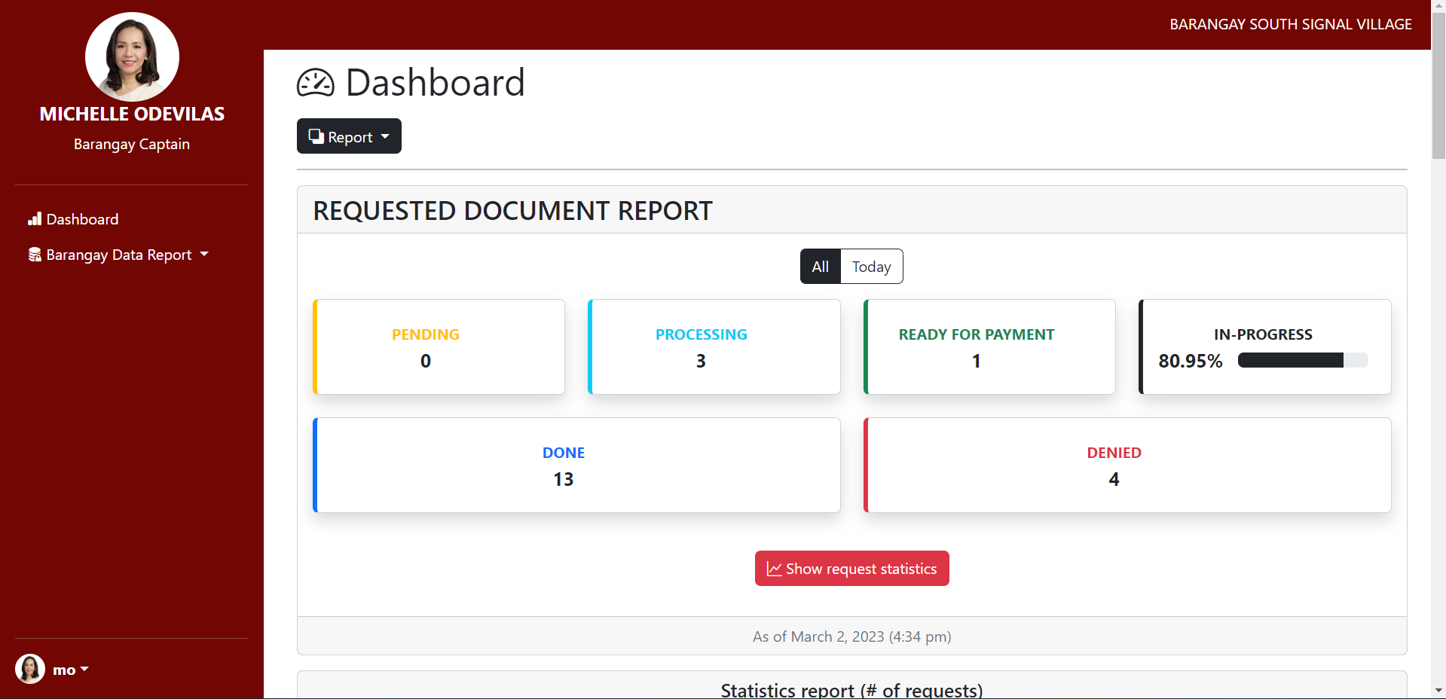

Figure 54 Barangay Captain Dashboard

The Barangay Captain Dashboard provides a comprehensive view of the web-app's report, lists of residents, employees, and requests, allowing the Barangay Captain to oversee all transactions within the web-app.

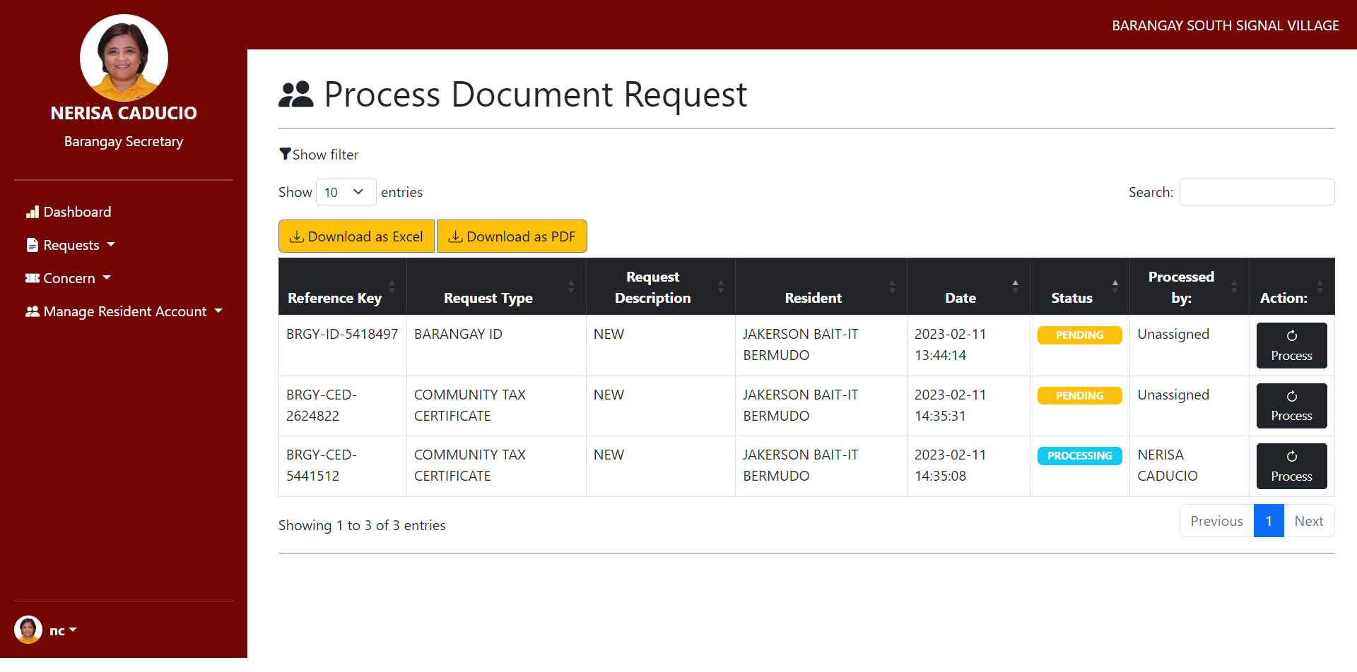

Figure 55 Barangay Secretary Dashboard

The Barangay Secretary Dashboard allows the Barangay Secretary to handle and process requests and concerns from residents in the web app, as well as have a comprehensive overview of all residents’ accounts.

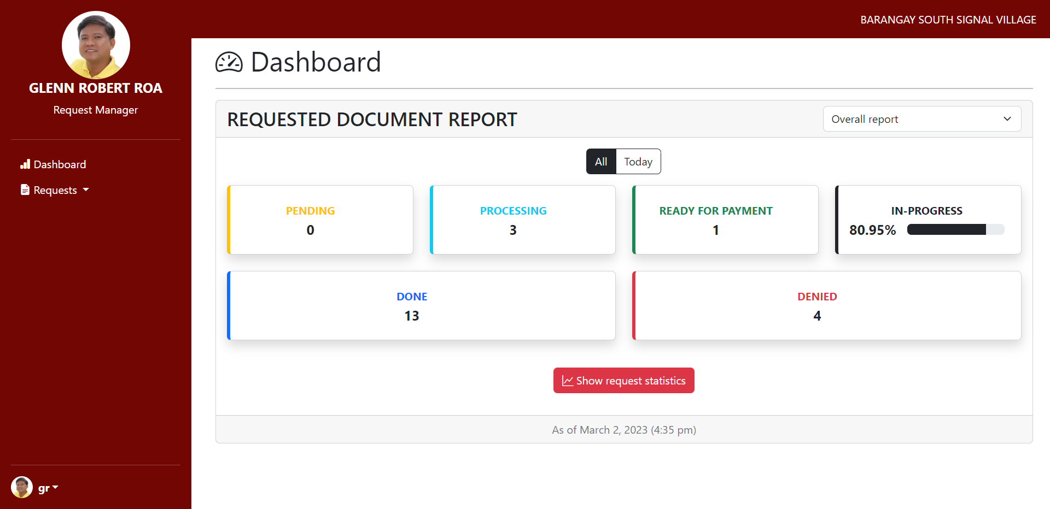

Figure 56 Request Manager Dashboard

The Request Manager Dashboard allows the Barangay Request Manager to handle and process requests from residents in the web app.

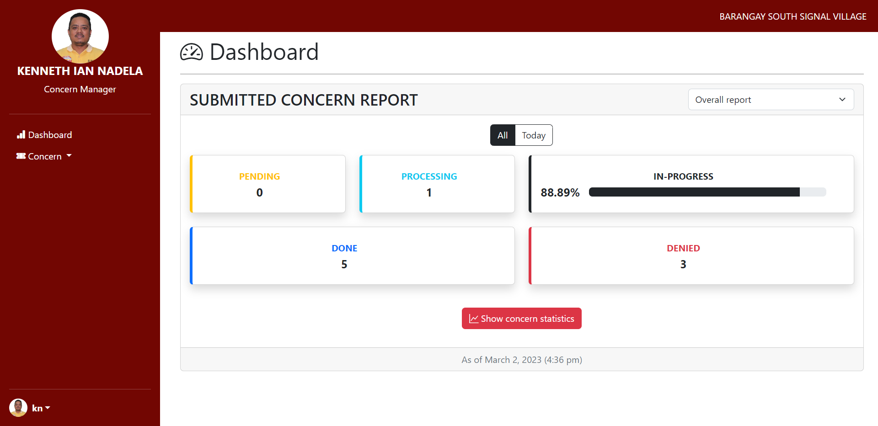

Figure 57 Concern Manager Dashboard

The Concern Manager Dashboard allows the Barangay Concern Manager to handle and process concerns from residents in the web app.

## 5.3 Use Classes and Characteristics

Table 20 Use Classes and Characteristics

|  |  |
| --- | --- |
| *Roles* | *Description* |
| *Resident* | * *This user is the primary visitor of the webapp.* * *He/she is the one who can access and avail themselves of the services offered by the web-app.* |
| *Administrator* | * *This user has the highest power over the web-app.* * *He/she assigns roles to barangay employees.* * *He/she manages the web-app.* |
| *Barangay Secretary* | * *This user handles and processes the requests and concerns created by the resident of barangay.* * *He/she verifies the requirements given by the residents of the barangay.* |
| *Barangay Captain* | * *He/she views the report of the web-app.* |
| *Barangay Concern Manager* | * *He/she processes and manages the concerns created by the resident.* |
| *Barangay Request Manager* | * *He/she processes and manages the requests created by the resident.* |

# Conclusion

In terms of accomplishments, the team progressed in many things, especially in identifying the web applications product backlog that contains short descriptions of all functionalities desired in the product. The team has also improved in developing the web application prototype and diagrams discussing the proposed system. The team progressed with the following features:

1. **Home/Main Page,** which contains information about the online services offered by the barangay.
2. **Online Document Request Page**, which shows the different documents and services, and the requirements and information about the different documents.
3. **Data Privacy Notice Popup,** informs the user about how and why personal data is being collected from them [21].
4. **Generated Reference Key** allows residents to track requests provided after submitting the form.
5. **The Requirement Page** shows the requirements, such as the payment, the process of getting the requirements, and the required documents the user needs to present.
6. **The Barangay Contact List** shows the different lists of contacts and hotlines about the barangay for the residents to use.
7. **The About Us Page** contains information about the barangay profile, specifically its History, Demography, Mission & Vision, and Barangay Officials.
8. **Log-in Page,** wherein the residents can log in with their credentials.
9. **Track Concern/Request Page,** this page can help residents track their requests/concerns by pasting a tracking key that shows a table with five statuses: Pending, Processing, Ready for Payment Denied, and Done.
10. **Dashboard Report,** this page can give the Barangay Captain details of the resident’s accounts and Barangay employee’s accounts.
11. **Resident Personal Account Details,** this page shows the personal information of each resident in the database, which the residents are limited to edit information.
12. **Barangay Employee Details,** this page is handled by the administrator, who can create, edit, and deactivate the Barangay Employee Accounts.
13. **Interactive Map,** this page shows web-based maps with the ability to click, plan, and zoom for more information about the Barangay South Signal Village area.
14. **Manage Concern,** this page can assist the residents regarding their concerns on Barangay South Signal Village.
15. **Administrator Dashboard,** can add, view, and edit Barangay Employee accounts.
16. **Barangay Employee Dashboard,** can edit, manage, and check residents’ accounts.
17. **Resident Dashboard,** is where the residents can view information and do their activities.
18. **Register Page,** allows the user to input information and be a Barangay South Signal Village member.
19. **Log-In Page,** allows users to access an application by entering their username and password.

The team has also succeeded in creating diagrams to assist the reader in visualizing the vision for Barangay South Signal Village Web App:

1. **Data Flow Diagram** is the flow of information through a process or system.
2. **Entity Relationship Diagram** is a graphical representation of the relationships between people, objects, places, ideas, or events [22].
3. **Context Flow Diagram** demonstrates how a system interacts with other actors it intends to communicate with.
4. **Use Case Diagram** is a graphic representation of potential user interactions with a system.
5. **Activity Diagram** is used by developers to gain a high-level understanding of program flow.
6. **Object Diagram** is a channel of instances that includes objects and data values.
7. **Class Diagram** is the blueprints of your system or subsystem.
8. **Sequence Diagram illustrates** the sequence of messages between objects in an interaction
9. **State Machine/Transition Diagram** used to represent a finite state machine.
10. **Package Diagrams** are used to depict how packages and their components are organized [23].
11. **Deployment Diagram** models a system’s physical structure.
12. **Component Diagrams** are unique types of UML diagrams utilized for various purposes.

The team has worked hard to complete the final deliverables, which will provide a solid foundation for the project's success. The following are:

1. **Creation of Test Case** refers to testing the web application, ensuring it works appropriately while having high quality, which gives feedback to the team for any needed improvement or fixes required for the web application.
2. **Creation of a Quality Plan,** refers to outlining the web application's standards and procedures to ensure it meets the level of high-level quality needed. Which makes sure it meets the expectations of our client.
3. **Creation of a User Acceptance Document,** refers to outlining the requirements and expectations of the end-users for the web application. The document plays an integral part in the software development process.
4. **Creation of the Change Management Plan,** refers to outlining the procedures for the project's changes in a controlled environment. This improves the web applications' efficiency and ensures the project is under control.
5. **Creation of Proofreading Endorsement,** refers to the document's approval after it has been proofread and reviewed, which will ensure the accuracy as well as the quality of the final document.

The researchers have improved the essential functions of the developed prototype with the help of user stories and meeting with different consultants, the project adviser, and the clients. That is why in the future, the team will continue to add/revamp the following to enhance the project even more:

Release 2 (please see at 5.1 Release Plan)

Release 3 (please see at 5.1 Release Plan)

# References

|  |  |
| --- | --- |
| [1] | Philippine Statistics Authorithy, "Barangay," 2 June 2020. [Online]. Available: https://psa.gov.ph/content/barangay-1. |
| [2] | P. Dennis S. Mapa, "2020 Census of Population and Housing (2020 CPH) Population Counts Declared Official by the President," Republic of the Philippines, Philippine Statistic Authority, 7 July 2021. [Online]. Available: https://psa.gov.ph/content/2020-census-population-and-housing-2020-cph-population-counts-declared-official-president?fbclid=IwAR3uNqwJWr_jlkncumwkLsFEDcqTFJsaeGlRtP80dKQh9RY2mtqbhwE_gdk#:~:text=The%20Philippine%20Statistics%20Authority%20. |
| [3] | United Nations, "Goal 8: Promote inclusive and sustainable economic growth, employment and decent work for all," 15 June 2020. [Online]. Available: https://unric.org/en/sdg-8/. [Accessed 24 April 2022]. |
| [4] | United Nations, "THE 17 GOALS," United Nations, 21 April 2018. [Online]. Available: https://sdgs.un.org/goals. [Accessed 24 April 2022]. |
| [5] | United Nations, "SDG 16: Promote peaceful and inclusive societies for sustainable development, provide access to justice for all and build effective, accountable and inclusive institutions at all levels," 13 June 2016. [Online]. Available: https://sdgcompass.org/sdgs/sdg-16. [Accessed 24 April 2022]. |
| [6] | J. Rogelio Bon. Intud, "Design and Implementation of a Hybrid Barangay Information Management System﻿," 30 May 2021. [Online]. Available: https://www.semanticscholar.org/author/Rogelio-Bon.-Intud%2C-Jr.%EF%BB%BF-Rogelio-Bon.-Intud%2C-Jr.%EF%BB%BF/2123668040. [Accessed 26 April 2022]. |
| [7] | Barangay Fort Bonifacio, "Barangay Fort Bonifacio," City of Taguig, 2020. [Online]. Available: https://www.barangayfortbonifacio.com/online-services. [Accessed 11 February 2023]. |
| [8] | City of Taguig, "Official Webite of the City of Taguig," City Government of Taguig, 2013. [Online]. Available: https://www.taguig.gov.ph/. |
| [9] | P. City, "Pasig City Government," Rakso CT, 2018. [Online]. Available: https://www.pasigcity.gov.ph/home. |
| [10] | M. J. P. Lado, M. I. Maloloy-on, G. C. Perez, P. K. M. Rizaldo and S. A. Tacocong, "COMPUTERIZED INFORMATION SYSTEM IN BARANGAY POBLACION, DANAO CITY, CEBU - CAPSTONE PROJECT," February 2017. [Online]. Available: https://www.slideshare.net/MarkJohnPerezLado/computerized-information-system-in-barangay-poblacion-danao-city-cebu. [Accessed 25 April 2022]. |
| [11] | J. P. Imus, E. D. Magleo, M. A. Soriano and R. L. Olalia, "Barangay Management Information System (BMIS) for Cities and Municipalities in the Philippines," 15 February 2018. [Online]. Available: https://www.semanticscholar.org/paper/Barangay-Management-Information-System-(BMIS)-for-Kevin-Elmer/ab07ab25cc65f702be70631feacf6ff364764ed1?fbclid=IwAR1_2bXDrPJ9pAe9LOQtPHx7hNGwSuCL0uUaV_O2oZzBXT34A18DseHG0Vg#references. [Accessed 26 April 2022]. |
| [12] | C. O. Carpio, "Barangay Management System," *International Journal of Multidisciplinary Research and Publications,* vol. 3, no. 2, pp. 26-32, 2020. |
| [13] | B. Jacobe, M. L. Pascua, B. J. Tumbali, M. C. Aquino and M. V. Gumabay, "Barangay Profiling System with Analytics," *International Journal of Advanced Trends in Computer Science and Engineering,* vol. 10, no. 4, p. 2697– 2700, 2021. |
| [14] | J. K. P. Imus, E. D. Magleo, M. A. A. Soriano and R. L. Olalia, Jr., "Barangay Management Information System (BMIS) for," *International Journal of Computer Applications,* vol. 180, no. 19, 2018. |
| [15] | I. A. A. Cristobal, C. K. O. Cruz, J. M. P. Dela Cruz, J. H. Manalansan, B. S. Fabito, R. L. Rodriguez and M. V. Octaviano, "Pasigueño Assistant: An E-Participation Mobile Application Framework for the City of Pasig, Philippines," in *TENCON 2018 - 2018 IEEE Region 10 Conference*, 2018, pp. 1807-1812. |
| [16] | P. R. Bringula, M. A. D. Vale, J. A. Napolis, F. P. Oliva and D. J. T. De La Serna, "E-Barangay: A Framework for a Web-Based System for Local Communities and Its Usability," *International Journal of Electronic Government Research,* no. 18, 2022. |
| [17] | J. E. L. Caubang, "Barangay Resident Record Management and Certificate Issuance System of Barangay Ticol Sorsogon City," 2017. [Online]. Available: https://www.academia.edu/31530757/Barangay_Resident_Record_Management_and_Certificate_Issuance_System_Of_Barangay_Ticol_Sorsogon_City. |
| [18] | R. &. V. M. &. N. J. &. O. F. &. S. D. Bringula, "E-Barangay: A Framework for a Web-Based System for Local Communities and Its Usability," *International Journal of Electronic Government Research. 18. 10.4018/IJEGR.288071.,* 2022. |
| [19] | C. J. S. Santiago, M. L. P. Ulanday, Z. J. R. Centeno and M. C. D. Bayla, "Access, Skills and Constraints of Barangay Officials towards the Use of Information and Communications Technology (ICT)," *International Journal of Knowledge Content Development & Technology,* vol. 11, no. 2, 2021. |
| [20] | L. Chaudhary, "EDUCBA," Agile in SDLC, 16 September 2019. [Online]. Available: https://www.educba.com/agile-in-sdlc/. [Accessed 04 April 2022]. |
| [21] | National Privacy Commission, "Day to Day," National Privacy Commission, 05 April 2017. [Online]. Available: https://www.privacy.gov.ph/implementing-privacy-and-data-protection-measures/day-to-day/. [Accessed 13 February 2023]. |
| [22] | SlideModel.com, "ER Model: What is an Entity Relationship Diagram.," SlideModel.com, 16 November 2022. [Online]. Available: https://slidemodel.com/entity-relationship-diagram/. [Accessed 13 February 2023]. |
| [23] | A. Lynch, "What is UML | Unified Modeling Language," Wondershare, 15 February 2022. [Online]. Available: https://www.edrawsoft.com/what-is-uml-diagram.html. [Accessed 13 February 2023]. |

# Appendices

## Appendix A: Project Vision

|  |
| --- |
| Project Vision |
| FOR: Barangay South Signal Village Staff and Residents |
| WHO: wants to have an efficient and effective way to process requests, spread information to a large audience, and store, organize and maintain data. |
| THE: Barangay South Signal Village |
| IS: an online web application |
| THAT: would help the barangay residents have a new way to access public information about their barangay and provide an easier way to request barangay documents online ahead without having to wait in line and spend time requesting at the barangay. |
| UNLIKE: manually processing transactions, and storing documents and data physically |
| OUR: system makes it easier and more efficient for both the barangay staff and barangay residents |

Figure 58 Project Vision

## Appendix B: Schedule

* 1. SCHEDULE TABLE

Schedule Table provides a comprehensive and organized overview of critical events, tasks, and activities for creating the Barangay South Signal Village Web App. This section presents a schedule table specifically designed for the team involved in the project's Planning, Analysis, Design, and Development Phase. It is an essential tool to keep track of important dates and deadlines, ensuring that the project stays on schedule and that all milestones are met.

Table 21 Schedule Table

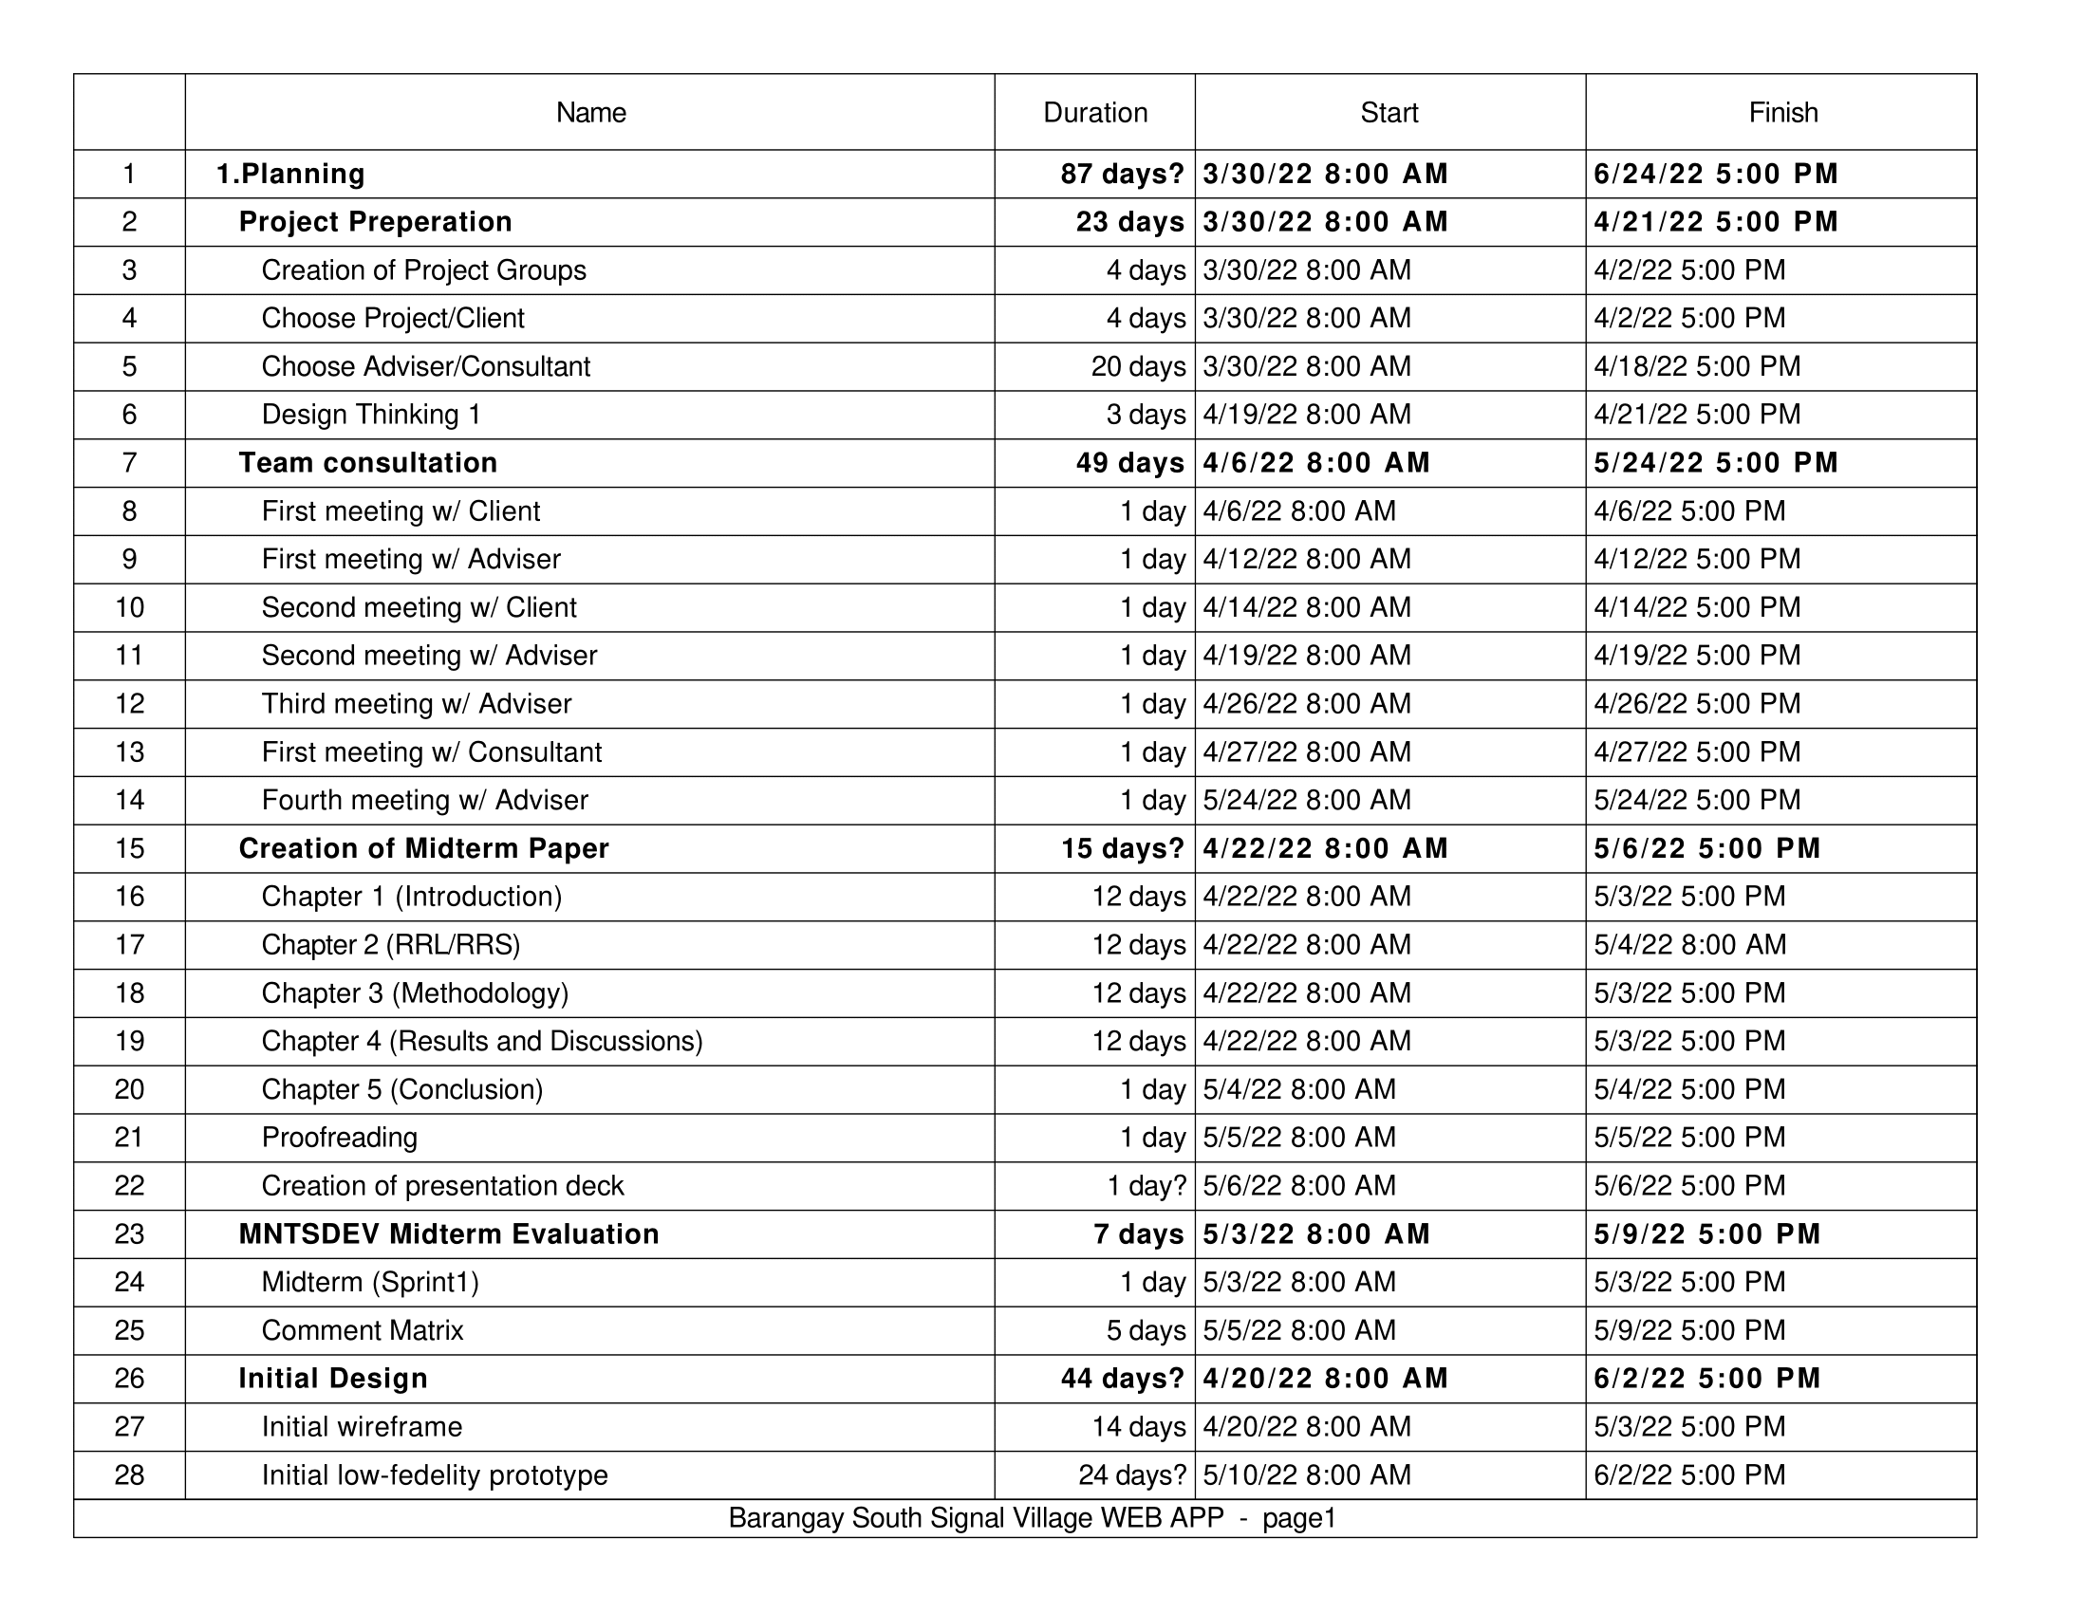

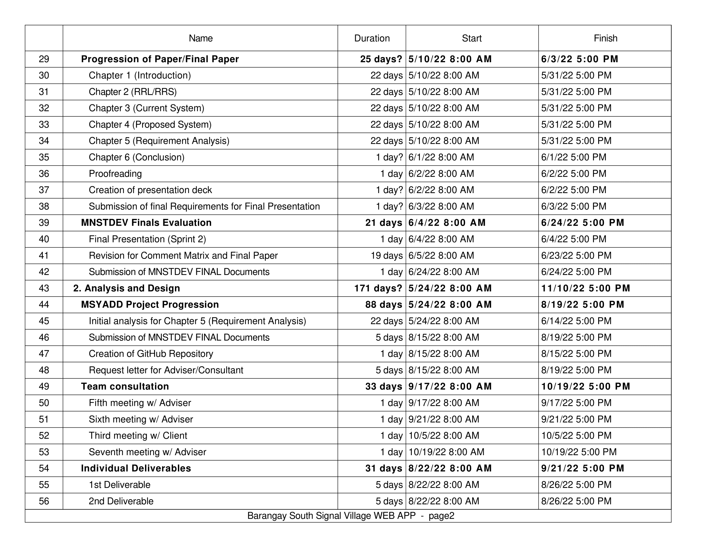

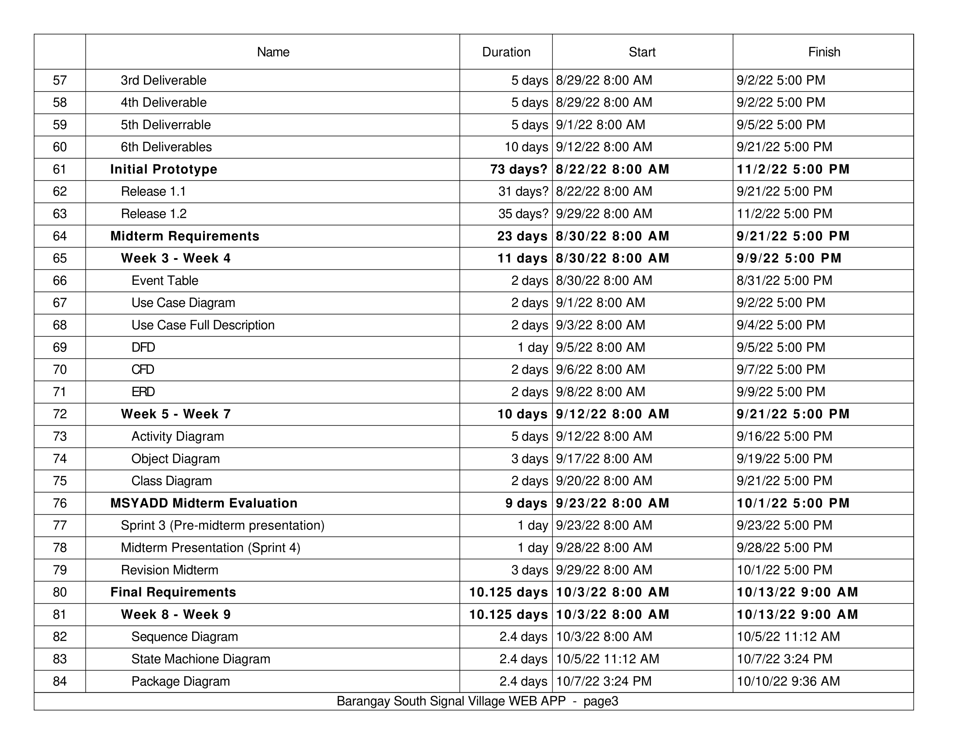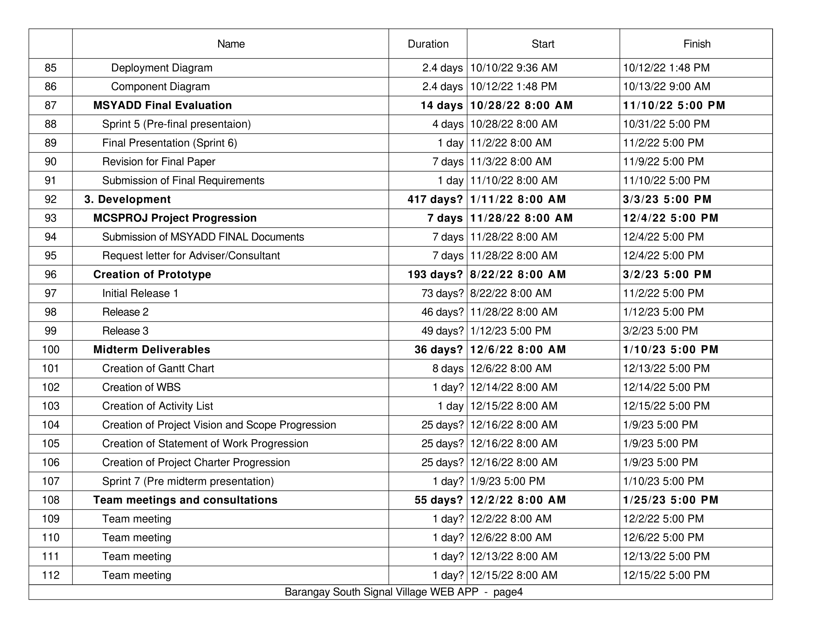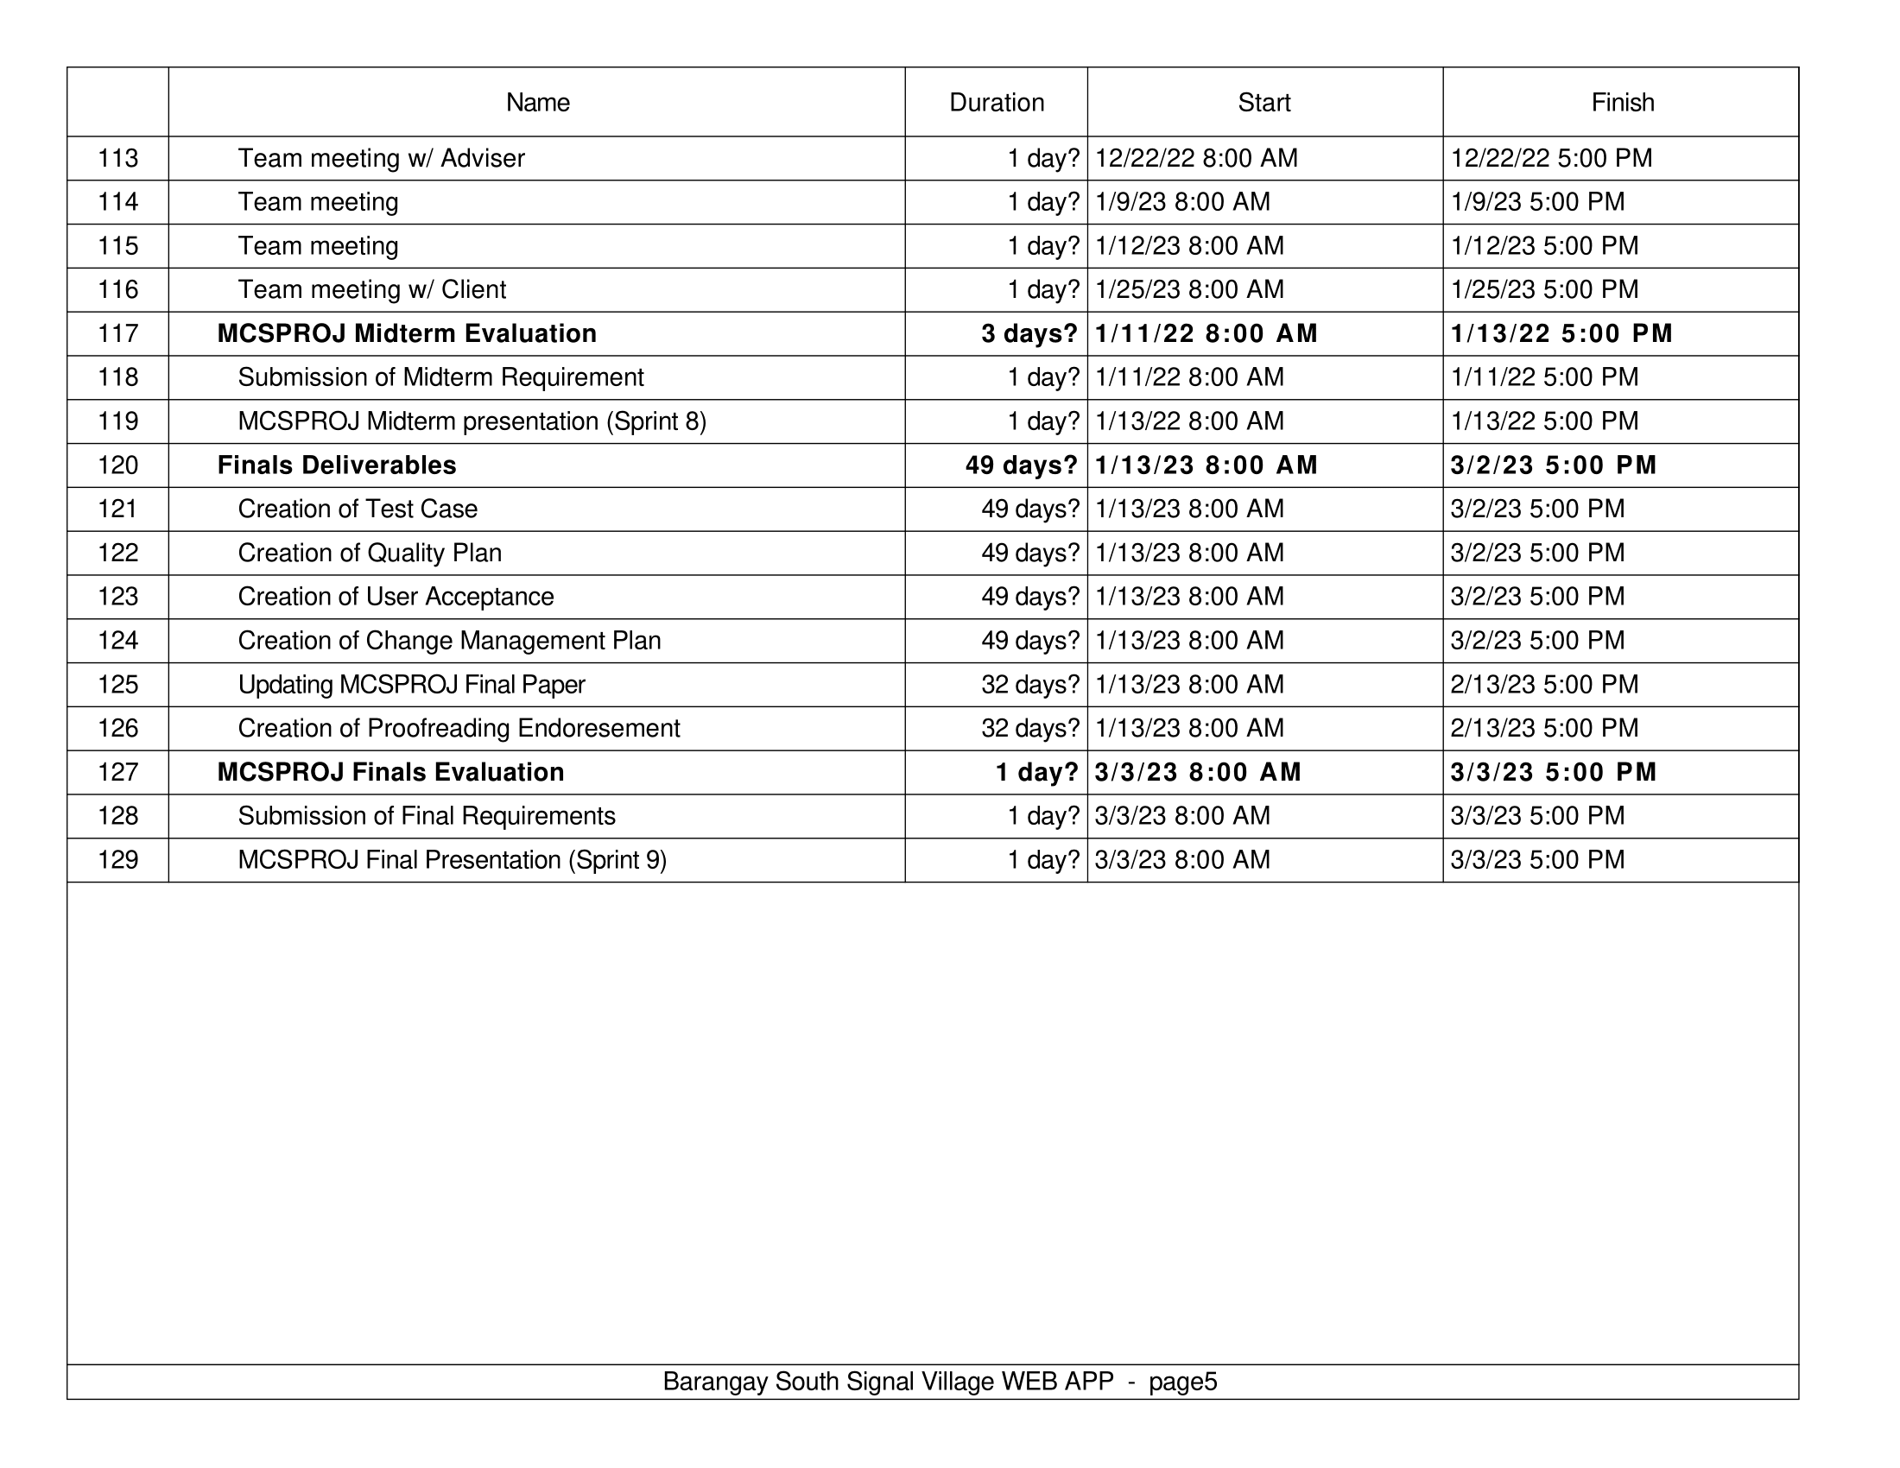

* 1. **Work Bench Structure**

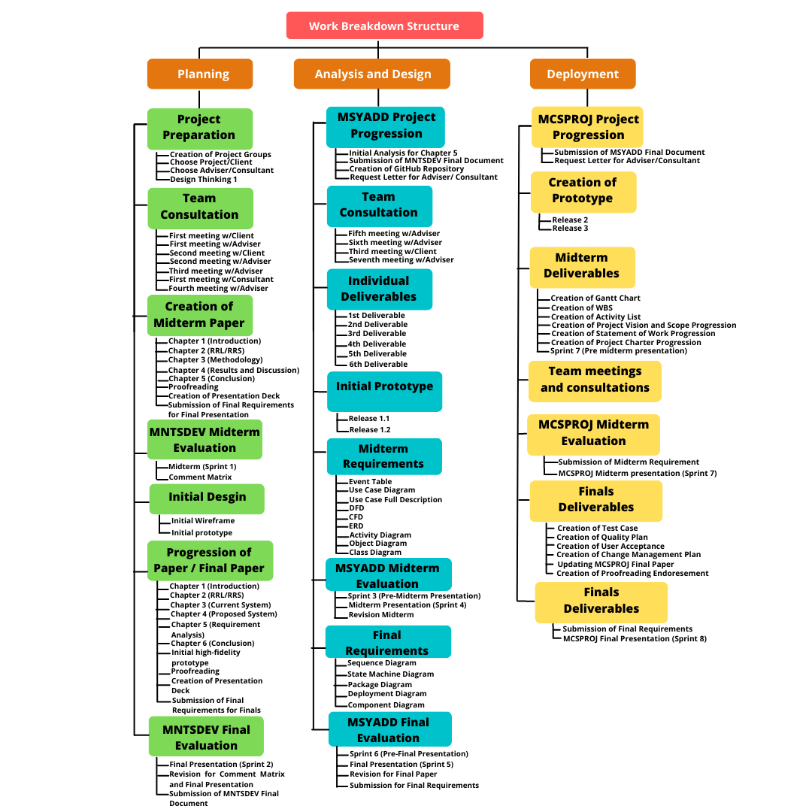

Figure 59 Work Bench Structure (WBS)

## Appendix C: Product Roadmap

|  |  |  |
| --- | --- | --- |
| **MNTSDEV** | **MSYADD1** | **MCSPROJ** |
| **Pitch Presentation**   * Research Paper/ Documentation * Pitch video/ Product Teaser     **UI / UX Design**   * Barangay South Signal Village Webapp | **Pitch Presentation**   * Documentation * Product Teaser   **UI / UX Design**   * Administrator Dashboard * Secretary Dashboard * Barangay Captain Dashboard   **Increment Release**   * Release 1 | **Increment Release**   * Release 2 * Release 3 |

Figure 60 Product Roadmap

## Appendix D: Users’ Manual

Resident and Admin Manuals can be accessed in this link: [Barangay South Signal Village Web App User's Manual](https://asiapacificcollege.sharepoint.com/:w:/s/MCSPROJMI201202/EeLe-T6DDv9HjRutQ41mGcUBQNWQF5x8oOsYmWlfGLapsQ?e=lPUqEx)

## Appendix E: Team Meetings

**Minutes of the Meeting Date: March 28, 2022**

**Agenda**

Discussion of potential Client and Advisor | Email for Client and Advisor

**Discussion**

1. Client
   1. Barangay South Signal
   2. Appointment Letter for Client
   3. Meeting with the Client (Wednesday, April 6)
   4. Introduce to client what are the project are
   5. Ask the client, what are the problems of barangay south signal in terms of the website f) Propose a solution to that problem
2. Barangay Appointment System (Website)
   1. User and Admin
   2. Potential problem with the system (Busy, Time and Election Day) c) Database
   3. Velo by Wix
   4. Features of system (Barangay ID, Barangay Clearance, Business Clearance)
   5. Reference for appointment system [(Barangay Fort Bonifacio)](https://www.barangayfortbonifacio.com/online-services)
3. Advisor
   1. Choosing advisor
      1. Ms. Jo Anne M. de la Cuesta
      2. Mr. Alvin C. Limpin (
      3. Mr. Hans Oliver M. Schuck II

**Minutes of the Meeting Date: April 05, 2022**

**Agenda**

Planning for tomorrow’s meeting with the Client | Choosing the Advisor

**Discussion**

1. Preparation for meeting with Client
   1. Discussing the proposal project
   2. Objectives, List down the risk, Expenses
   3. Tools
   4. Features of Application (Request by the client)
   5. Design
   6. Website (News, Transaction, About, Announcement)
   7. After meeting with the client, Brainstorm with the team
2. Advisor
   1. Finalize advisor (Mr. Alvin C. Limpin)

**Minutes of the Meeting Date: April 6, 2022**

**Agenda**

Meeting with the Client

**Discussion**

1. Barangay Appointment System suggested by the Client

* It does not need to login (Public)
* Attach requirements (Accepted correct requirements)
* Transaction through barangay and the estimated plan 1-2 days
* Minimum of 50-100 transactions everyday
* Fast and easy to use
* History Check (Database)
* Online Services
  + 1. (Home: News and Announcement)
    2. (Online Request: Business Clearance, Barangay Clearance/Certificate, and Barangay ID)
    3. (About Us: Profile of Barangay)
    4. (Contacts: Barangay emergency hotline)

**Notes**

* Request the following to the Client
* Sample fill-up form
* Organizational Chart
* Barangay Profile
* Mission/Vision
* Soft copy Logo of the Barangay and Taguig
* Emergency Hotline

1. News and Announcement
2. Requirements to submit for (Business Clearance, Barangay Clearance/Certificate, and Barangay ID)

Next Meeting with Client

* Prepare Wireframe to discuss the system

**Minutes of the Meeting Date: April 12, 2022**

**Agenda**

Meeting with the chosen advisor | Talking about proposal with the advisor

**Discussion**

1. About the Project
   1. Discussing the features of the proposal
   2. New questions to discuss with barangay officials
   3. Meeting with the Client (Tuesday, April 13)
2. Discussed Features and changes to proposal
   1. Cloud based server
   2. Title proposal change to “Barangay Website”
   3. Validation and requirements of documents
   4. Running numbers of requests per day
   5. Log-in system, registered and unregistered
   6. About data privacy notice and terms of conditions
3. Questions to clients
   1. Completion time of different request on the documentation
   2. Questions about PDF copy or soft copy of the documents
   3. More on the process of the barangay and its population
   4. Identifying stakeholders and administrator
   5. About data privacy notice

Notes

* More new questions for the clients based on what we have discussed with our advisors
* Title change to Barangay South Signal Village Website
* Change into log-in system instead of being public

**Teams Meeting Date: April 12, 2022**

**Agenda**

Meeting with Adviser

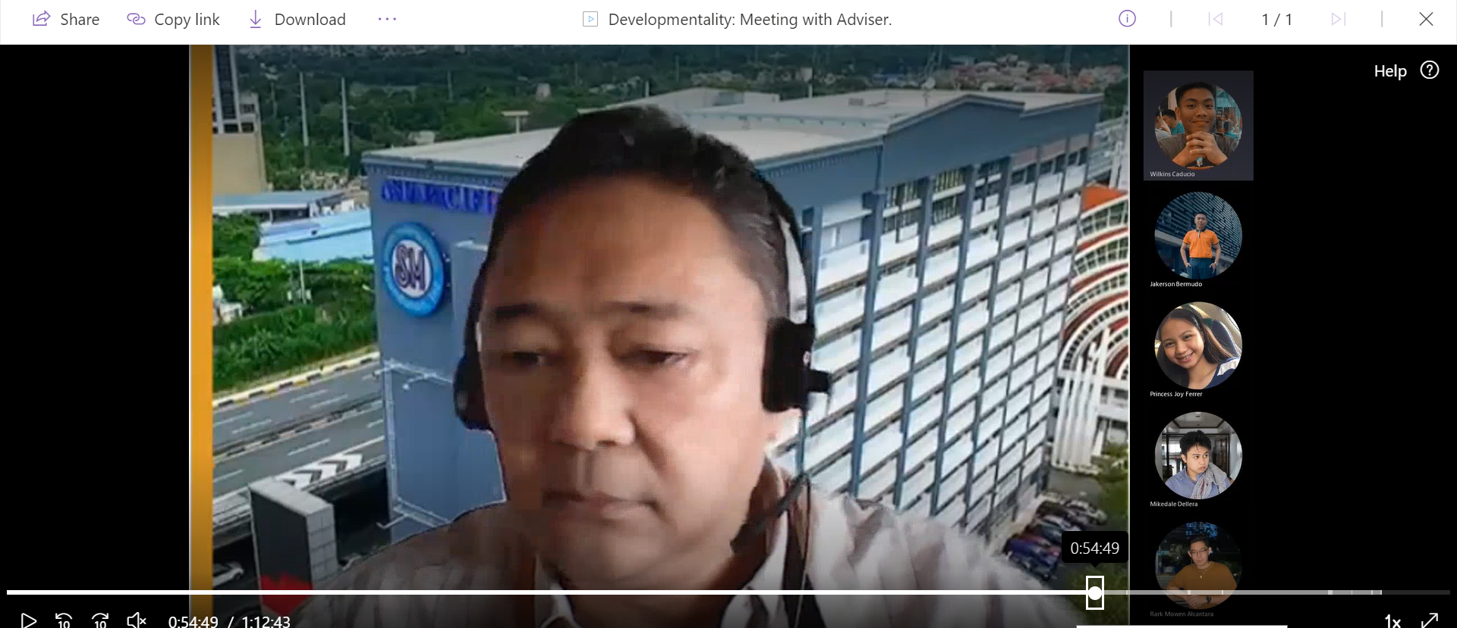

**Teams Meeting Date: April 13, 2022**

**Agenda**

Making a proposal and wireframe/prototype to our client

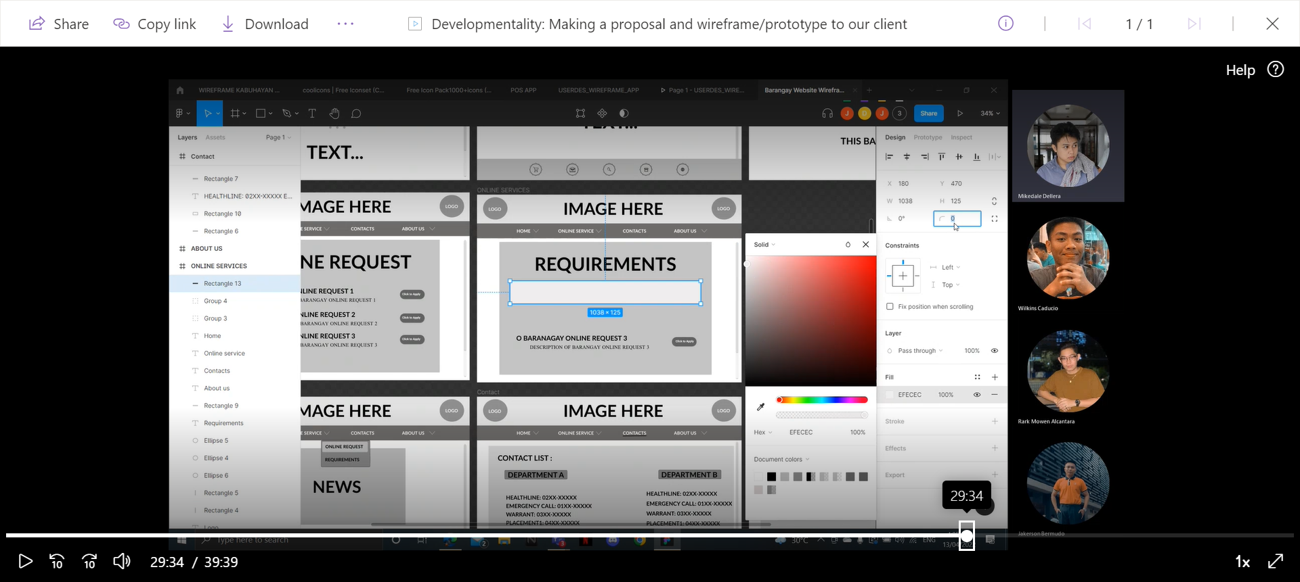

**Minutes of the Meeting Date: April 14, 2022**

**Agenda**

Meeting with Client

**Discussion**

* Introduction/Recap to the team
* Figma Wireframe presentation to barangay
* Explanation about the wireframe
* Data privacy notice agreement of both parties -barangay captain
* Between council and group
* Development phase

Software discussion

* Finding free software’s
* Low budget as possible
* Contact number
* Explanation barangay base is not possible
* Cloud base suggestions

Wireframe presentation

* Explaining features
* Showing diagram
* Data privacy discussion
* Barangay form
* Explaining the process of administrator

Questions to Barangay

* Required email address? No
* Photocopy or original copy? Present original copy then submits xerox copy
* Fill in form and requirements? Soft copy is valid/agreed
* Concerns about leaked information
* Creating manual instructions / simple UI for the administrator
* Prototype theme color, Yellow and black
* Is it possible to have a transaction like blotter? Nope, not possible for some application
* Population of barangay in south signal village, 40k suggestion limitations of software requirements
* current process of the barangay

Citizen charter given to us

* Information hidden where? Logbook
* estimated time of completion
* Citizen charter
* Demography ng barangay

**Minutes of the Meeting Date: April 15, 2022**

**Agenda**

Finishing the wireframe

**Discussion**

1. Wireframe for Barangay Website System

1. Homepage
   1. News
   2. Announcements
2. Online Services
   1. Online request (Request Form)
   2. Requirements
   3. Track your request (W/code)
3. Contacts
4. About Us (Profile of the Barangay)

**Teams Meeting Date: April 17, 2022**

**Agenda**Creating the proposal through PowerPoint

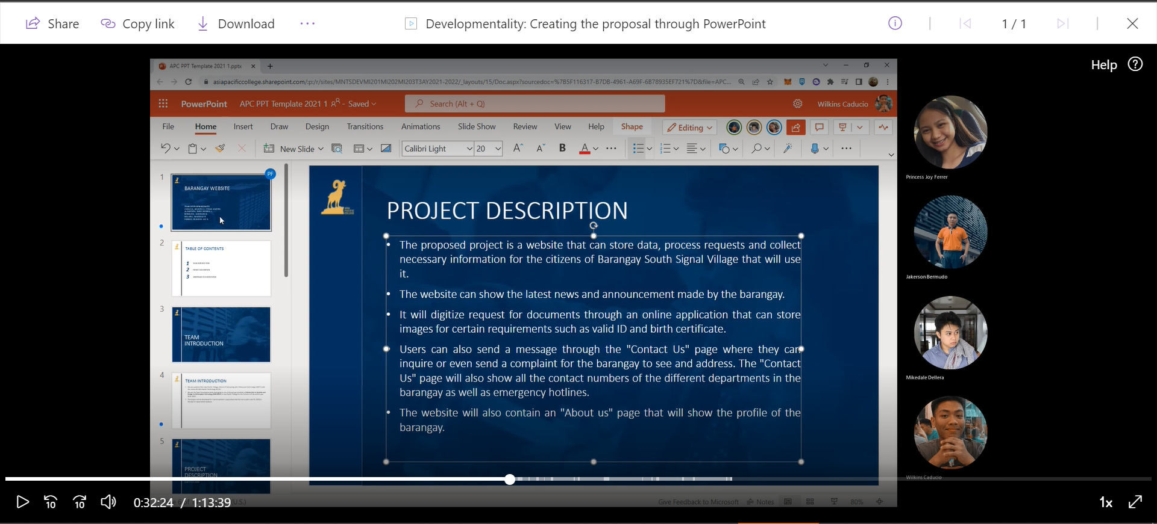

**Teams Meeting Date: April 19, 2022**

**Agenda**Meeting with Adviser

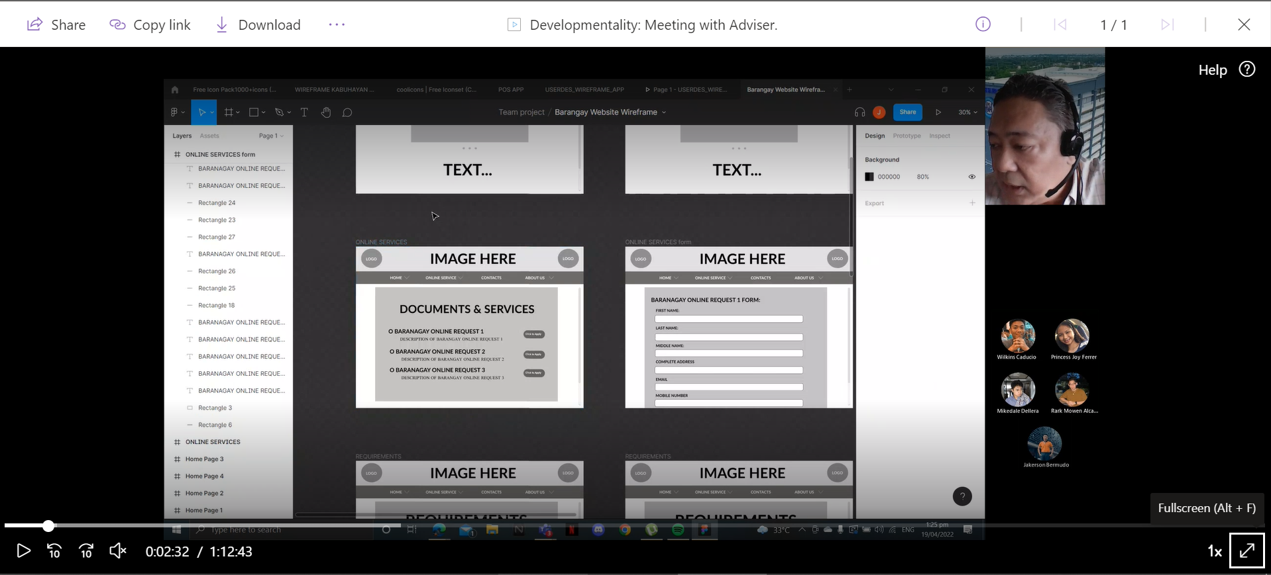

**Minutes of the Meeting Date: April 26, 2022**

Meeting with Adviser

**Agenda**

Finalization of Prototype using HTML and CSS

**Discussion**

* Viewing / dropdown for safety section
* Link the same webpage, admin know the database
* MERN Stack for database - more on document
* Complete requirements Approved
* Search by transaction number or by date
* For walk-in / new document, new request
* Cloud base for the client, Linode, MongoDB
* How many courses, how many bandwidths, how many storages capacity
* Request for day, number of viewers of website, number of hints
* Test SDLC (Software Development Life Cycle) – Unit

**Notes**

* Ask the client for expiration of request document
* Online Services (Add confirmed for the status)

**Teams Meeting Date: April 27, 2022**

**Agenda**Paper Completion / Meeting with Consultant

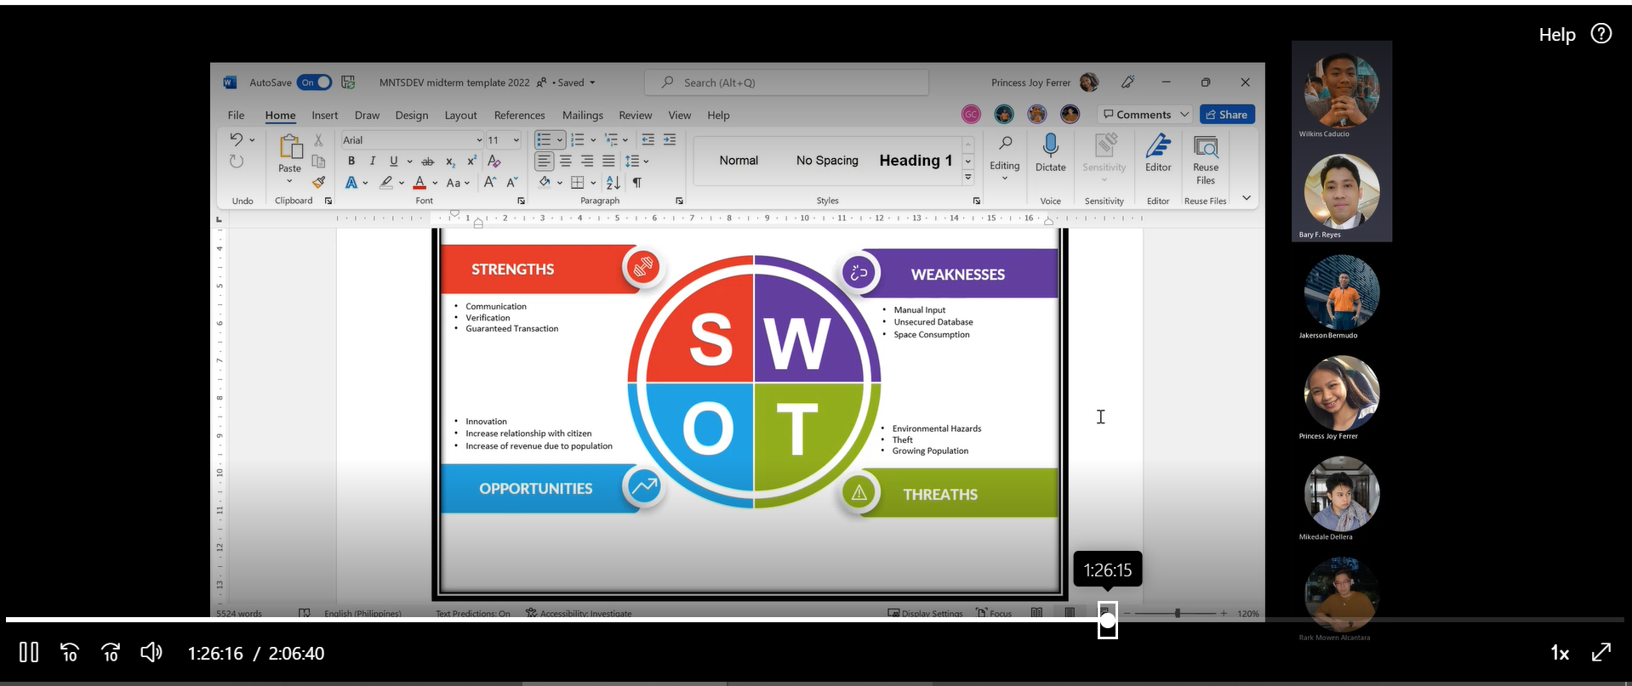

**Teams Meeting Date: April 28, 2022**

**Agenda**Paper Completion 2.0

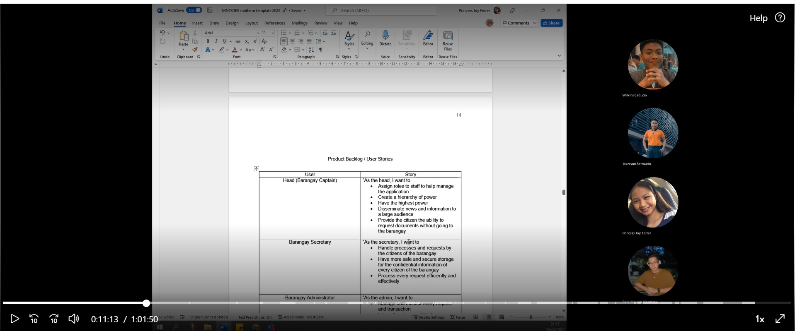

**Teams Meeting Date: May 04, 2022**

**Agenda**Brainstorming and recap

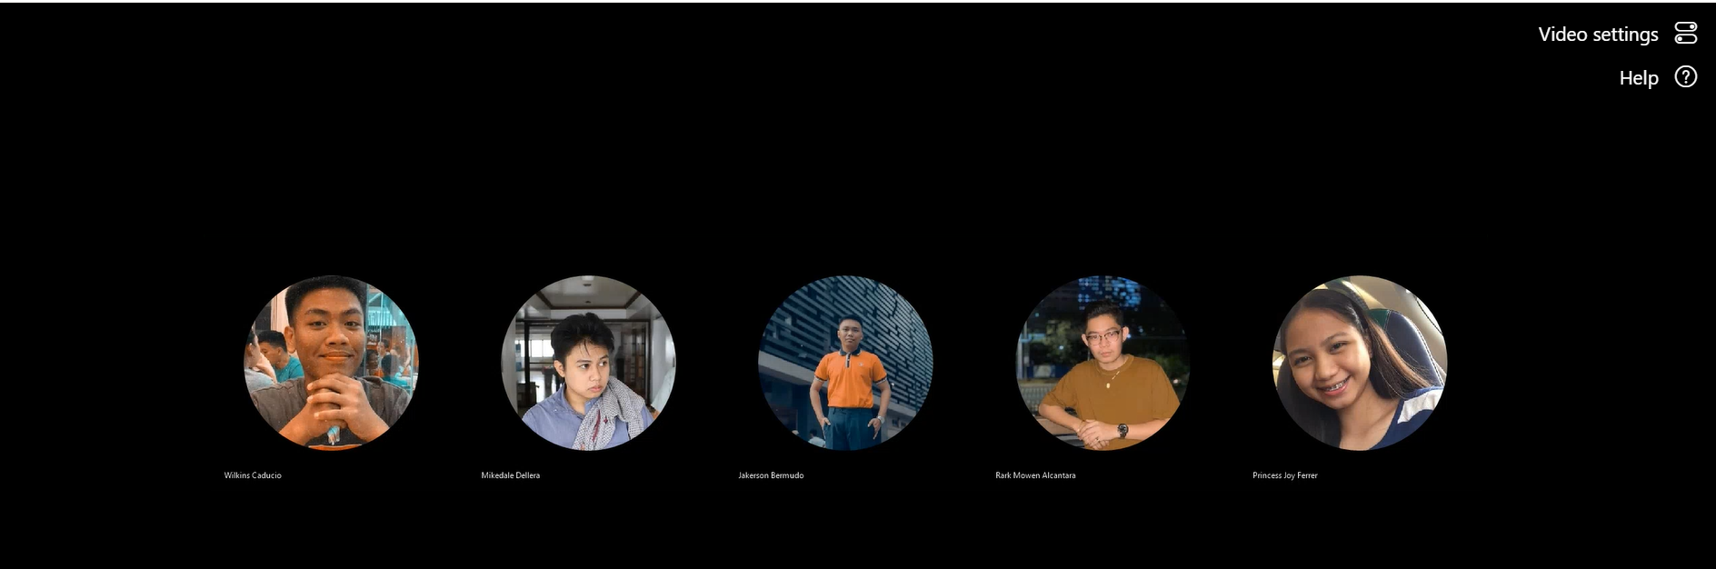

**Teams Meeting Date: May 12, 2022**

**Agenda**Brainstorming and Project Planning

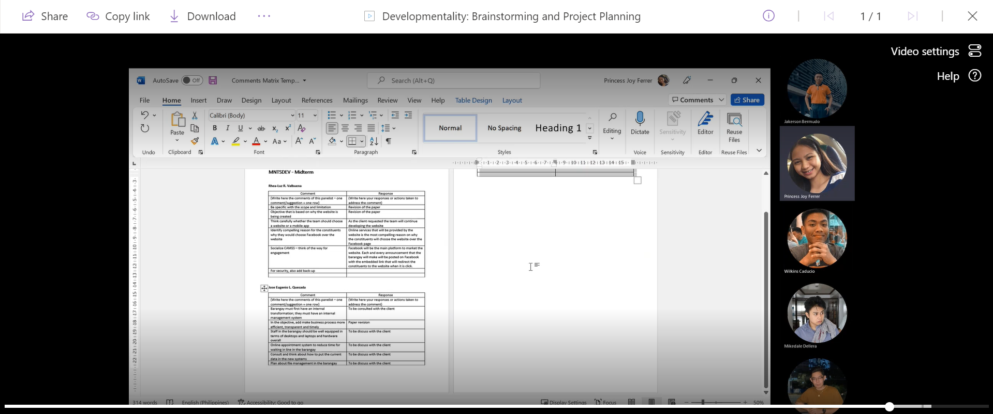

**Teams Meeting Date: May 14, 2022**

**Agenda**Comment Matrix

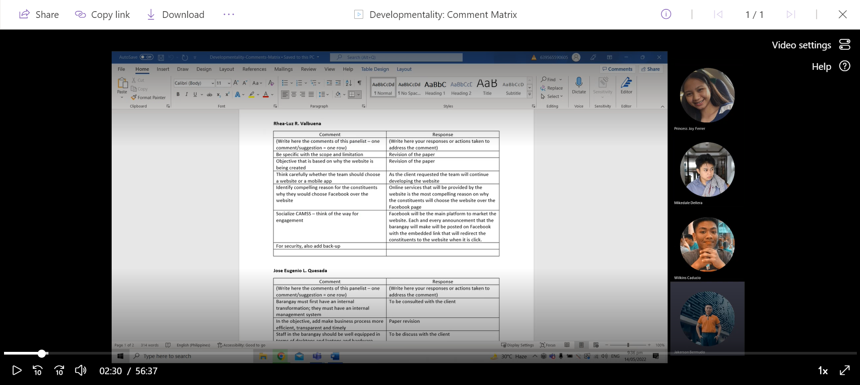

**Teams Meeting Date: May 16, 2022**

**Agenda**SOP Progression

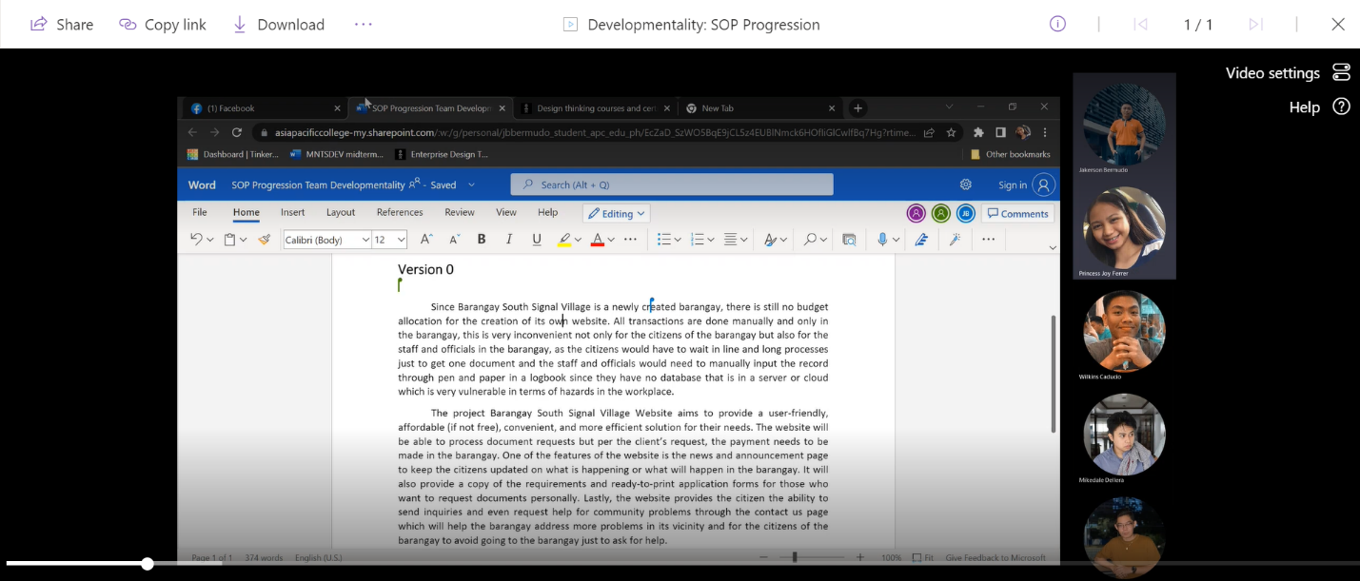

**Teams Meeting Date: May 24, 2022**

**Agenda**Progress Meeting with Adviser

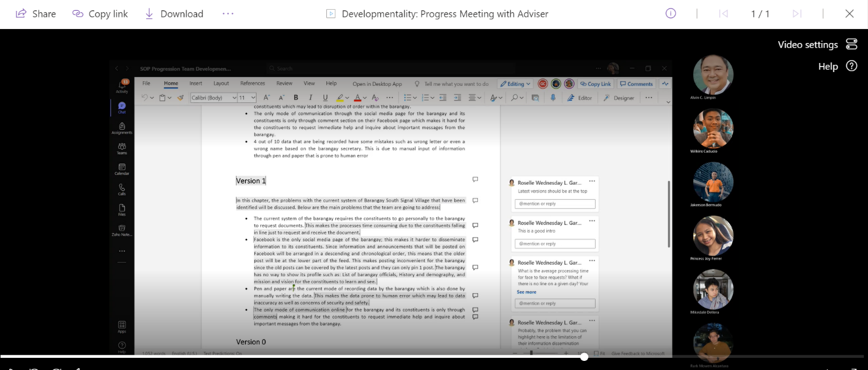

**Teams Meeting Date: May 30, 2022**

**Agenda**Planning and Progress Meeting

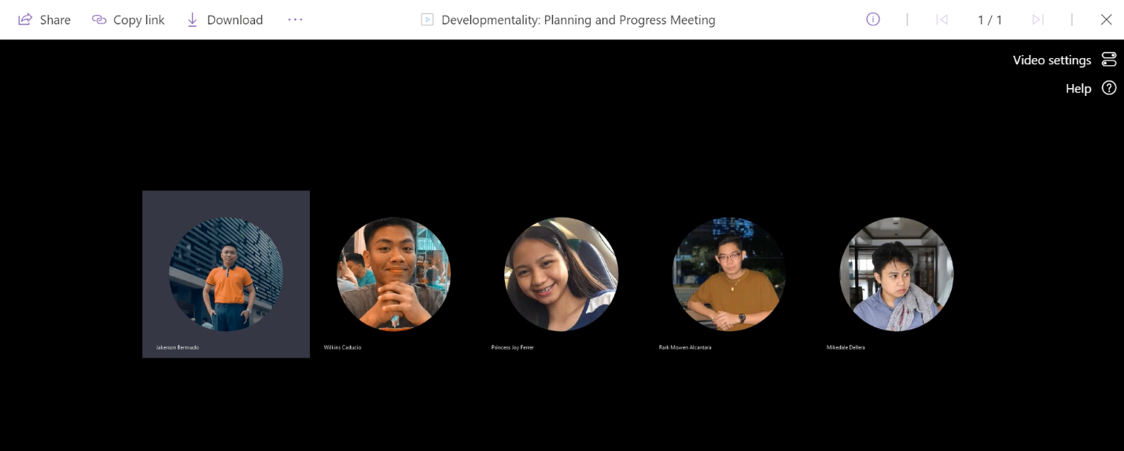

**Teams Meeting Date: May 31, 2022**

**Agenda**  
Update Meeting

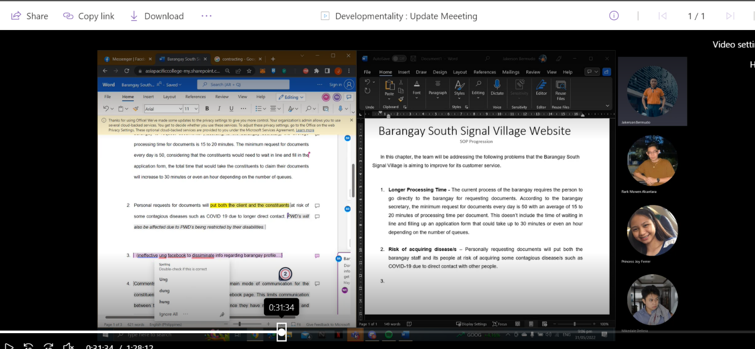

**Teams Meeting Date: August 31, 2022**

**Agenda**  
Existing Event Table of Existing Business Process

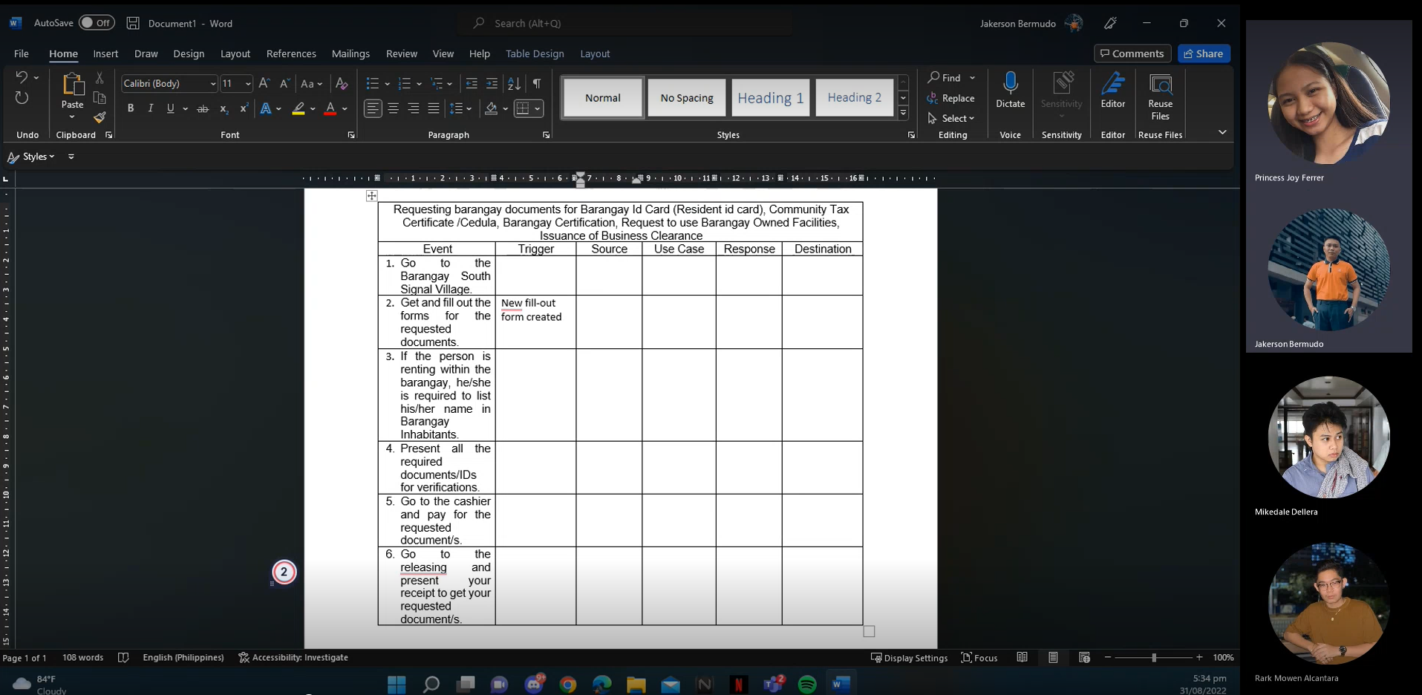

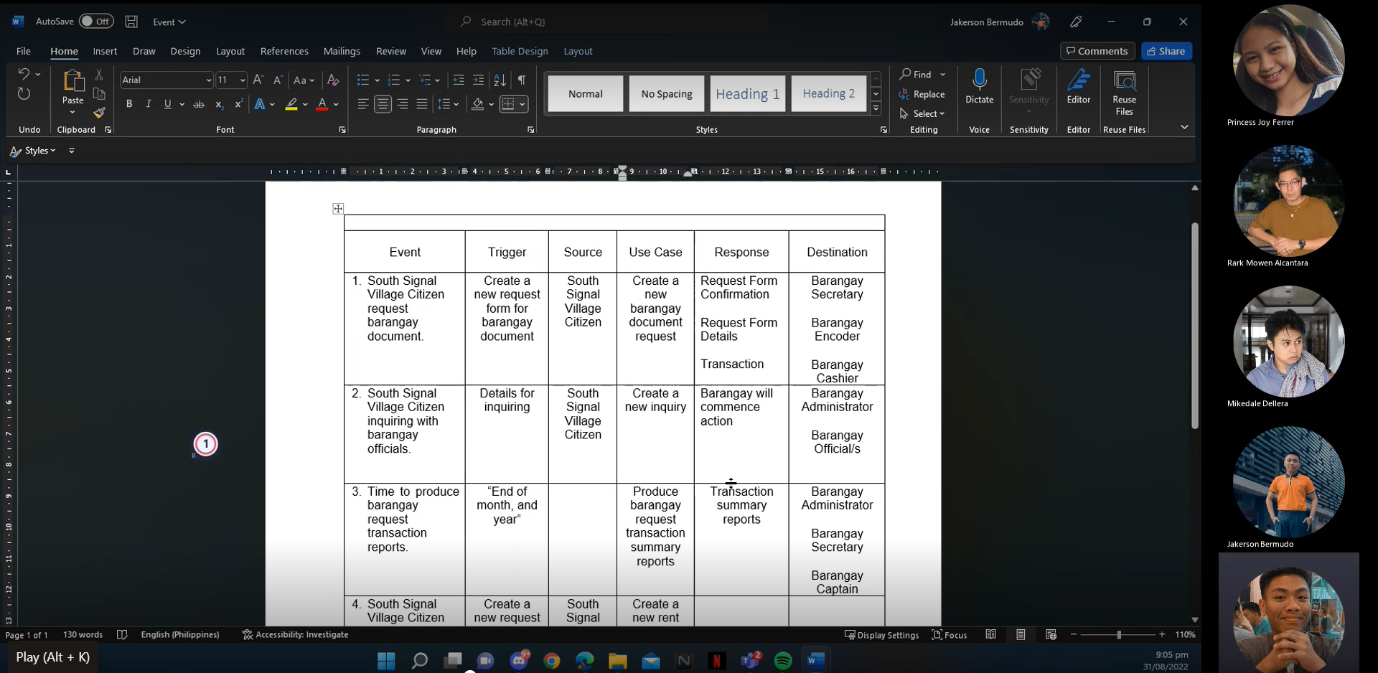

**Teams Meeting** **Date: September 3, 2022**

**Agenda**  
Existing Business Process

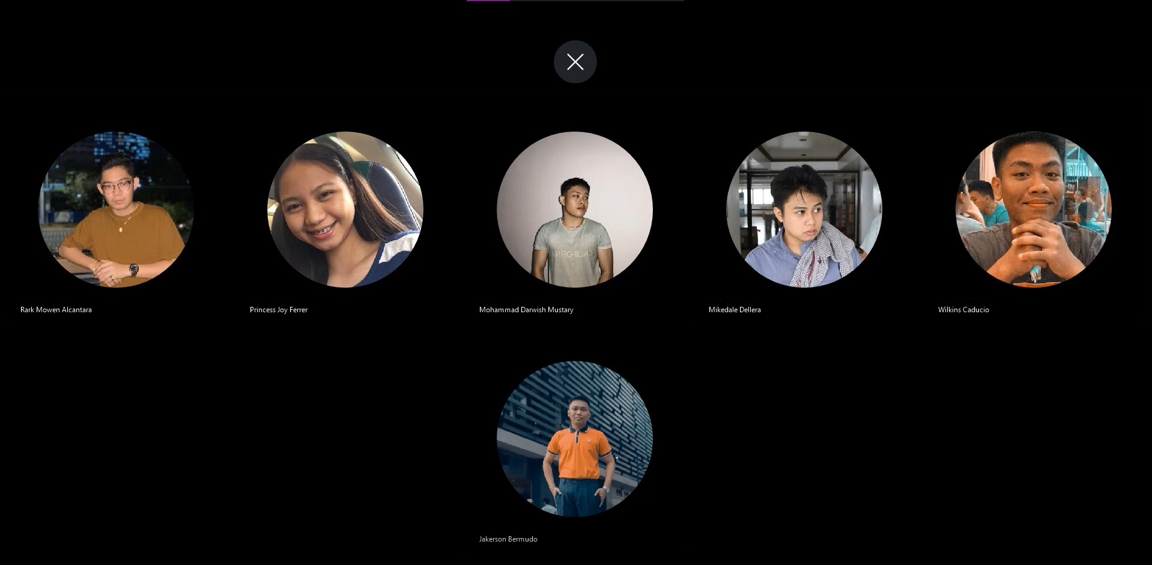

**Teams Meeting** **Date: September 6, 2022**

**Agenda**  
Existing Use Case Diagram

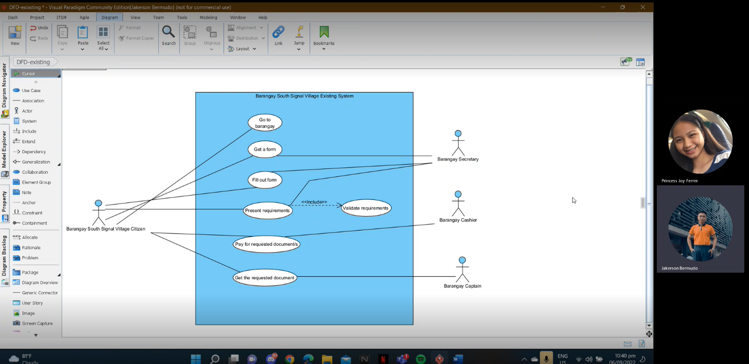

**Teams Meeting** **Date: September 7, 2022**

**Agenda**  
Proposed Event Table, Existing ERD, DFD, CFD

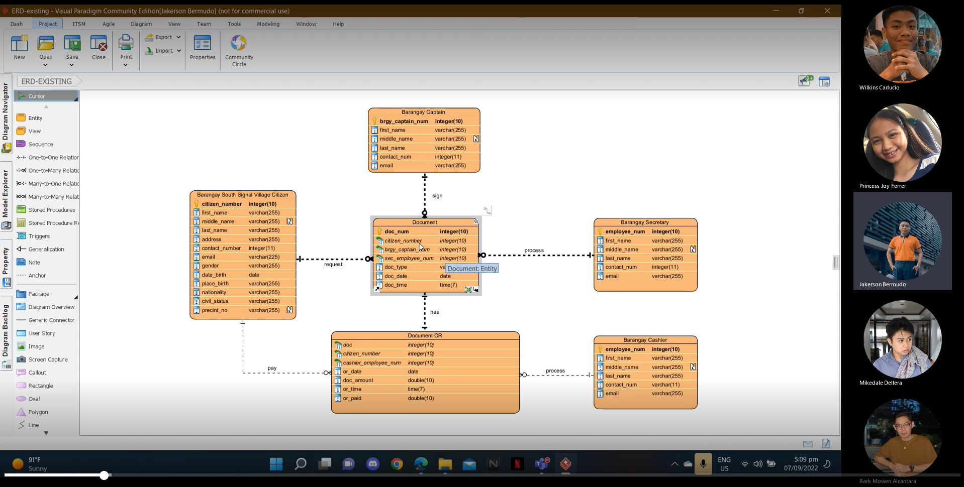

**Teams Meeting** **Date: September 13, 2022**

**Agenda**  
Proposed CFD

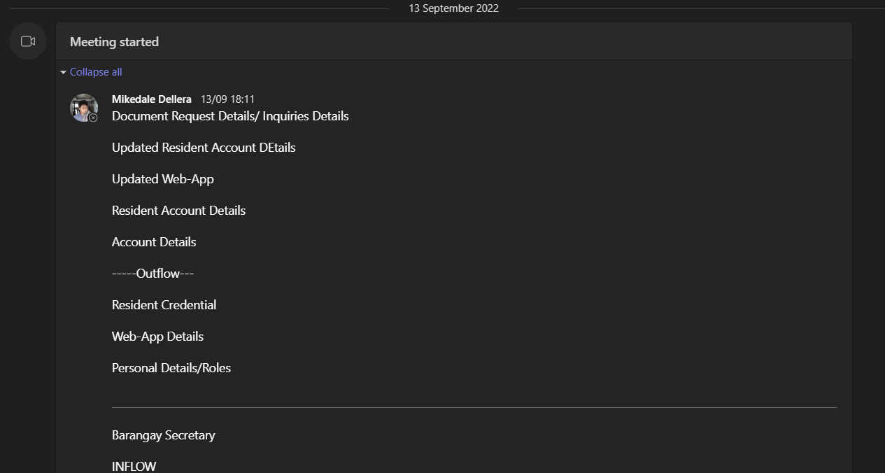

**Teams Meeting** **Date: September 14, 2022**

**Agenda**  
Proposed DFD, Use Case Diagram

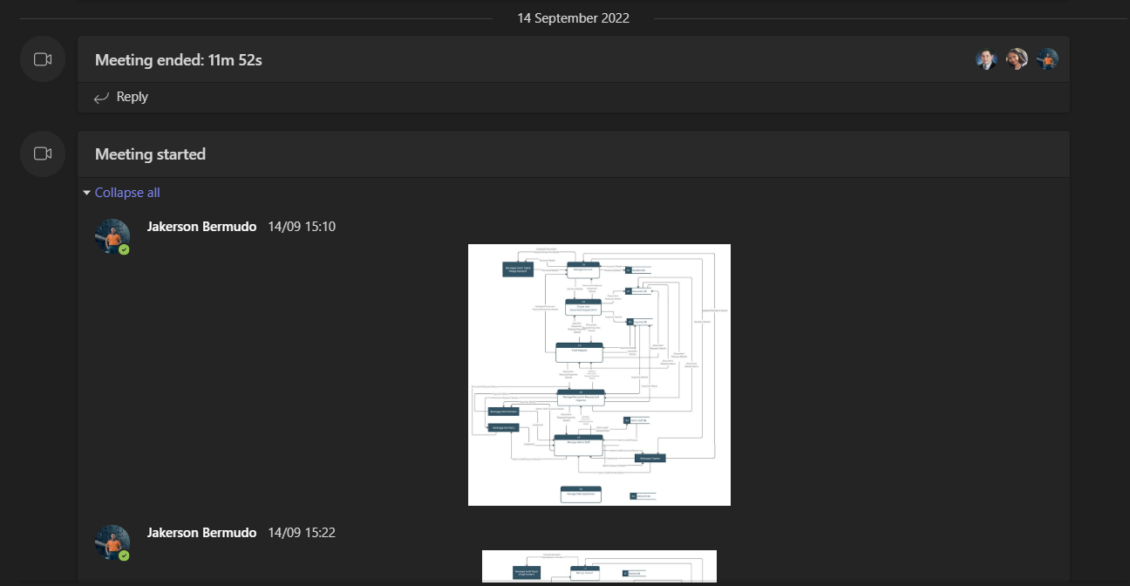

**Teams Meeting** **Date: September 17, 2022**

**Agenda**  
Meeting with Project Adviser

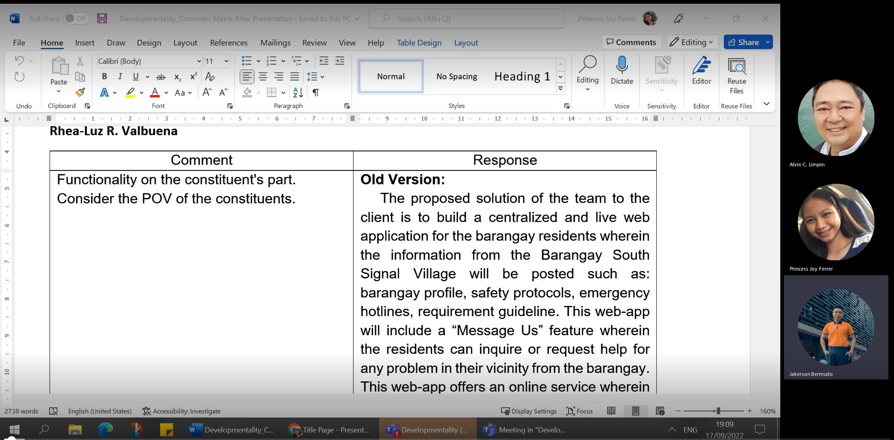

**Teams Meeting** **Date: September 20, 2022**

**Agenda**  
Proposed Event Table, Use Case Diagram, ERD, Use Case Full Description, Activity Diagram, Object Diagram, Class Diagram, User Stories and Acceptance Criteria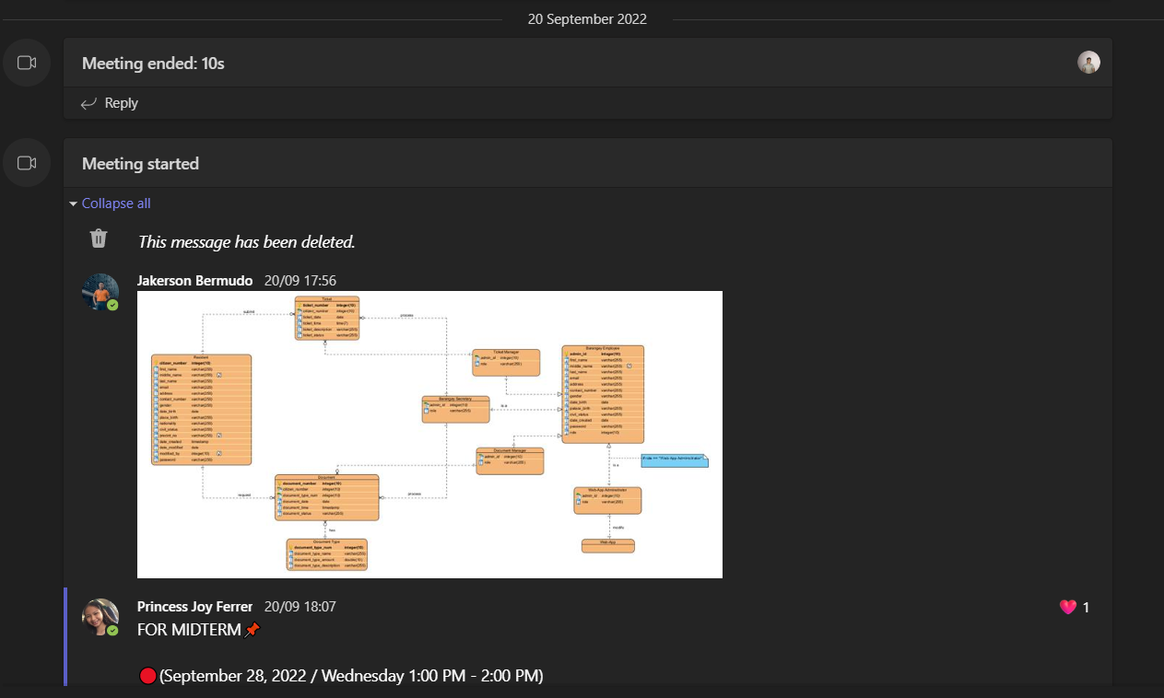

**Teams Meeting** **Date: September 21, 2022**

**Agenda**  
Consultation with Project Adviser

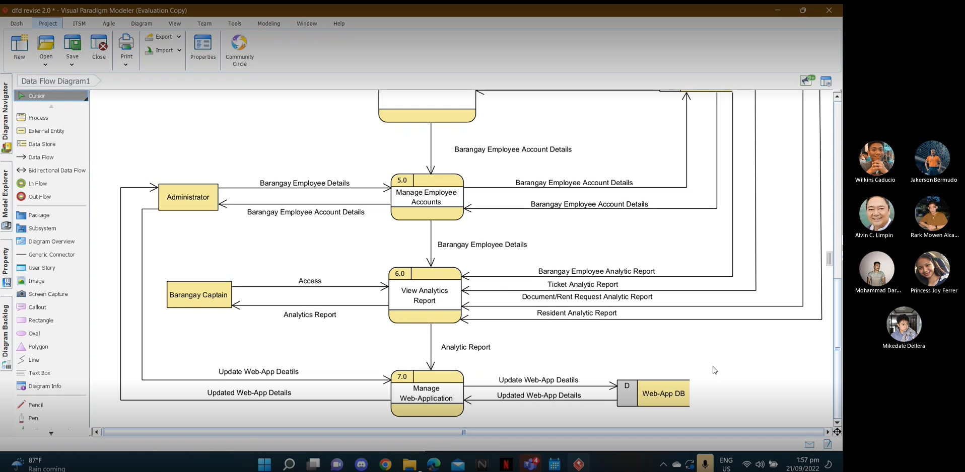

**Teams Meeting Date: September 25, 2022**

**Agenda**  
Finalization Proposed Event Table, Use Case Diagram, ERD, Use Case Full Description, Activity Diagram, Object Diagram, Class Diagram, User Stories and Acceptance Criteria, Prototype

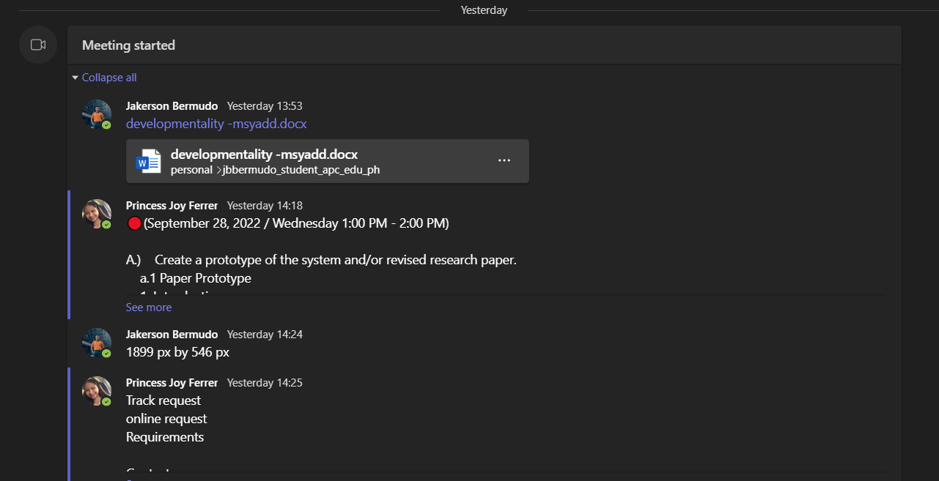

**Teams Meeting Date: September 27, 2022**

**Agenda**  
Dry Run

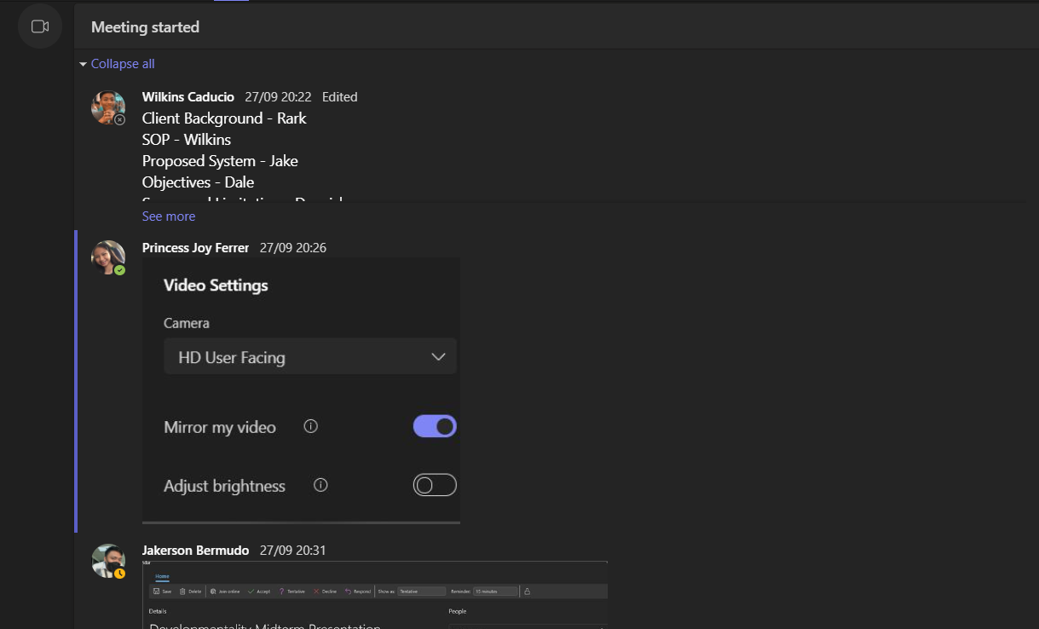

**Teams Meeting Date: September 28, 2022**

**Agenda**  
Dry Run 2.0

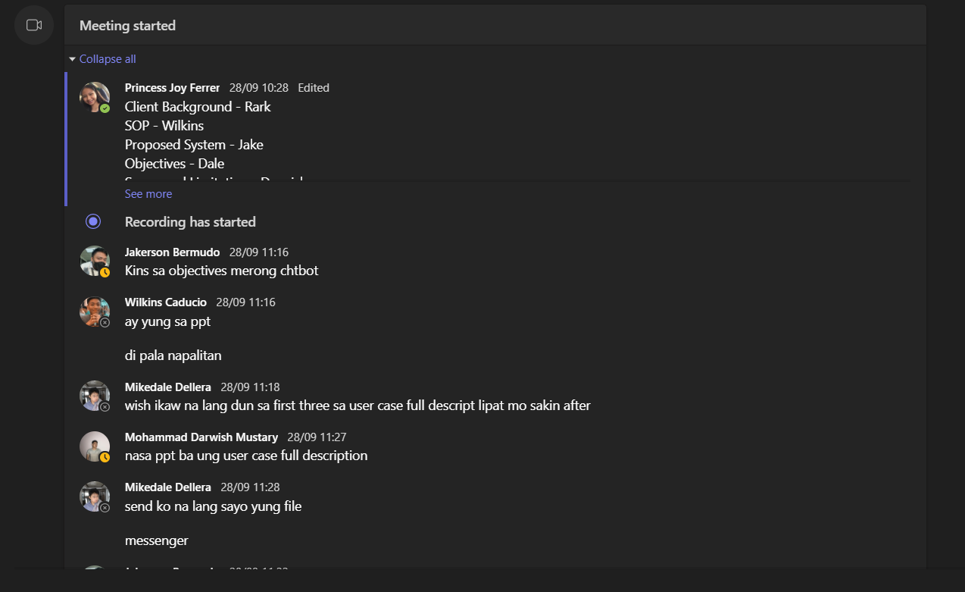

**Teams Meeting Date: October 31, 2022**

**Agenda**  
Finalization of Paper / Diagrams 1.0

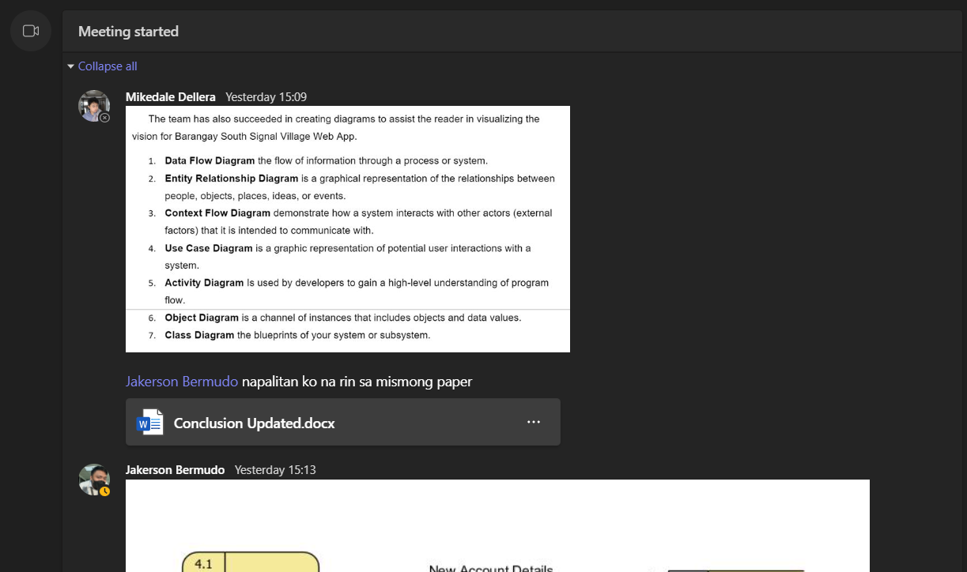

**Teams Meeting Date: November 2, 2022**

**Agenda**  
Finalization of Paper / Diagrams 2.0

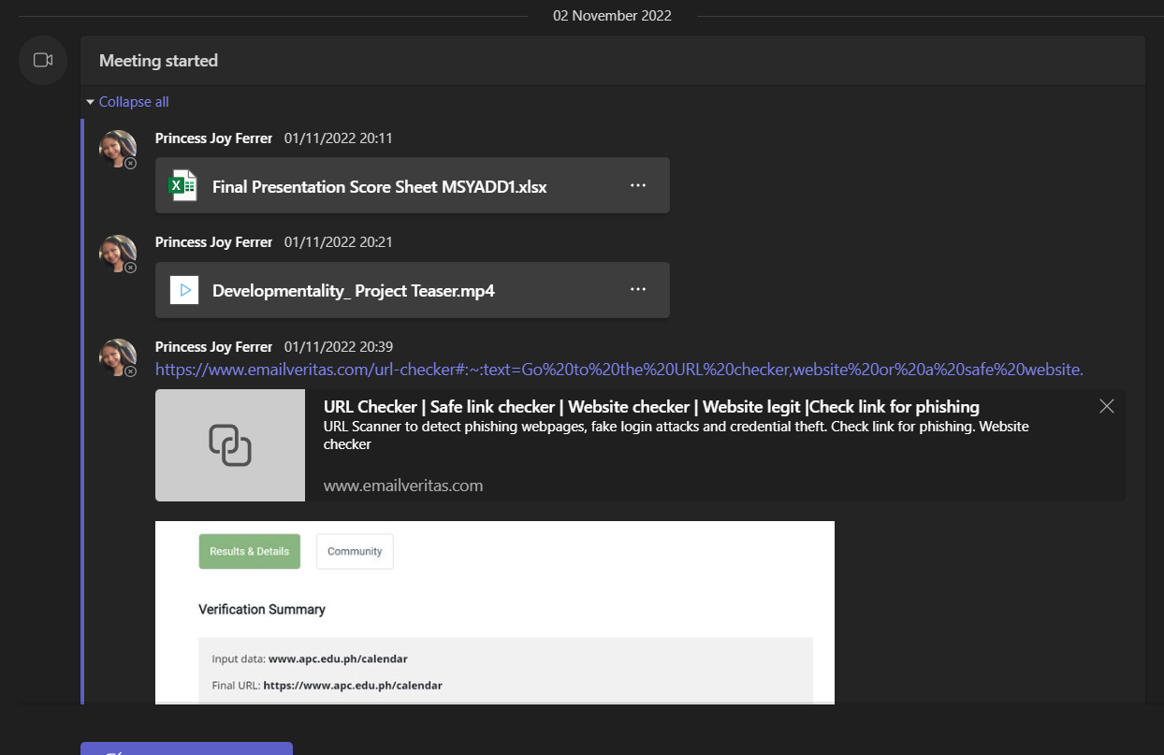

**Teams Meeting Date: December 2, 2022**

**Agenda**  
Group Update 1.0

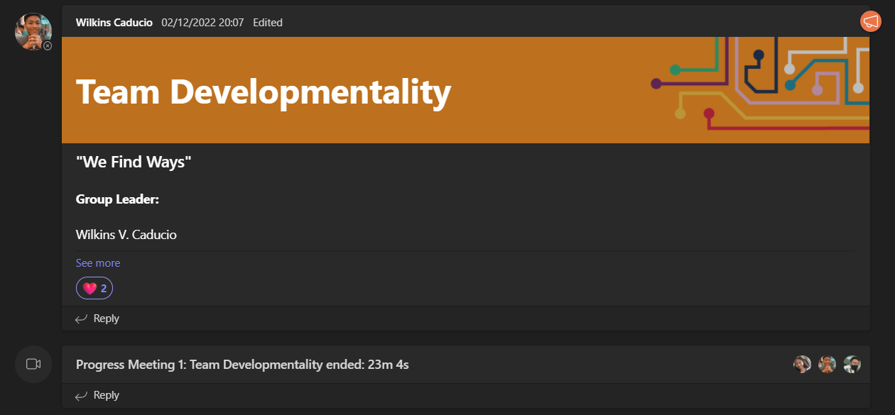

**Teams Meeting Date: December 6, 2022**

**Agenda**  
GANTT Chart Creation

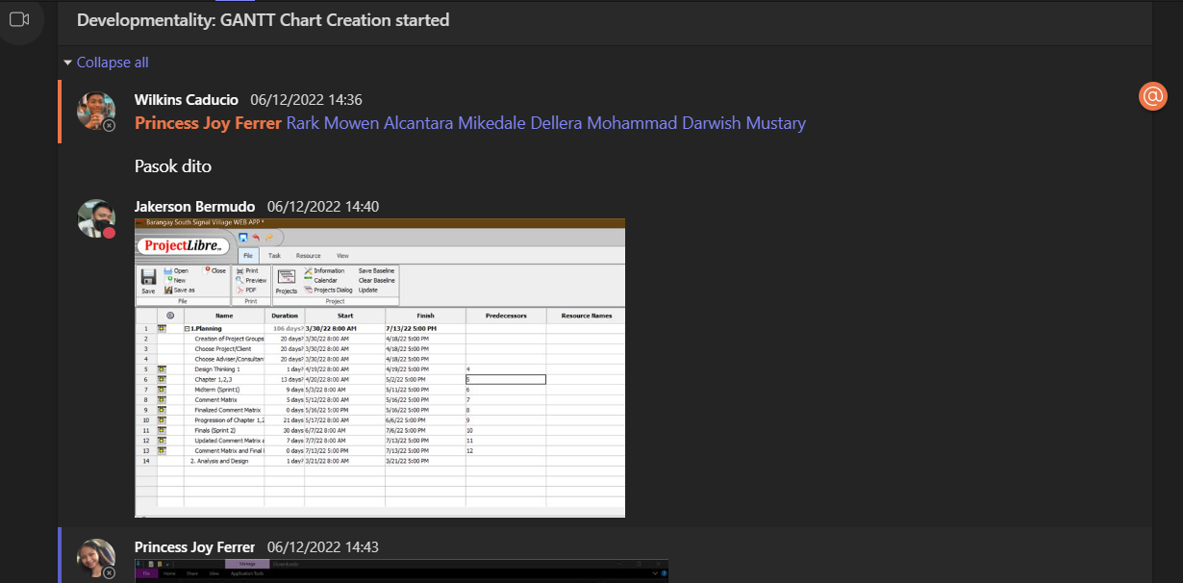

**Teams Meeting Date: December 13, 2022**

**Agenda**  
Group Update 2.0

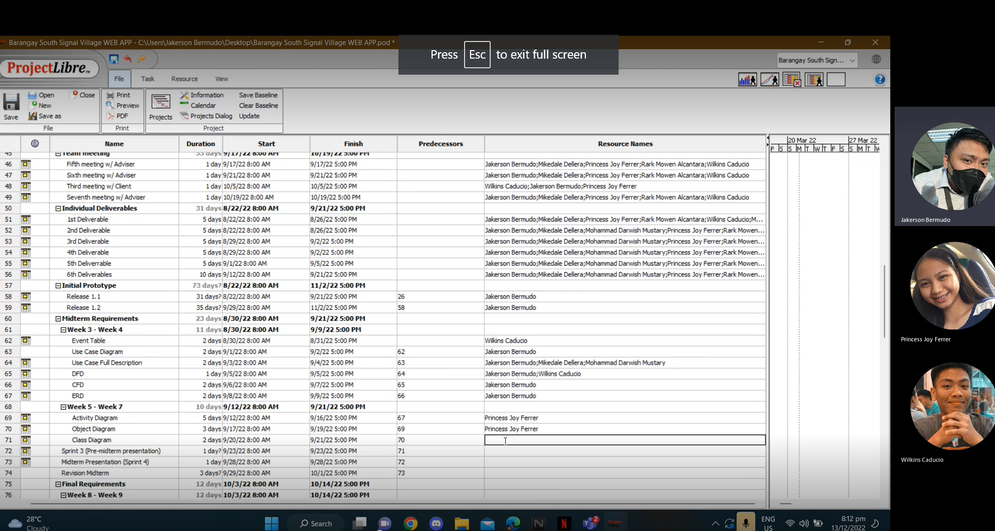

**Teams Meeting Date: December 15, 2022**

**Agenda**  
Group Update 2.0

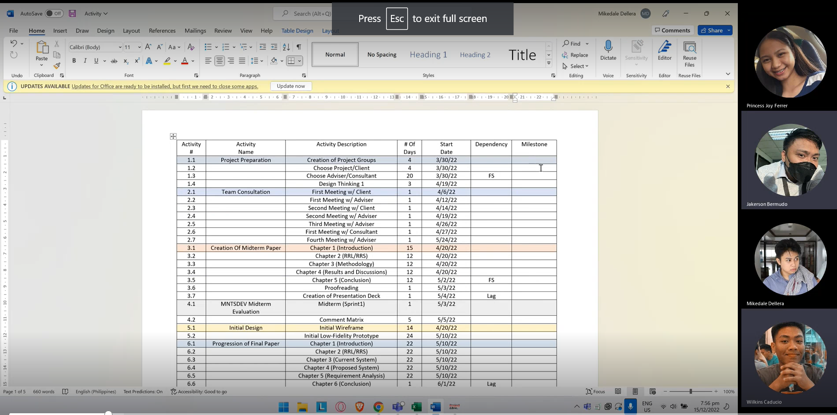

**Teams Meeting Date: January 8, 2023**

**Agenda**  
Update Prototype

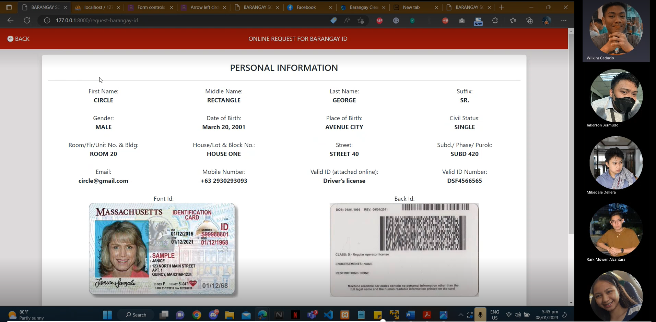

**Teams Meeting Date: January 11, 2023**

**Agenda**  
Project Deliverables Review and Revision 1.0

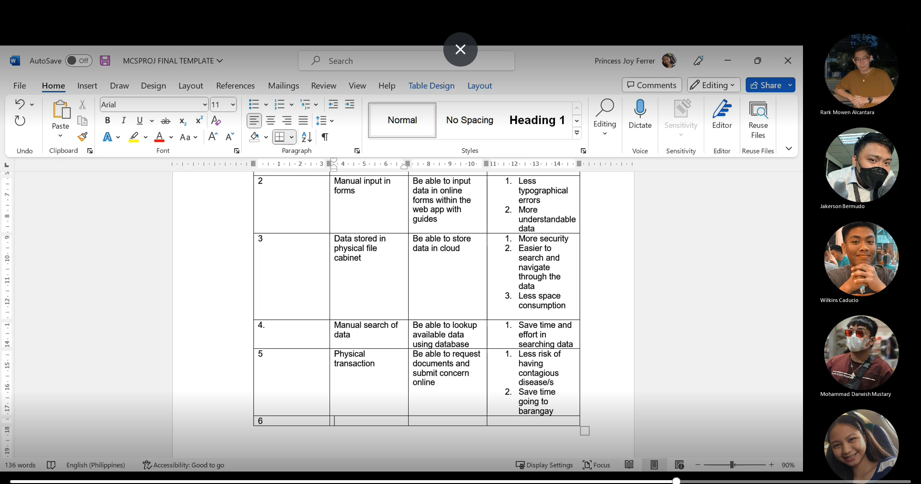

**Teams Meeting Date: January 12, 2023**

**Agenda**  
Project Deliverables Review and Revision 2.0

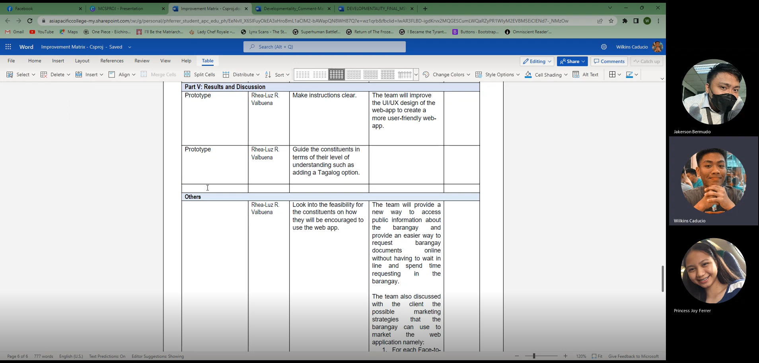

**Minutes of the Meeting Date: January 25, 2023**

**Agenda**

Meeting with the client

**Web-app**

1. **BARANGAY OFFICIALS**

Included Treasurer and administrator  
(Tres, sec, admin and hepe)`

1. **OBJECTIVES:**

Instead of Tree planting > (Urban Gardening) (Added Composting)

1. **DEMOGRAPHY:**  
   Population needs to update
2. **CONTACTS**  
   Barangay hotline: (09956531922 Updated Globe / 09491551111 Updated Smart)  
   Emergency Hotline: Instead of blk4 > change to (police substation 6)  
   Clarify sun number to the secretary
3. **REQUIREMENTS**  
   Line of text needs to Justify (Format of Charter)
4. **ONLINE LOGIN**

Data Privacy Notice: They will provide the data privacy (barangay)  
Registration Form: instead of subd/phase> (Purok/Zone before street)   
Dropdown of street > Copy of List of Streets to secretary

Email address: 1 email per account > allowed the user to use many mobile numbers per account

Request of change for ID: Time of Process (7 days)

1. **ONLINE TRANSACTION**Types of Residencies: (Added Visitor and need 6 months) Allowed to create an account but she/he stays more than 6 months (Validate)

Create an account for don’t have the valid id: It’s okay to use a school id and birth certificate

Clearance for Minor: waiting for the update

1. **Business Clearance >** waiting for the update
2. **TRANSACTION HISTORY** > instead BarID reference change to (BGRYID)

Request information Price change to (Barangay treasury office)

1. **BARANGAY SECRETARY PAGE**

(Added: limit of types of clearance certification)

Change Color of font (Resident form)

Ticket manager > Concern manager

**Teams Meeting** **Date: January 28, 2023**

**Agenda**

Final Paper Revision

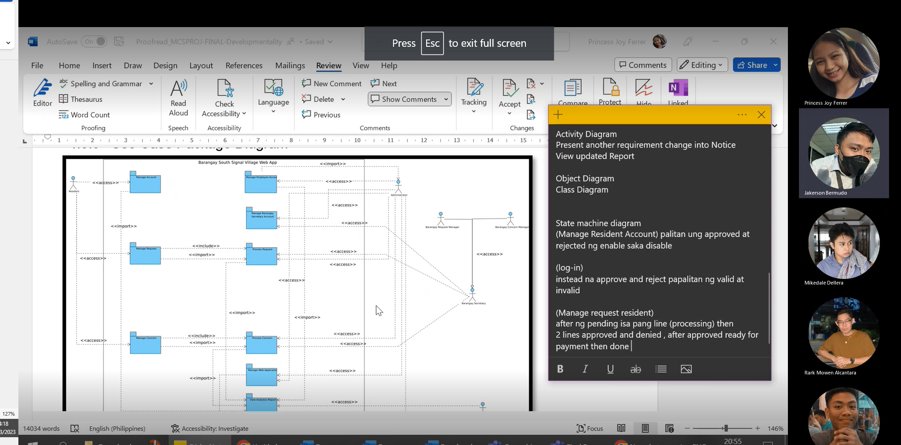

**Minutes of the Meeting**

**Agenda**

Last consultation with the client March 1, 2023

Attendance:   
1. Hon. Kenneth Ian V. Nadela (Bgry. Kagawad)

2. Hon. Norman H. Hortilano (Brgy. Kagawad)

3. Hon. Cesar S. Tiglao (Brgy. Kagawad)

4. Hon. Glenn Robert N. Roa (Brgy. Kagawad)

5. Hon. Kenneth D. Caneda (SK Chairman)

6. Nerissa V. Caducio (Brgy. Secretary)

7. Wilkins V. Caducio (Team Leader)

8. Jakerson B. Bermudo

9. Rark Mowen L. Alcantara

10. Mikedale B. Dellera

11. Mohammad Darwish T. Mustary

12. Princess Joy H. Ferrer

Question to the Client

**Data Privacy Policy**Our client gave us consent to create a draft for a data privacy policy notice for temporary.

**OR CTC and Reference number**  
Our client decided to input the OR and CTC, and Reference number manually.

**Barangay ID and Cedula**No copy is needed for PDF to send to the client.

**Expiration Date for all printed documents** 1-year Validation

**Minutes Of the Meeting** March 2, 2023

**Agenda**

Discussion with Sir Alvin

Topics about:  
Services

Email Key Code

Concern

Transaction History

Verification Through Email

Interface Changes for barangay Secretary

Expiration of Document

Process concern

Show concern.

History of Concern

Open Concern

**Concern:**

-Green Area for correct input ng Registration Form

-Table type dashboard of pending processing, request document report

With filter options, according to the user, according to the transaction, range date, status

-Mock certificate

- Reassign Ticket Not Reopen Ticket

-Concern, request dashboard statistics

-number of registered users’ statistics dashboard

## Appendix F: Source Code

GitHub Repository - <https://github.com/seans888/Developmentalityb>

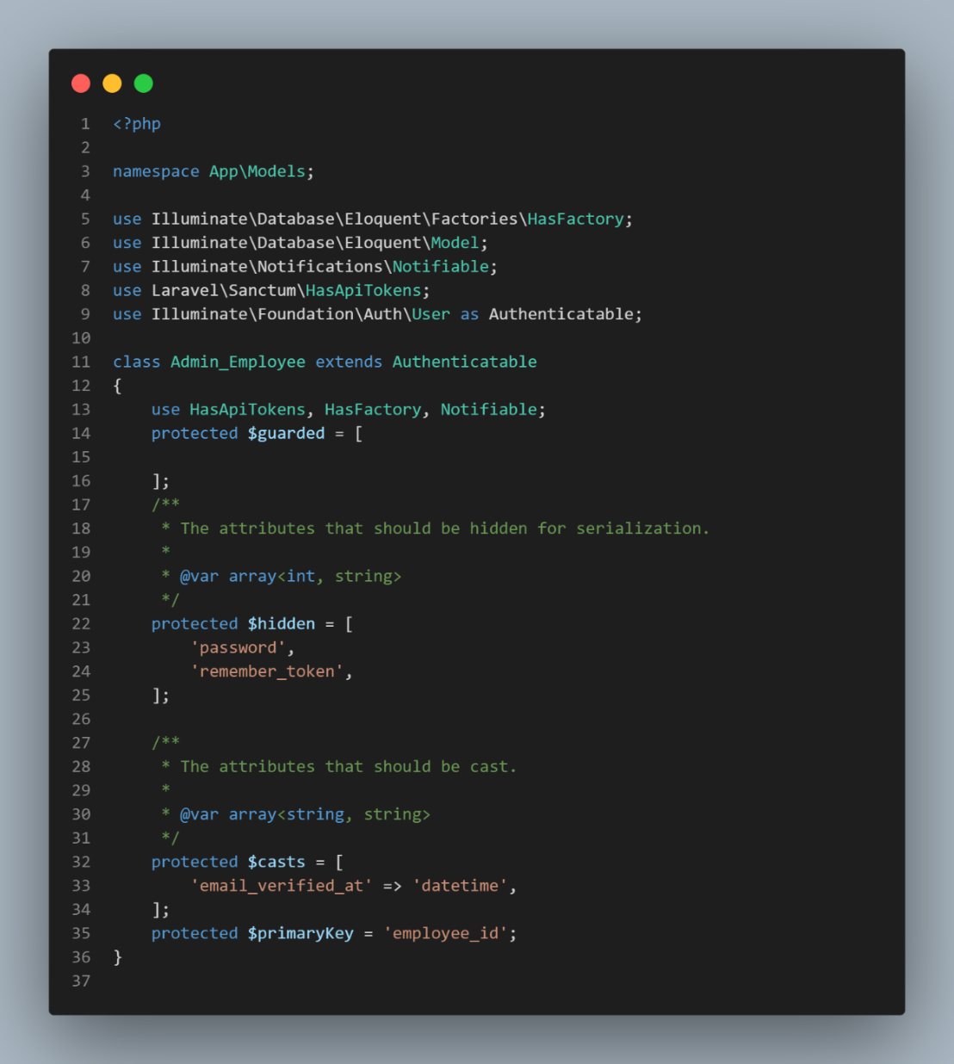

Figure 61 Source Codes

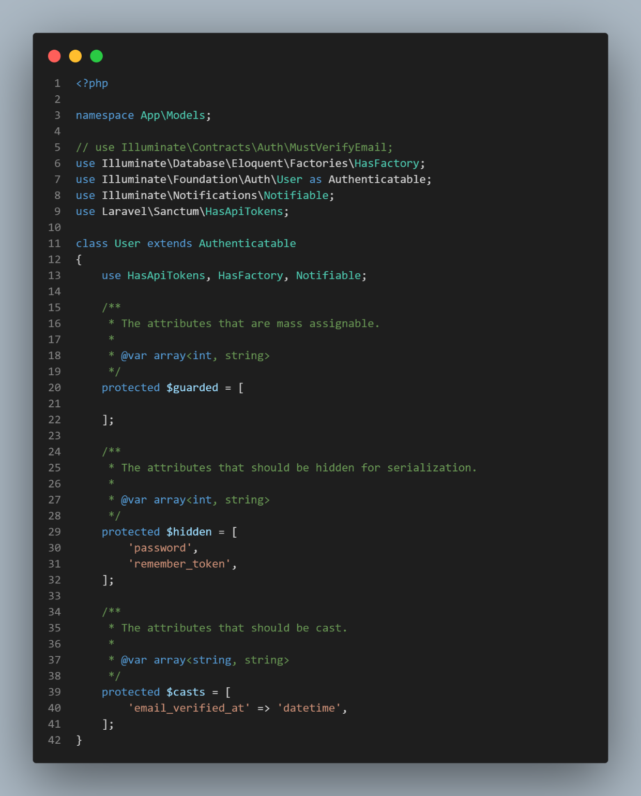

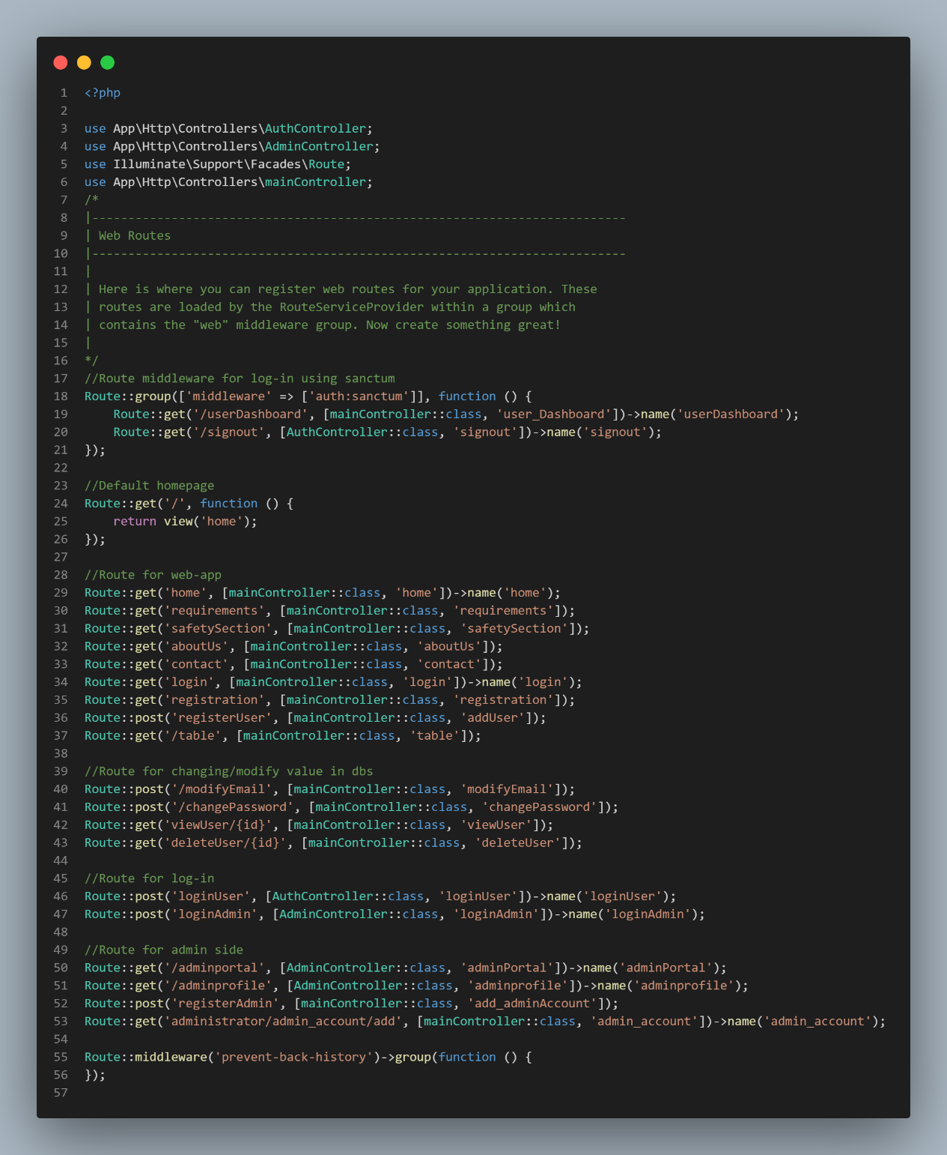

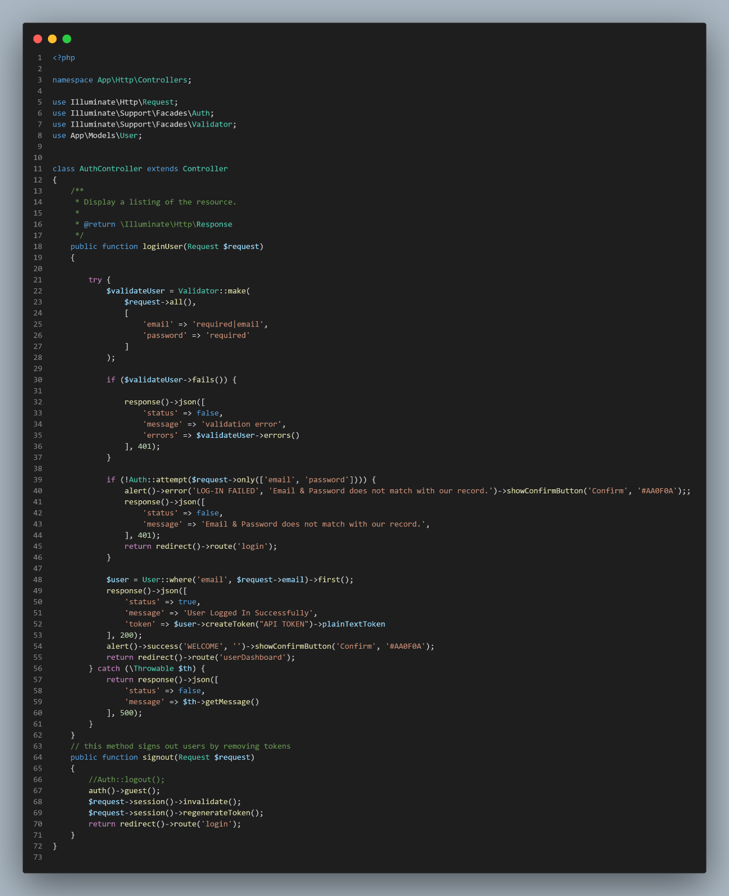

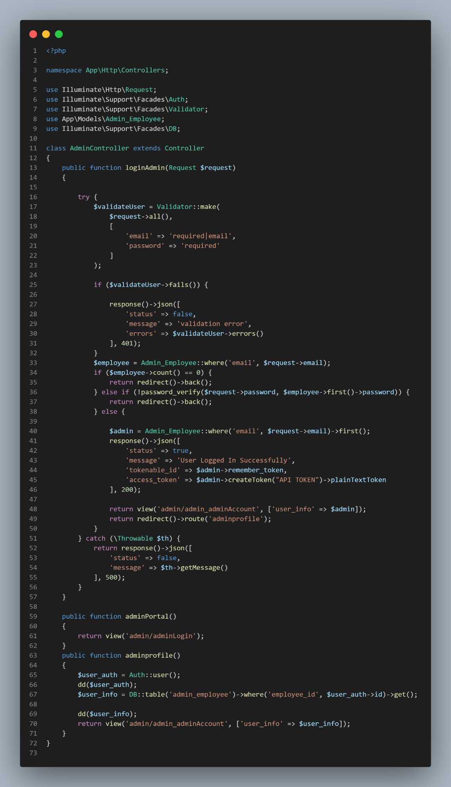

## Appendix G: Curriculum Vitae

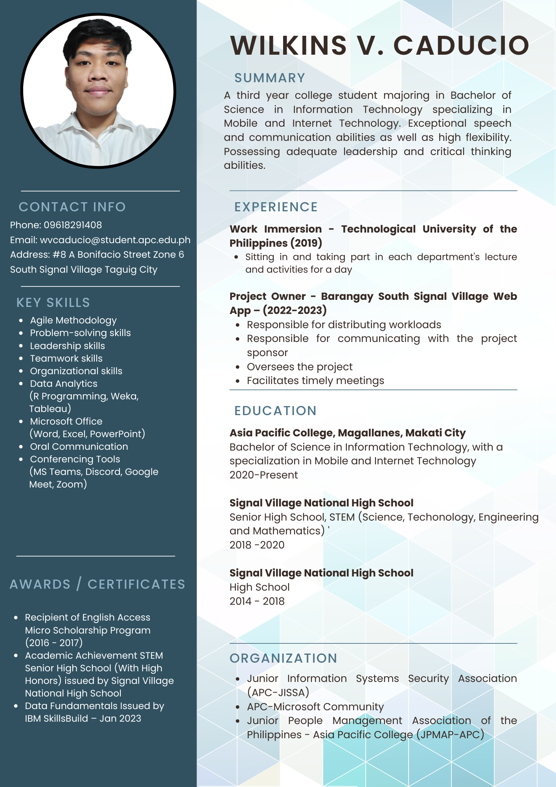

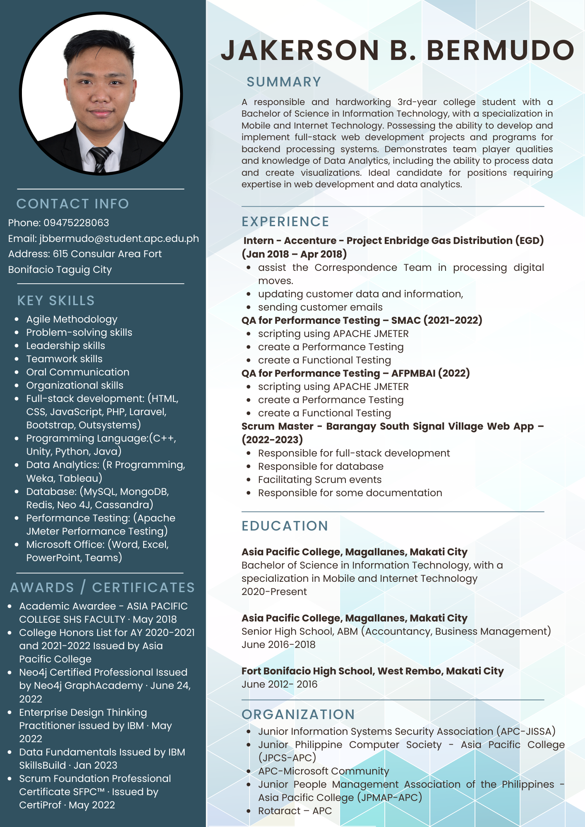

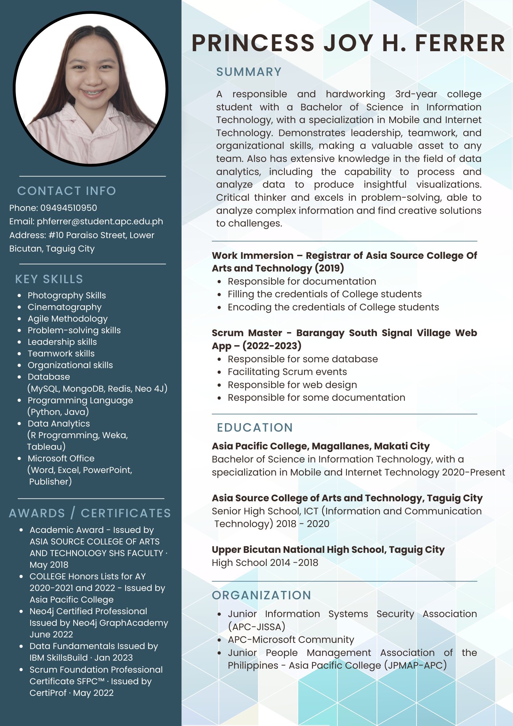



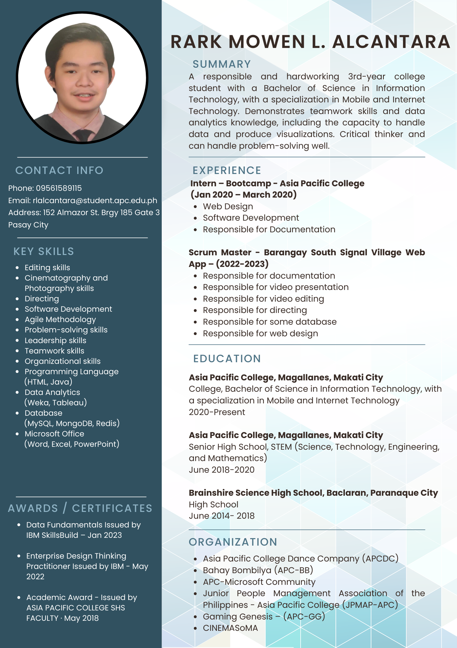

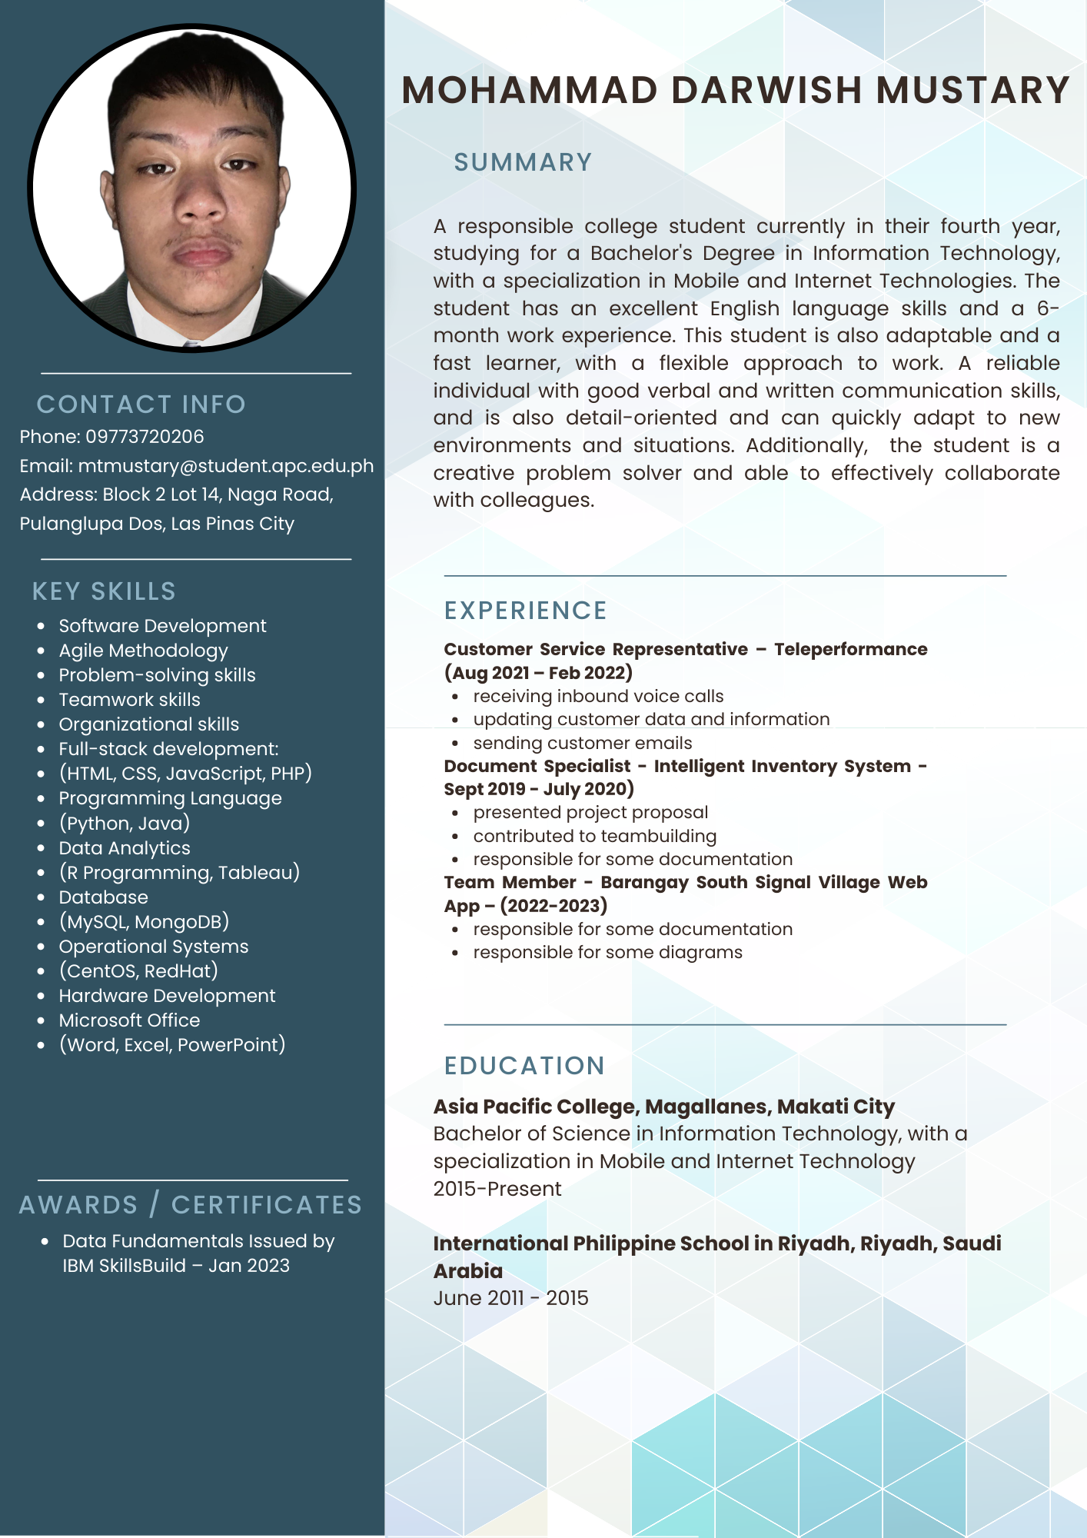

## Appendix H: Links

1. Project Charter - [Project Charter .docx](https://asiapacificcollege.sharepoint.com/:w:/s/MCSPROJMI201202/EakYnVDz40ZKjHs9V6OzZsoBf-7VAkMwR_rjumAgmWnJ7A?e=hWBmaA)
2. Vision and Scope Document - [Project Vision and Scope .docx](https://asiapacificcollege.sharepoint.com/:w:/s/MCSPROJMI201202/EXEm_CK_IPpLl79dzXPopuQB4dKHG2Zvf8e9U0gwHzapYQ?e=UusgTc)
3. Software Requirement Specification - [Software Requirement Specification.docx](https://asiapacificcollege.sharepoint.com/:w:/s/MCSPROJMI201202/EfqrUmgrO2lHmkXQ2ng5AnUBprepZBWgTjWW_F027RTztw?e=1O4g1t)
4. Statement of Work - [Statement of Work .docx](https://asiapacificcollege.sharepoint.com/:w:/s/MCSPROJMI201202/Ed5CUOCP-mRNszOWH4B3RnwBn_sh66fRHoNhlz4Djdv6KQ?e=Cljsvp)
5. Quality Plan - [Quality Management Plan.docx](https://asiapacificcollege.sharepoint.com/:w:/s/MCSPROJMI201202/Ee8Drgp-N-1IqnWzlXr4Lt8B983bD5STBeCNIhSG5NQDUw?e=dwKgnV)
6. Test Cases - [Test Case .xlsx](https://asiapacificcollege.sharepoint.com/:x:/s/MCSPROJMI201202/ERevJsTFzmNIsSxPR29y_iUBqqhgETFt9rt_5lLIoorPUg?e=RZMdtX)
7. Change Management Plan - [Change Management Plan .docx](https://asiapacificcollege.sharepoint.com/:w:/s/MCSPROJMI201202/EfPLal5Zg4BBj-k-grdIiF0BkFIzVqQdxpWRut9rg2LDzg?e=XcUoMy)
8. User Review - [User Project Review.docx](https://asiapacificcollege.sharepoint.com/:w:/s/MCSPROJMI201202/EQ2XVZsYiYNPlEHZcFkrDSYBwSOL3De0MF4tEucb6enQcQ?e=p3Hr1a)
9. Project Sway - [Project Sway.pdf](https://asiapacificcollege.sharepoint.com/:b:/s/MCSPROJMI201202/ETEZYREN_s5PorbQzHZQdZ8Bx2JA2slOpB4jge7_1ZL8Cw?e=p2moQw)
10. Project Teaser - [Project Teaser.mp4](https://asiapacificcollege.sharepoint.com/:v:/s/MCSPROJMI201202/EYjBkXTsseFCu__gOmIxjRoBneWohvl2HImDrYyIf3_Igw?e=Ys2Vfc)